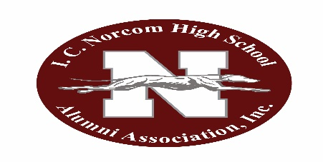
I. C. Norcom High School Alumni Association, Inc.

P. O. Box 3322
Portsmouth, Virginia 23701

November 1, 2022
Duration: 7-830pm (if needed)

‘The primary purpose of the I. C. Norcom High School Alumni Association, Inc. is to promote, by organized effort, the best interests of the school and those identified with it’.

AGENDA

Call to Order…………………………………………………………………………………………………….……Leah Stith, President
Invocation………………………………………………………………………………………………….…………Ray Smith, Chaplain
Minutes (silent reading)..………………………………………………………..…………………………….Frances Chavous, Secretary
Correspondence
Treasurer’s Report……………………………………………………………………………………Ethelyn Ingram, Financial Secretary

Standing Committee Reports*

Athletics………………………………………………………………………………………………………………………George Mack

Membership………………………………………………………………………………….…Misty Hayes(Online) Beverly Odom (LT)
Program……………………………………………………………………………………………………………………..
Public Relations………………………………………………………………………………………………………………...Karen Britt
Historian…………………………………………………………………………………………………….Mae Breckenridge- Haywood
Scholarship…………………………………………………………………………………………………………………...L. Armstrong

OLD BUSINESS

NEW BUSINESS…………………………………………………………………………………………………………...............L. Stith

Homecoming

110 Campaign
Grand Reunion/110th Anniversary (2023)

President’s Comments ……………………………………………………………………………………………………………..L. Stith
Birthday Recognition
Adjournment
Alma Mater

WEBSITE: icnaainc.org

‘For you, dear Norcom’

Please keep all reports and comments to no more than 2 minutes. Thank you.
*All reports to be submitted in writing to secretary for accurate documentation in minutes

NEXT MEETING (If Election Day or School Adjournment TBD) – Tuesday, December 6, 2022 if scheduled

Please remember to bring a friend, encourage membership in or make a donation in support of the alumni association!

