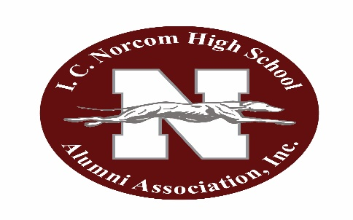
New site: www.icnaainc.org

I.C. Norcom Alumni Association, Inc. Monthly Meeting

October 4, 2022

The I.C. Norcom Alumni Association met on the above date. The meeting was called to order at 7:04 pm by our president, Leah Stith
Invocation – Ray Smith
Minutes (regular & Executive) motion to accept with correction to King William L. Armstrong 2nd Renetria Barnes-Hooker Carried
Correspondence: None
Treasurer’s Report - Ethelyn Ingram
General Fund $10, 033.98
Savings Account $17080.99
Scholarship Fund $16,295.37
Barry Smith Investment Fund $ 42,562.51
Special Account $ 3,223.23
Pearson Family Memorial Fund $10,000.01
Accepted pending audit
Committee Reports
Athletics: George Mack
Football Team 4-2. Volleyball 4-3
Membership: Misty Hayes Memberships for month of September 4 Associates; 23 regular 4 subscribing and 1 lifetime
Program—none
Public Relations: No report
Historian-- No report
Scholarship--L. Armstrong—thanks from some of the recipients; ODU check not cashed

OLD BUSINESS:
PCI Oral History Project: Lynn Briley No further correspondence received. Lynn still working
Library case not ready for new shipment 10/31/22 approx.../ Previous problems with broken items

NEW BUSINESS:
Nominating committee for new officers and positions discussed. Qualifications
Appointing committee Ray Smith chair; L. Armstrong; George Mack; Michelle Smith
November to bring back and vote (no associate members can vote)
Master list of membership being prepared by V. President. ( Mail chimp) for voting and other
Kita Allmond Ms. Fishbowl
Discussed 110 proposal ideas run 110 days thru October 1 thru April
Chairs for 110 reunion Ray and Shauntandra
Asking classes to nominate Living Legends (110)
Will also be honoring Ms. Edge, founder, 1st Principal Graduate Lynn Briley, Coach Savage, others etc

Possess characteristics of Mr. Norcom leading by dignity, etc.

Various activities throughout
110 Incentitive; Memberships and donations. Individual Donor levels @ 110 celebration-- silver, gold, Platinum

Motion to accept Donor Levels L. Armstrong 2nd V.Hardy Carried

Mae stated Casino had made a $25,000 donation to African American Historical Society

Leah to meet with company thru Mayor on behalf of Alumni

Vice-President submitted her suggestion for Square

Motion to Accept M. Whitehead 2nd L. Armstrong Carried

Mr. Savage congratulated association for all they are doing in support of school and activities

Decorations purchased by Lynn. Twists, Fringe, 100 yds; Laural to get lettering
1 Birthday –K. Harvey

Closing Prayer by: Ray Smith
Alma Mater
Adjournment: at 8:20 pm

Respectfully submitted
F. Chavous Secretary

