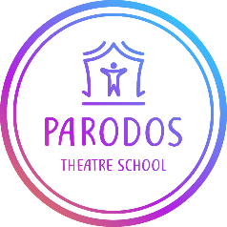
UNIFORM ORDER
FORM AND PRICE LIST
FULL NAME OF PARENT:
NAME OF CHILD/CHILDREN:

ITEM | SIZE | COST PER ITEM | QUANTITY | TOTAL
T-SHIRT |  | £ |  | £
SHOW T-SHIRT |  | £ |  | £
HOODIE |  | £ |  | £
TOTAL PAYABLE | £

UNIFORM PRICES
T-SHIRT CHILDREN aged 7 to 14: £15
T-SHIRT ADULT size S to XXL: £17
SHOW T-SHIRT* (sizes as above) £15
HOODIE CHILDREN aged 7 to 14: £22
HOODIE ADULT size S to XXL: £27

*Please state name or name of character to go on the reverse of the SHOW T-SHIRT
Please‌ ‌pay‌ ‌PARODOS‌ ‌THEATRE‌ ‌SCHOOL‌ ‌via‌ ‌BACS,‌ ‌Account‌ ‌Number:‌ ‌03914353‌
‌Sort‌ ‌Code:‌ ‌08-71-99‌ ‌
clearly‌ ‌stating‌ ‌your‌ ‌child’s‌ ‌full‌ ‌name‌ ‌as‌ ‌reference.‌ ‌

