CYLINDER :

The “Think Outside The Board Game” Rulebook

Table of Contents
1. Introduction
2. Components and Setup
3. Starting the Game
4. Green Zone: Positioning Field
5. Red Line: Launch Zone
6. Goal Line: Scoring Zone
7. Dice Rules: Special Rolls
8. Winning the Game
9. Summary
10. Multiplayer Rules
10A. 4-Player Individual Play
10B. 4-Player Team Play

1. Introduction
Cylinder: The “Think Outside The” Board Game is a fun, fast-moving marble strategy game. It’s played on a unique board where the field wraps around both horizontally and vertically — challenging players to think in new ways.

2. Components and Setup
Each 2-player game includes:  - One game board (5.25” x 10” each)  - 10 marbles per player  - One six-sided die (D6) per player  - Each additional 2 players requires another game board.  Each board contains:  - A 7x7 grid of holes plus a Home zone on a 2x5 grid and each end of the playboard  - Color-coded zones: Home (Turquoise), Green Field (Green), Red Line (Red), Goal Line (Purple)  - Magnets on the sides for expansion  - Internal storage for marbles | 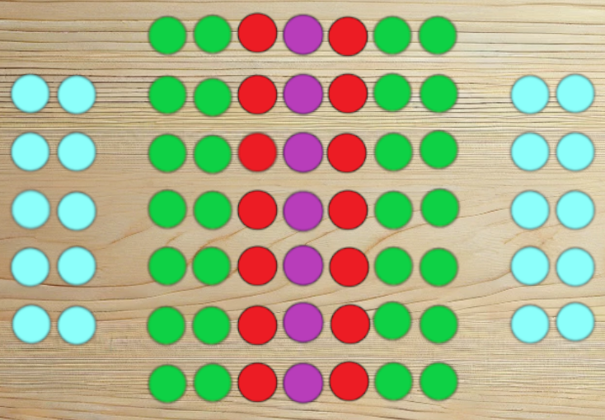

3. Starting the Game
Each player starts with 10 marbles in their Home Zone. To enter the board, roll an even number (2, 4, or 6). Place one marble into any open space on your adjacent Green Line. If you can’t make a legal move, your turn is skipped. If a spot is occupied by an opponent, you may land on it and send their marble back to their Home Zone.

4. Green Zone: Positioning Field
Once in the Green Zone, marbles can move in any direction — up, down, sideways, or diagonally — by the exact number rolled. You may jump over any marbles, but you may not land on an occupied space unless you're removing an opponent’s marble. You may not move back and forth between two adjacent positions repeatedly.

5. Red Line: Launch Zone
The Red Line is the only place from which you can challenge marbles in the Goal Line. Movement is limited to straight lines — either across or forward/back — but not diagonal. To remove an opponent from the Goal Line, you must land directly next to them in the Red Line and roll a 1 on your next turn.

6. Goal Line: Scoring Zone
The Goal Line is the purple center row. You may enter it only with an exact roll. Once inside, marbles may move only left or right within the Goal Line using exact dice rolls. You cannot leave the Goal Line, nor may you remove other marbles while in it.
You cannot cross the Goal Line from either direction. Remember: the board wraps — you’re already on the other side.

7. Dice Rules: Special Rolls
- Roll a 3: Take your turn and then roll again.
- Roll a 6: You may split the move between two marbles or divide moves (e.g., move one marble 3, then another 3). This is the only case where move splitting is allowed. It cannot be used to exit home or attack from the Goal Line.

8. Winning the Game
The goal is to place four of your marbles in a continuous row in the Goal Line. Wraparound is allowed — meaning a line of two on one edge and two on the other still counts as a win.

9. Summary
Cylinder challenges traditional board game mechanics with a wraparound layout and clever positioning rules. Plan carefully, time your moves, and control the Goal Line to win.
Now includes expanded multiplayer modes for 4 players. Play individually or team up for a cooperative challenge.

10A. 4-Player Individual Play
In Individual Play, four players compete on an expanded field using two connected boards. Standard rules apply, with each player trying to be the first to achieve four in a row in the Goal Line. Wraparound and removal mechanics work the same, but players must consider multiple opponents simultaneously.

10B. 4-Player Team Play
Teams: Two teams of two players each, seated opposite one another. Each player still starts with 10 marbles and their own Home Zone.
Objective:
- One teammate places 5 marbles in a row in the Goal Line — OR —
- Both teammates each get 4 in a row in the Goal Line.
Shared Strategy Rules:
- Marbles cannot be shared.
- Teammates cannot remove each other's marbles.
- Teammates may not intentionally block each other.
- Discussion is allowed but no private signaling.
Goal Line Rule:
- Winning line must belong to one player — no mixed teammate rows.
Optional Variant — Assist Token:
- One token per team. Allows one-time move of a teammate's marble (non-attack).

