**Committee**

Chairman Hilary Kaye 01189343595

[hilary.kaye@kcosas.com](mailto:hilary.kaye@kcosas.com)

Treasurer Ken Docking 01189 690274

[kendocking70@gmail.com](mailto:kendocking70@gmail.com)

other committee members

Hazel Evans, Chris Beck, Christine Duggan, Katy Slatford and Bob Reed

Annual subscription £30 (plus a £1 per ordinary and £4 per tutor session).

The charge for non- members at tutorials is £5 except by special agreement.

For programme queries please contact

Hilary Kaye

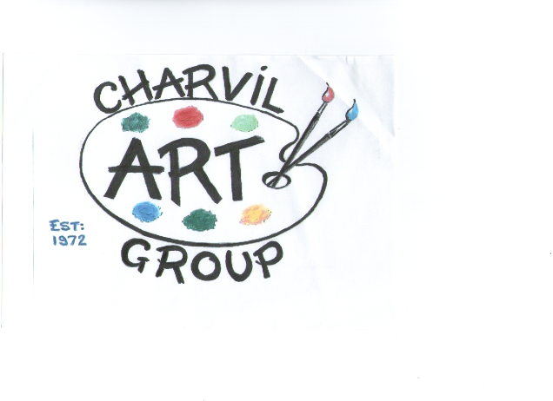

**Programme for Spring/Summer 2019**

Meetings are held every week on a Wednesday evening

From 7.30 to 9.30pm

at

Charvil Village Hall

Park Lane

Charvil RG10 9TR

Web address

www.charvilartgroup .com

At sessions where a tutor is engaged all members are asked to participate

**Spring term 2019**

**Jan**

16th Try a winter landscape in acrylic.

23 Paint an animal or bird “at home”

30 Draw or paint in the style of Paul Gauguin

**Feb**

**6 Tutorial: Jane Williams –People in profile**

13 Own choice, perhaps practice last week’s lesson

20 A wet day

**27 Bexy Butcher – Marbling in acrylic**

**March**

**6 AGM**

14 Wild life!

21 Try pastels own choice of subject.

**27** **Life class: Bernadette**

**April**

3 Spring flowers.

*\*Easter holiday no meeting for 2 weeks \**

24 Active people in the landscape

**May**

**1 Tutorial TBC**

8 Own choice perhaps practice last week’s lesson

15 Down the garden path

22 Draw each other

29 An interior or just part of a room from sketch or photo.

**June**

**5 Clare Buchta – Monochrome in oil**

12 Own Choice.

**19 Appraisal - Jane Wheaton**

26 Boats.

Any updates to the programme will be put on line on our web site. Messages will also be given out at meetings.

Look out for next year’s summer painting days. Details before the end of the summer term.