Introduction to Windy Slopes
Mission: Windy Slopes Health Foundation is a registered charity whose sole purpose is to raise funds in support of priority health care equipment needs and health care programs delivered at Pincher Creek Health Centre. The volunteer Board of Directors is made up entirely of volunteers from Pincher Creek and district that act as stewards of donated funds, so your gifts are used wisely.
History and Purpose
The Windy Slopes Foundation was established in 1996 under the Regional Health Authorities. The Foundation is a registered charitable organization dedicated to raising funds in support of vital health care needs at our Pincher Creek Health Centre.
The board consists of up to 11 hard-working volunteer trustees of the Pincher Creek and surrounding area. We work closely with the Site Manager and AHS Foundation Relation officer. As stewards of donated funds, the volunteer board of directors ensures that all dollars raised in the community stays in the community and is spent wisely. This includes the purchase of equipment, facility enhancement and program funding.
To date, the foundation has raised over 2.5 million dollars of life-saving medical equipment and health programs. This couldn't have been possible without the hard work and dedication of our volunteer board and the community support. We are responsible for the effective governance of the foundation. We are so proud of our accomplishments to date. We have purchased equipment and enhancements for almost every area of the Centre, including the Operating Room, Day Surgery, Acute care, ICU, Maternity, Lab, Emergency Room, Physio, and Home Care.
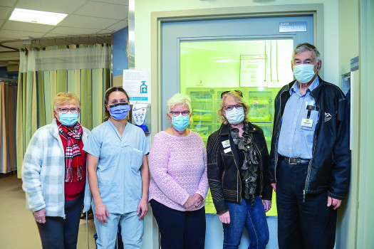

Photo Credit: Jenaya Launstein, Shootin’ the Breeze

Ways to Be Involved
We welcome all who are interested in participating with Windy Slopes. We encourage new participants to think about the best way for them to be involved.
Volunteer / Community Representative
Don’t want to come to board meetings, but you would like to help with events?
We are always happy to have volunteers who are willing to be Windy Slopes representatives in our community. We host a variety of events throughout the year and frequently need help. We also appreciate help spreading the word about our Foundation to others. If you would like to be added to our Volunteer List, please send an email to our administrator: windyslopespc@gmail.com.
Advisory Committee
We know that the professionals at our hospital and in our community are very busy, but we need help reviewing equipment requests and with our strategic planning. Let us know if you have a specialty and would be willing to share your expertise.
Member at Large
Becoming a Member at Large is a great way to try out the Windy Slopes Health Foundation Board without the commitments of being a full board member. We are always happy to have more Members at Large (Board Members in Training).
Board Trustee
If you are interested in becoming a Board Trustee, we would encourage you to contact our Administrator to acquire an application form.
Find Out More
Visit our Webpage: windyslopes.ca
Follow us on Facebook: facebook.com/windyslopesfoundation.pinchercreek
Follow us on Instagram: @windyslopes
Contact our Administrator: (403) 627-1216 or via email at windyslopespc@gmail.com

