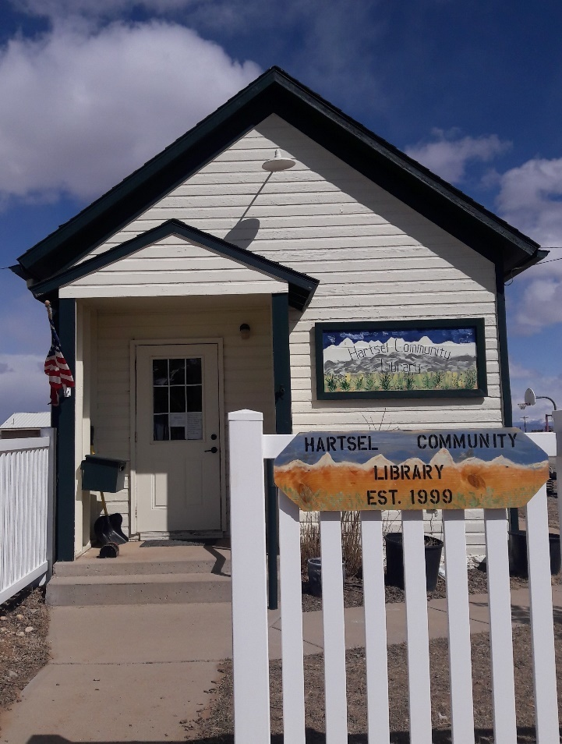
HARTSEL LIBRARY
NEWSLETTER
SUMMER 2026

LIBRARY HOURS:
1-4 PM FRI
1-4 PM SAT
1-4 PM SUN
1-4 PM MON (June – September)

Hartsel Library Friends
P.O. Box 281
Hartsel, CO 80449
Email: hartsellibrary@gmail.com
Phone: 719-836-2745

FROM THE PRESIDENT’S DESK
This year’s library volunteers are the following: Kathy Hill, President; Lark Harvey, Vice President; Charmaine Freeny, Secretary; Lisa Konen, Treasurer; Darleen Darnell, Board Member at large; Full-time Librarians are – Charmaine Freeny, Kathy Hill and Karen Dudnikov. We have also recruited several fill-in librarians when a substitute is needed – Lori Bennett and Lori Gundersen. This trusty group serves our library during operating hours. We are always looking for willing volunteers to fill in for projects and schedules when necessary. Contact us or drop in to visit.

We continue our open request for donated items of books and DVD’s. We continue to expand our offerings of children’s books, fiction, non-fiction, vintage books, and DVD selections. We still provide Wi-Fi connections for patron use and printing for black and white and color copies. “Back Room Book Sale” continues during hours of operation. Children and adult hard cover books are 50 cents each or 3 for $1. All paperback books are 25¢ or 5 for $1. Buy our colorful book bag for $5 and fill it up for only an additional $1. Vintage books are also sold for $1 each. You may even find jigsaw puzzles and games for a fantastic price.

The Book Club group still meets at 11 a.m. the first Monday of each month following our board meeting. Come meet new friends and discuss interesting books. Participants select and read their own selection corresponding to the genre for the month and then give their report and critique. A participant for the month brings a dessert to share. Check out the schedule on our social media sources.

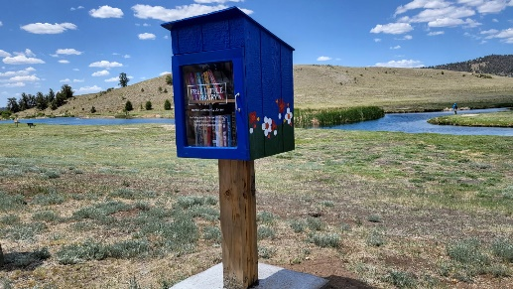
Our “Little Library Boxes” at Eleven Mile and Spinney Recreation area are restocked by Memorial Day. We have constructed a new box and are looking for a new location. Please give us your suggestions. Our library crew maintains and stocks the supply throughout the summer.

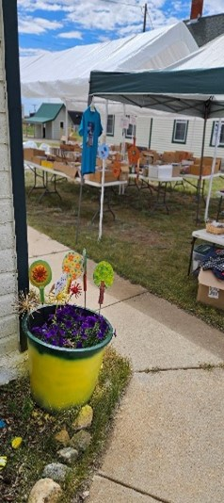

Hartsel Days Book & Bake Sale is happening this year the weekend of August 1st and 2nd. T-shirt sales and financial donations will be received to bolster our scholarship fund.
Come by and check out our ice cream freezer goodies.

Check us out on social media. We are always looking for ideas to benefit our community and welcome visitors. Thank you for your continued support!

Kathy Hill

LET ME COUNT THE WAYS…
The following are some ways you can support us:
- Become a Hartsel Library Friend - (form is enclosed, can be picked up at the library, or downloaded from our website.) Annual individual membership - $5.00; Family membership - $10.00; Business membership - $25.00.
- City Market Community Rewards Program – (to enroll, pick up a form at the library or at any City Market or King Sooper’s Store, or on line at CityMarket.com) Each time you use your City Market/King Sooper’s card at their stores or Loaf & Jug Gas Station, a portion of your purchase is designated for the Hartsel Library – it does not affect your accumulated points. The library will receive a quarterly check but you must remember to designate Hartsel Library Friends as the group you want to join.
- PayPal donations on our Facebook page
- Support our fundraisers –
Back Room Book Sale & T shirt sales – open during library hours 1-4 p.m.
Hartsel Days Book & Bake Sale
- Hartsel Library Scholarship Fund – make cash or check donation with designation for the “Scholarship Fund.” This fund is set up for applicants who are graduating high school seniors, reside in the Hartsel community and plan to attend college, community college or a trade school.
- Donation Can on the library counter – just drop in your loose change
The Hartsel Library is a non-profit 501c3, all volunteer organization. That means we totally depend on donations and fundraising throughout the year to keep our doors open. We are happy to provide documentation for any tax-deductible donation.

HOW TO STAY CONNECTED WITH US
We’re on Facebook at Hartsel Community Library. Find our postings as to library happenings: book and bake sales, book group gatherings and community social events.
Our Website – visit us at hartselcommunitylibrary.org
You can e-mail us at hartsellibrary@gmail.com
Call us at 719-836-2745
Mailing address: Hartsel Library Friends
P.O. Box 281Since 2022, Hartsel Library Friends has awarded $5,500.00 in scholarships to South
Park High School students! This year our award goes to

HARTSEL LIBRARY FRIENDS 2026 SCHOLARSHIP RECIPIENT
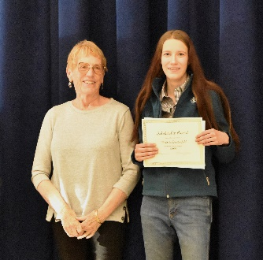
Congratulations to South Park High School senior Victoria Breitenfeld! Tori was the recipient of a $1,000.00 Hartsel Library Friends scholarship. She took a class in small engines her junior year of high school and found her passion. She plans to attend Pikes Peak Community college to earn an associate’s degree in automotive repair. Best of luck to Tori as she pursues her educational goals!
This is the eighth scholarship that Hartsel Library Friends has funded since offering it to high school students. Fortunately, we've been able to fund every scholarship that has been applied for even if it meant stretching the scholarship budget. If you would like to donate to the library's scholarship fund, you may do so by either sending your check to the library or by coming in during our hours of operation. Please indicate on the check memo line “scholarship fund”. Thank you for helping future Hartsel high school seniors realize their educational goals!
HARTSEL HAIRCUT CLUB
A few years ago, a Hartsel resident who is a licensed cosmetologist started offering her services to fellow Hartselians, driving to their homes to cut their hair. Word grew as did her client base; by now a few of her clientele were library volunteers. So now the group uses the library as a central meeting place for people to get haircuts. The Hartsel Haircut Club was born! The club meets every six or seven weeks; those who can make it, do; those who can't, don't. New members are welcome!

HARTSEL LIBRARY EVENTS
JACK FROST WINTER WALK
In late January, the library partnered with the Hartsel Community Center to sponsor the Jack Frost Winter Walk and new clothing giveaway for residents. People could stop at the community center for soup and bread, Zuccaro's Kitchen for a slice of pizza, and the Hartsel Library for hot chocolate and desserts all free of charge. Because of generous donations from various contributors, the community center was able to offer new clothing, blankets, and hygiene products free to anyone in need. Those who cared to stroll Valley Ave. did so by walking backwards, sideways, arm-in-arm, and even dancing. New friendships were made and old friendships were rekindled. It was a wonderful evening of community comradery
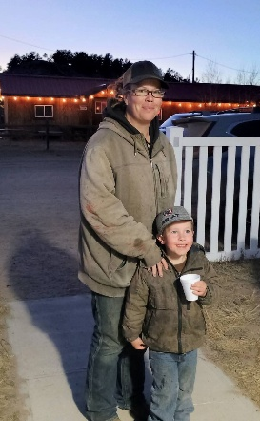
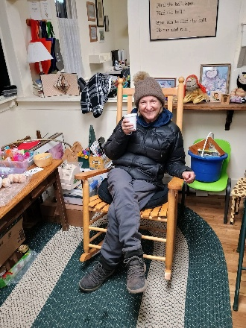
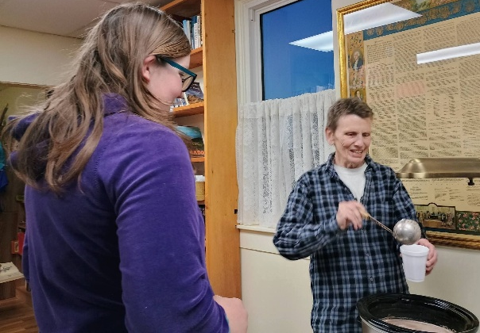

VALENTINE’S DINNER

The library was pleased to host a community Valentine’s Dinner on February 4, 2026. The Hartsel Fire Station conference room was festively decorated and served over 50 guests. Our feast showcased a Mexican cuisine with a taco bar, chili, and dessert bar. Attendees enjoyed their delicious home cooked meal interspersed with crowd teaser competitions and table puzzles. The dinner was a success as our profit of over $600 will benefit the scholarship fund. We look forward to hosting this event again next year with surprises in store.

BOOK BAG SALES
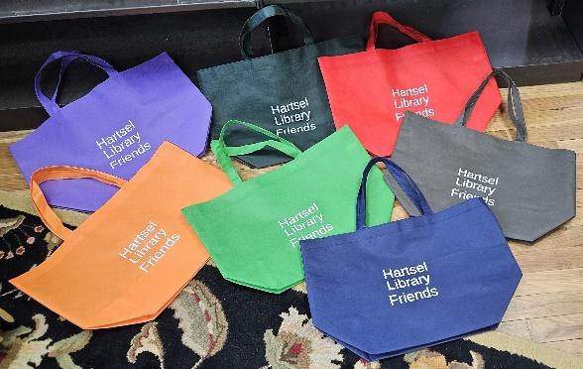
The library is proud to offer a colorful assortment of book bags for $5. Use them for shopping or a special deal at the library. When you purchase a bag and pay an additional $1, you can fill it with your choice of hard back or paperback books.

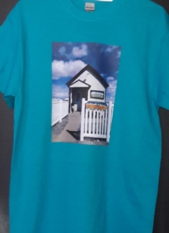
LIBRARY T SHIRT SALES
The library is proud to offer T-shirts for our visitors and community.
They are available in the library during open hours for $15 each. Sizes
are in Small, Medium, Large & X Large and the colors are charcoal,
maroon, cobalt blue and tropical blue (pictured).
The proceeds for all T-shirt sales go to replenish our Scholarship fund.

IT’S SUMMER AT THE HARTSEL LIBRARY
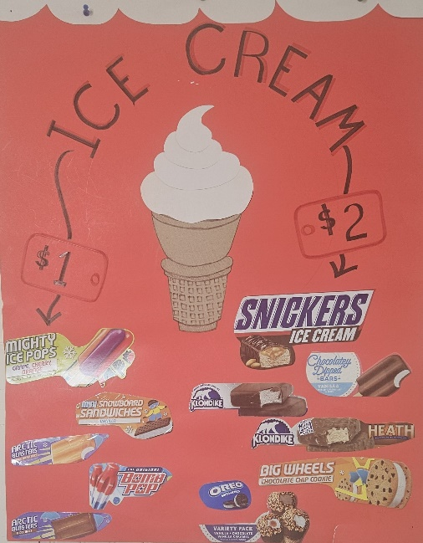
The freezer is stocked and waiting for you – popsicles, fudgesicles, ice cream bars, “Drumsticks”, Klondike bars, ice cream sandwiches and other specialty refreshers. Come in for the sweet treat of your choice (for $1 or $2) and help support or scholarship fund.
Money well spent!!!

PARK COUNTY HISTORICAL SOCIETY CONTRIBUTION

This is the new look for the republished book first written by Linda Bjorklund. Linda was a participant with the Park County Historical Society and a patron of the Hartsel Library since its inception in 1999. The republished version by Jim Sapp, is available at the library for $10.

About the Book
Founded in 1880, Hartsel is close to the geographic center of Colorado and is often referred to as "The Heart of Colorado". The namesake of the community is Samuel Hartsel, a local farmer and cattle rancher who came to Park County in 1860. He developed the Hartsel hot springs and built a hotel, sawmill, blacksmith shop, and a trading post to lay the groundwork for the town.
HARTSEL DAYS 2026
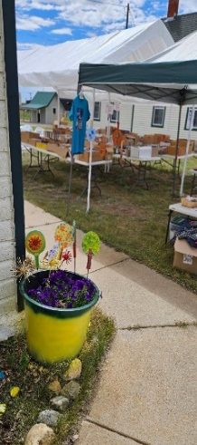
Our library is known for its presence at Hartsel Days, especially with our
Book and Bake sale. The tent covers literally hundreds of books: hard
backs, paperbacks, children's books, cookbooks, coffee table books and
vintage books. Included in the mix are jigsaw puzzles, DVD’s, arts and
crafts and a freezer full of popsicles, ice cream sandwiches, and other
novelties. Visit us this year on August 2nd and 3rd!
Hartsel Days 2025 was record setting for the Hartsel Library. The turnout for the festival was huge and Hartsel Library saw a profit of $1,180.00 for its book and bake sale! We sold $515.00 worth of books and dvds, the bake sale netted $465.00, and the craft, jigsaw puzzles and games sale netted $200.00. This was the most profitable Hartsel Days sale to date not to mention we reduced our sale inventory significantly!
Reminder: our proceeds go to help fund our annual scholarship program!
BOK CHOY SALAD
1 head Bok Choy or Nappa cabbage shredded
One small onion or 5 green onions (chopped)
Saute in 1/4 cup butter
Add to:
2 ounces slivered almonds
3 ounces Rice noodles broken
1/2 cup sunflower seeds
DRESSING:
3/4 cup salad oil
2/3 cup sugar
1/4 cup vinegar
2 Tablespoons soy sauce

Pour dressing over above ingredients and serve

HARTSEL LIBRARY FACTS AND STATS
2025-2026
The Hartsel Library is entirely run on volunteers from the community; it is not connected with any governmental agency. Because of this, our funding comes solely from donations by patrons and community members and from our fundraising efforts. We are open 4 days a week during the summer and 3 days a week in winter. In addition to the community library on Valley Avenue, the volunteers maintain a free library box at both Eleven Mile Reservoir and Spinney Reservoir for the enjoyment of visitors and campers.
Some interesting statistics:
Volunteer librarian, board member and community
member hours 900
Volunteer hours for Hartsel Days 120
Volunteer hours for annual newsletter (writing articles, emailing letters
to patrons, printing paper copies) 50
TOTAL annual volunteer hours: 1,070 HOURS!!

We are always looking for additional librarians to help us keep the library open and running. If you're not sure about committing to a regular weekly librarian time slot, why not volunteer as a substitute?
Last year we had 680 people visit the library and that doesn't include all the visitors we had during Hartsel Days, the Winter Walk or the Memorial Day Community Yard Sale! A total of 152 books and 237 DVD's were checked out. Librarians used the computer a total of 73 hours of computer, mainly for cataloging, library emails, contacting patrons, and researching. Visitors utilized the library's Wi-Fi 17 hours.
The library board meets the first Monday of every month at 10:00 a.m. and we welcome everyone. Our book group meets immediately following the board meeting, usually at about 11:00 a.m. Our book group format is such that we have a different genre every month and members are free to pick a book of their choice in that genre. Discussion is had on each member's book choice at the group meeting. Dessert is provided. Everyone and anyone is welcome to join the group. We love to see new faces!
Stop by and see what the little Hartsel Community Library has to offer! We are open from 1pm-4pm Friday, Saturday, Sunday and Monday during the summer and from 1pm – 4pm Friday, Saturday and Sunday during fall through spring. Hope to see you soon!!

Visit our Book and Bake Sale at Hartsel Days August 1st and 2nd!!

Charmaine Freeny
Hartsel Library Secretary

HOOKED ON BOOKS
By Darleen Darnell
For the month of April 2026, our Hartsel Book Club chose the genre Books Turned into Movies.
We certainly had many books to choose from. Here is a list of some the books we chose:
Hunger Games: Catching Fire, Sunrise of the Reaping: Suzanne Collins
The End of the Spear: Steven Saint
Remotely Bright Creatures: Shelby Van Pelt
Project Hail Mary: Andy Weir
One Second After EMPs: William R. Forstchen
The Count of Monte Cristo: Alexander Dumas
We certainly had a lot of discussions pertaining to this diverse choice of books. You would be entertained by reading any of these choices.
Our next genre will be “Biography “.
You are welcome to join our book club any time. We meet on the first Monday of every month at the library at 11 a.m.

HARTSEL FIRE PROTECTION DISTRICT NEWS
Much has happened with the Hartsel fire department the past few years. In 2023, Chief Brian Cook built a live fire training facility by Station 1 and conducts trainings for firefighters inside and outside of Park County. In 2024, a mill levy ballot initiative was passed by voters which has and will allow for the replacement of aging fire trucks, an increase in the number of personnel resulting in 24/7 full time staffing, and the building of new fire stations. In that regard, Station 6 near County Rd. 23 and Hwy. 24 was completed in May 2026 and construction of Station 3 (Ranch of the Rockies) will commence in late 2026/early 2027.
The Hartsel Fire Auxiliary's annual spaghetti dinner and fundraiser 2025 was a huge success and the most profitable fundraiser to date. An online auction was conducted with amazing results. The money raised will allow for the refurbishment of a trailer given to Chief Cook for the firefighters use during incidents when they need to be on scene for extended periods of time. This trailer will be equipped with beds, refrigerator, microwave, coffee maker, phone charging ports, a toilet and hand washing station, and will have a mobile command post. The refurbished trailer will be completed and ready for use by summer 2026. Thank you Chief Cook for keeping Hartsel safe!
Charmaine Freeny,
HFPD Auxiliary Secretary

BECOME A HARTSEL LIBRARY FRIEND
You are invited to join the Hartsel Library Friends. We are a non-profit 501c3, all- volunteer organization, providing our community with a library since 1999. Because we are an all-volunteer library without ANY funding, we rely heavily on donations to keep our doors open.

Annual membership fee per year is:
Individual $5.00
Family $10.00
Business $25.00

Cash donations are also welcomed. All donations are 100% deductible on your tax return. You are not required to purchase a membership to be registered as a library patron and use our facilities.

Fill out this form and mail it along with your check to:
Hartsel Library Friends
P.O. Box 281
Hartsel, CO 80449-0281

Or just drop it off at the library at 86 Valley Ave. – between the community center and the Fire Station #1. If the library is closed, just drop the form in the book drop box on the library porch. THANK YOU!!!!

DATE:_________________
NAME:_____________________________________________________________
MAILING ADDRESS: __________________________________________________
PHONE: _________________________________
EMAIL

