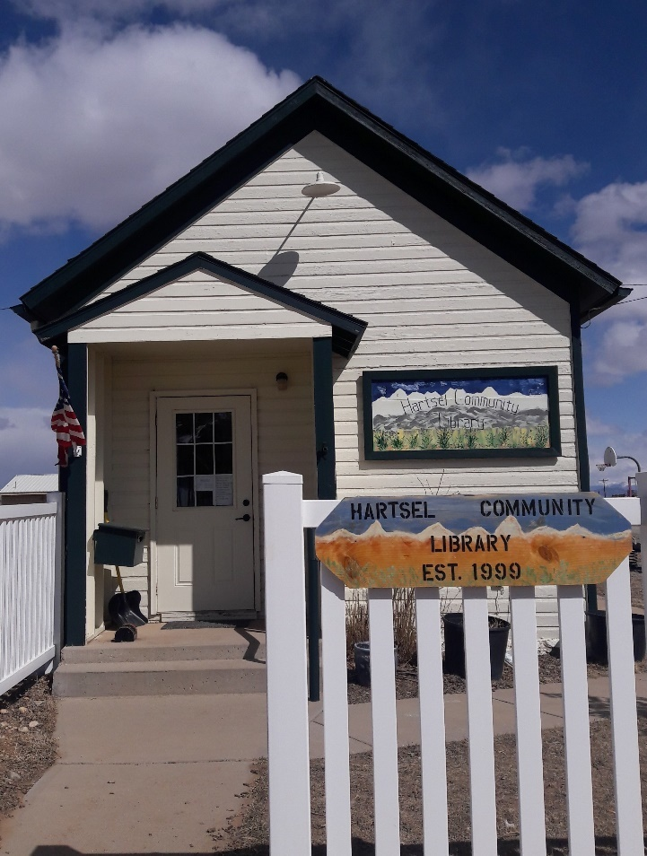

**HARTSEL LIBRARY**

**NEWSLETTER**

**SUMMER 2025**

**LIBRARY HOURS:**

**1-4 PM FRI**

**1-4 PM SAT**

**1-4 PM SUN**

**1-4 PM MON**

Hartsel Library Friends

P.O. Box 281

Hartsel, CO 80449

Email: [hartsellibrary@gmail.com](mailto:hartsellibrary@gmail.com)

Phone: 719-836-2745

**FROM THE PRESIDENT’S DESK**

***BUSY YEAR OUR LOCATION***

This was a busy year here at the library. Lots of activities with crafting and rock art. The scenery outside became inhabited with lots of critters and many forms of art of all shapes and colors. It provided a fantasy landscape for the summer.

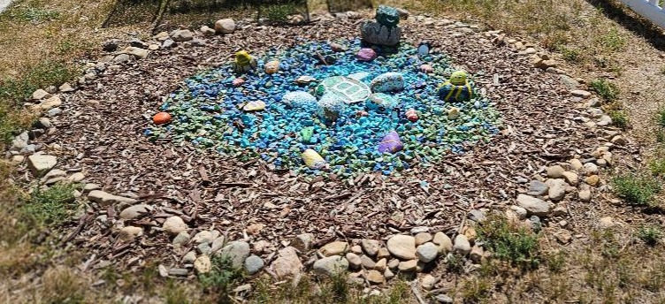his year’s library volunteers are the following: Kathy Hill, President; Lark Harvey, Vice President; Charmaine Freeny, Secretary; Lisa Konen, Treasurer; Darleen Darnell, Board Member at large; Full-time Librarians are – Charmaine Freeny, Kathy Hill and Karen Dudnikov. We have also recruited several fill-in librarians when a substitute is needed. This trusty group serves our library during operating hours. We are always looking for willing volunteers to fill in for projects and schedules when necessary. Contact us or drop in to visit.

Our open request for donated items has met with a wonderful response, many boxes of donated DVD’s have grown our shelves to rival any Blockbuster Video store of the past. We continue to expand our offerings of children’s books, fiction, non-fiction, vintage books, and DVD selections. We still provide Wi Fi connection for patron use and printing for black and white and color copies. “Back Room Book Sale” continues during hours of operation. Children and adult hard cover books are 50 cents each or 3 for $1. All paperback books are 25¢ or 5 for $1. Buy our new colorful book bag for $5 and fill it up for only an additional $1. Vintage books are also sold for $1 each. You may even find jigsaw puzzles and games for a fantastic price.

The Book Club group still meets at 11 a.m. the first Monday of each month following our board meeting. Come meet new friends and discuss interesting books. Participants select and read their own selection corresponding to the genre for the month and then give their report and critique. A participant for the month brings a dessert to share. Check out the schedule on our social media sources.

Our “Little Library Boxes” at Eleven Mile and Spinney Recreation area are restocked by Memorial Day. This year we’ve added a new location at Wildwood subdivision off The Elkhorn Road. Hartsel Days Book & Bake Sale is happening this year the weekend of August 2nd & 3rd. T-shirt sales and financial donations will be received to bolster our scholarship fund.

Come by and check out our ice cream freezer goodies.

Check us out on social medial. We are always looking for ideas to benefit our community and welcome visitors. Thank you for your continued support!

Kathy Hill

**LET ME COUNT THE WAYS…**

The following are some ways you can support us:

* Become a Hartsel Library Friend - (form is enclosed, can be picked up at the library, or downloaded from our website.) Annual individual membership - $5.00; Family membership - $10.00; Business membership - $25.00.
* City Market Community Rewards Program – (to enroll, pick up a form at the library or at any City Market or King Sooper’s Store, or on line at CityMarket.com) Each time you use your City Market/King Sooper’s card at their stores or Loaf & Jug Gas Station, a portion of your purchase is designated for the Hartsel Library – it does not affect your accumulated points. The library will receive a quarterly check but you must remember to designate **Hartsel Library Friends** as the group you want to join.
* Support our fundraisers –

Back Room Book Sale & T shirt sales – open during library hours 1-4 p.m.

Hartsel Days Book & Bake Sale

* Hartsel Library Scholarship Fund – make cash or check donation with designation for the “Scholarship Fund.” This fund is set up for applicants who are graduating high school seniors, reside in the Hartsel community and plan to attend college, community college or a trade school.
* Donation Can on the library counter – just drop in your loose change

The Hartsel Library is a non-profit 501c3, all volunteer organization. That means we totally depend on donations and fundraising throughout the year to keep our doors open. We are happy to provide documentation for any tax-deductible donation.

**HOW TO STAY CONNECTED WITH US**

We’re on Facebook at **Hartsel Community Library**. Find our postings as to library happenings: book and bake sales, book group gatherings and community social events.

Our **Website** – visit us at hartselcommunitylibrary.org

You can **e-mail** us at [hartsellibrary@gmail.com](mailto:hartsellibrary@ghmail.com)

Call us at 719-836-2745

**Mailing address**: Hartsel Library Friends

P.O. Box 281

Hartsel, CO 80449

**SCHOLARSHIP NEWS**

Unfortunately, we had no applicants for our 2024/2025 scholarship. According to the high school counselor, of the four students who qualified for the scholarship, none planned on pursuing secondary education in the fall or spring semester following high school. Hopefully we'll have applicants next year. Since 2022, Hartsel Library Friends has awarded $5,500.00 in scholarships to South Park High School students!

**FUNDRAISING**

In addition to our back room used book sale, we now have used dvd's; jigsaw puzzles; handmade aspen bowls, vases, and containers; artwork; handmade crafts; fruit butters and jams; and more for sale! Portions of fundraising proceeds go towards the library's scholarship fund.

**HARTSEL HAIRCUT CLUB**

A few years ago, a Hartsel resident who is a licensed cosmetologist, starting offering her services to fellow Hartselians, driving to their homes to cut their hair. Word grew as did her client base; by now a few of her clientele were library volunteers. So a little over a year ago, it was suggested to use the library as a central meeting place for people to get haircuts. The Hartsel Haircut Club was born! The club meets every six or seven weeks; those who can make it, do; those who can't, don't. New members are welcome!

**GARLIC TUSCAN CHICKEN**

2 Tbs. olive oil

1 ½ lbs. boneless, skinless breasts, thinly sliced

1 cup heavy cream

½ cup chicken broth

½ cup grated Parmesan cheese

1 tsp. garlic powder

1 tsp. Italian seasoning

1 cup fresh spinach, chopped

½ cup sun-dried tomatoes

Heat olive oil in skillet over medium-high heat. Cook chicken until browned, 3-5 minutes per side. Remove chicken and keep warm. Add cream, chicken broths, Parmesan cheese, garlic powder, and Italian seasoning to skillet. Whisk sauce over medium heat 5 minutes. Add spinach and sun dried tomatoes. Simmer until spinach starts to wilt, about 1 minute. Return chicken to pan and cook until heated through, 2-3 minutes.

Serve over pasta.

Submitted by Charmaine Freeny

**HARTSEL LIBRARY EVENTS**

**VALENTINE’S DINNER**

The library was pleased to host a community Valentine’s Dinner on February 15, 2025. The Hartsel Fire Station conference room was festively decorated and served over 40 guests. Our menu this year featured pork tenderloin with green beans, baked potatoes, sauteed mushrooms, salad and dessert. Attendees enjoyed their delicious home cooked meal interspersed with crowd teaser responsive questions.

There were multiple door prizes given out including artwork, book bags and T-shirts. The dinner was a success as our profit of $650 will benefit the scholarship fund. We look forward to hosting this event again next year with surprises in store.

**FAIRPLAY CRAFT FAIR PARTICIPATION**

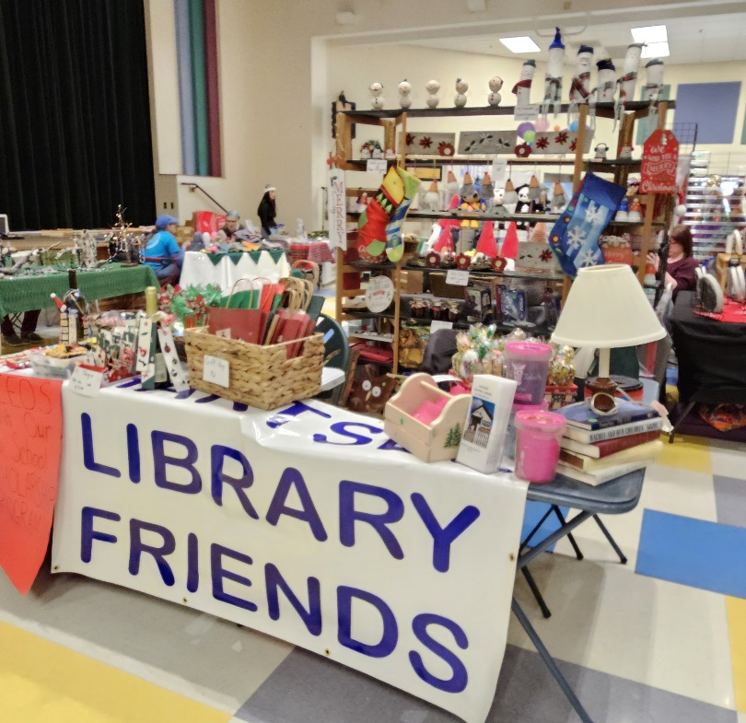

The library crafters entered their items this year at the Holiday Bazaar in Fairplay. The items were varied and quite creative. The community response was very favorable and the funds that were collected will serve to increase the library’s scholarship fund. There are hopes to continue sales at a location in Hartsel and the library for a summer Christmas sale.

**BOOK BAG SALES**

The library is proud to offer a colorful assortment of book bags for $5. Use them for your shopping or a special deal at the library. When you purchase a bag and pay an additional $1, you can fill it with your choice of hard back or paperback books.

**LIBRARY T SHIRT SALES**

The library is proud to offer T-shirts for our visitors and community.

They are available in the library during open hours for $15 each. Sizes

are in Small, Medium, Large & X Large and the colors are charcoal,

maroon, cobalt blue and tropical blue (pictured).

The proceeds for all T-shirt sales go to replenish our Scholarship fund.

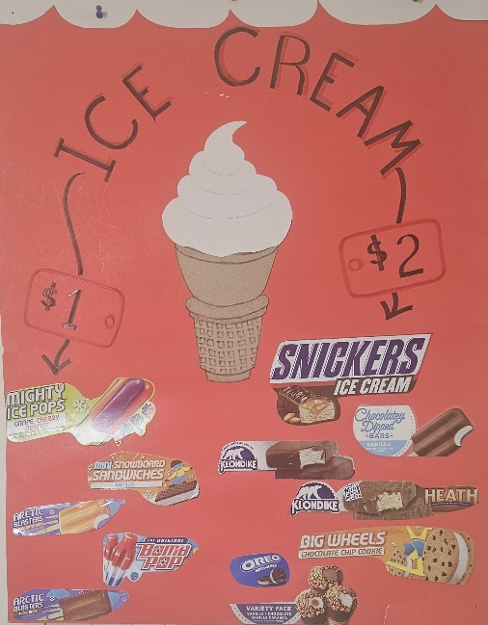

**IT’S SUMMER AT THE HARTSEL LIBRARY**

The freezer is stocked and waiting for you – popsicles, “Bomb Pops”, fudgesicles, ice cream bars, “Drumsticks”, Klondike bars, ice cream sandwiches and other specialty refreshers. Come in for the sweet treat of your choice (for $1 or $2) and help support or scholarship fund.

Money well spent!!!

**PARK COUNTY HISTORICAL SOCIETY CONTRIBUTION**

[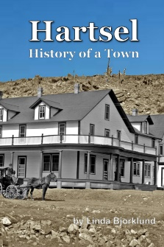](https://www.blurb.com/books/11556583-hartsel)This is the new look for the republished book first written by Linda Bjorklund. Linda was a participant with the Park County Historical Society and a patron of the Hartsel Library since its inception in 1999. The republished version byJim Sapp, is available at the library for $10.

Bottom of Form

**About the Book**

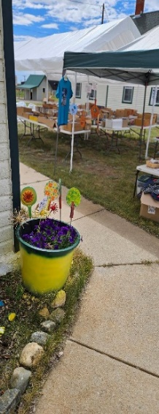Founded in 1880, Hartsel is close to the geographic center of Colorado, and is often referred to as "The Heart of Colorado". The namesake of the community is Samuel Hartsel, a local farmer and cattle rancher who came to Park County in 1860. He developed the Hartsel hot springs and built a hotel, sawmill, blacksmith shop, and a trading post to lay the groundwork for the town.

**HARTSEL DAYS 2024**

Our library is known for its presence at Hartsel Days, especially with our

Book and Bake sale. The tent covers literally hundreds of books: hard

backs, paperbacks, children's books, cookbooks, coffee table books and

vintage books. Included in the mix are jigsaw puzzles, DVD’s, arts and

crafts and a freezer full of popsicles, ice cream sandwiches, and other

novelties. Visit us this year on August 2nd and 3rd!

**HARTSEL LIBRARY FACTS AND STATS – 2024 -2025**

The Hartsel Library is entirely run on volunteers from the community; it is not connected with any governmental agency. Because of this, our funding comes solely from donations by patrons and community members and from our fundraising efforts. We are open 4 days a week during the summer and 2-3 days a week in winter. In addition to the community library on Valley Avenue, the volunteers maintain a free library box at both Eleven Mile Reservoir and Spinney Reservoir for the enjoyment of visitors and campers. An additional library box was added to the Wildwood subdivision in 2025!

Some interesting statistics:

Volunteer librarian, board member and community

member hours: 905

Volunteer hours for Hartsel Days: 95

Volunteer hours for annual newsletter (writing articles, emailing letters

to patrons, printing paper copies) 50

**TOTAL** annual volunteer hours: 1,050 **HOURS!!**

We are **always** looking for additional librarians to help us keep the library open and running. If you're not sure about committing to a regular weekly librarian time slot, why not volunteer as a substitute?

Last year we had 623 people visit the library and that doesn't include all the visitors we had during Hartsel Days! A total of 75 books and 356 DVD's were checked out. Library visitors used our computers a total of 10 hours while librarians had 73 hours of computer usage time, mainly for cataloging, library emails, contacting patrons, and researching.

The library board meets the first Monday of every month at 10:00 a.m. and we welcome everyone. Our book group meets immediately following the board meeting, usually at about 11:00 a.m. Our book group format is such that we have a different genre every month and members are free to pick a book of their choice in that genre. Discussion is had on each member's book choice at the group meeting. Dessert is provided. Everyone and anyone is welcome to join the group. We love to see new faces!

Stop by and see what the little Hartsel Community Library has to offer! We are open from 1pm-4pm Friday, Saturday, Sunday and Monday during the summer and from 1pm – 4pm Friday, Saturday and Sunday during fall through spring. Hope to see you soon!!

**Visit our Book and Bake Sale at Hartsel Days August 2nd and 3rd**

Charmaine Freeny

Hartsel Library Secretary

**BECOME A HARTSEL LIBRARY FRIEND**

You are invited to join the Hartsel Library Friends. We are a non-profit 501c3, all- volunteer organization, providing our community with a library since 1999. Because we are an all-volunteer library without ANY funding, we rely heavily on donations to keep our doors open.

Annual membership fee per year is:

Individual $5.00

Family $10.00

Business $25.00

Cash donations are also welcomed. All donations are 100% deductible on your tax return. You are not required to purchase a membership to be registered as a library patron and use our facilities.

Fill out this form and mail it along with your check to:

Hartsel Library Friends

P.O. Box 281

Hartsel, CO 80449-0281

Or just drop it off at the library at 86 Valley Ave. – between the community center and the Fire Station #1. If the library is closed, just drop the form in the book drop box on the library porch. **THANK YOU!!!!**

**DATE:_________________**

**NAME:_____________________________________________________________**

**MAILING ADDRESS: __________________________________________________**

**PHONE: _________________________________**

**EMAIL**

**HOOKED ON BOOKS**

By Darleen Darnell

The first Monday of every month the Hartsel Library entertains a Book Club meeting. Each month suggests a different genre and members can make their own selection of title and author. Since each member has a different book, there are amazing titles and authors who offer different opinions of the chosen genre.

**Biography** was the choice for our last meeting.  
I found it very interesting that several members chose Biographic books that included stories before, during and after the history of WWII.

Such examples included people who risked their lives to save Jewish children from death, men and women trained to be Code Breakers, women trained to be spies and send out false information to foreign troops.

I will list the titles of some of the books we shared in case you are interested in this part of history.

The Secret Lives of Code Breakers by Sinclair McKay

Irene’s Children by Tilar Mazzeo

Propaganda Girls: The Secret War of the Women in the OSS by Lisa Rogak

Each book had a different approach to the war and the devotions and sacrifices of the women and men in these biographies.

**SLOW COOKER BABYBACK RIBS**

Ingredients:

3 pounds baby back ribs, trimmed 1 onion sliced

Salt and pepper to taste 1 clove of garlic minced

½ cup water or one can or bottle of beer 1 18 ounce bottle of barbeque sauce

Directions:

1. Season ribs with salt and pepper
2. Pour water or beer into slow cooker. Layer the ribs into the slow cooker. Top

The ribs with onion and garlic.

1. Cook on High for 4 hours or on Low for 8 hours
2. Preheat oven to 375 degrees F
3. Transfer ribs to a baking sheet. Discard onion and garlic. Coat ribs with barbeque sauce.
4. Bake in preheated oven until the sauce caramelizes and sticks to the meat, 10 to 15 minutes.