
January 2026
Sunday | Monday | Tuesday | Wednesday | Thursday | Friday | Saturday
“Hello January - fresh starts and warm hearts”  All activities are subject to change |  |  |  | 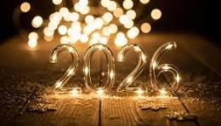  New Year’s Day | 9am-Handing out Calendars  10:30am-New Years Resolutions  2pm-Board Games
  1
  2
  3
 | 9am-Morning Chats  10:30am-Yahtzee  2pm-Fun with Marg!! | 9am-Morning Walks  9:30am-Crafts  (Thank you Cards)  2pm-Music(Lorrie) | 9am-One on one visits  2pm-Bingo | Un-deck the Halls    2pm-Coloring Circle | 9am-Morning Connect  10:30am-Your Favorite things Time  2pm-Card Bingo
  4
  5
  6
  7
  8
  9
  10
 | 9am-Morning Chats  10:30am-Yahtzee  2pm-Fun with Marg | 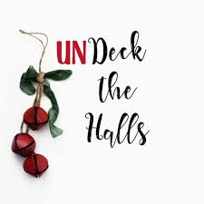  9:30am-Church(David) | 9am-One on one visits  2pm-Yahtzee | 9am-Morning Connect  10:30am-Church  Lloyd&Janet  2pm-Bingo | 9am-Morning Walks    10:30am-Resident Council  2pm-Hymn Sing
  11
  12
  13
  14
  15
  16
  17
 | 9am-Morning Chats  10:30am-Yahtzee  2pm-Fun with Marg | 9am-Morning Walks  10:30am-Paint & Pamper  2pm-Virtual Sliding Party | 9am-One on one visits  2pm-Music(Gerald Joe and Vicky) | 9am-Morning Walk  10:30am-Crafts    2pm-Cash Bingo | 9am-Morning Connect  10:30am-Painting Party  2pm-Coffee Club
  18
  19
  20
  21
  22
  23
  24
 | 9am-Morning Chats  10:30am-Yahtzee  2pm-Fun with Marg | 9am-Morning Chats    10:30am-News & Views  2pm- Root Beer Floats on the Go | 9am-One on one visits    1:30pm- Movie | 9am-Morning Walks  10:30am-Mini-Olympics  2pm-Bingo | 9am-Morning Chats  10:30am-Hand Massages  2pm-Moncton Rhythm Pals
  25
  26
  27
  28
  29
  30
  31

