USA Softball Bat Testing & Certification Program
*** Information on non-linear bats with unique barrel compression thresholds can be seen on the Non-Linear Bat Compression Thresholds page.
CERTIFIED/APPROVED: The official bat for USA Softball Championship Play must meet all the USA Softball specifications and the requirements of Rule 3, Section 1, and:
- The official bat, made up of the knob, handle, grip, taper, barrel and end cap shall be free of burs, dents cracks, sharp edges, rattles and show no signs of excessive wear. The official bat may be marked OFFICIAL SOFTBALL by the manufacturer, and shall be no more than 34 inches long nor exceed 38 ounces in weight. The official bat shall not be more than 2.250 inches in diameter at its largest part, including any tolerance for expansion. The official bat must bear either the 2000 Certification Mark or 2004 Certification Mark, as shown below and must not be listed on the USA Softball Non-Approved Bat List with 2000 or 2004 Certification Mark.
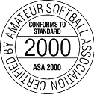 | 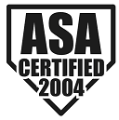
NOTE: USA Softball has begun transitioning to the new USA Softball Certification Marks for the 2020 calendar year. On behalf of equipment manufacturers, the USA Softball Equipment Testing and Certification Committee requested that the new certification marks be approved for the 2019 calendar year and the USA Softball Board of Directors approved the new marks (seen here) for 2019 USA Softball Championship Play. The Official Rules of Softball, Rule 3, Sections 1 and 3 will be updated for 2020 to identify the new Certification Marks for Championship Play.
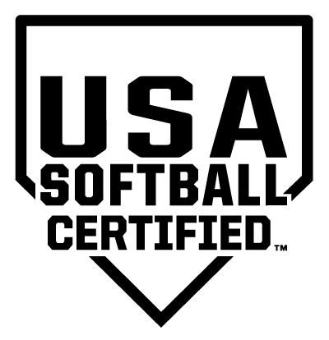
All Games
AND
- must be included on a list of approved bat models published by USA Softball
OR
- must, in the sole opinion and discretion of the umpire, have been manufactured prior to 2000 and if tested, would comply with USA Softball Bat Performance Standard. This includes wooden bats.
Exception: Senior Softball bats may be used in Senior Championship Play only.
All bats in USA Softball Championship Play, except Seniors, must pass USA Softball's Bat Performance Standard. All bats having the 2000, 2004 or 2013 (Slow Pitch, Men's Adult Fast Pitch, Junior Olympic Boy's Fast Pitch and Men's Modified Pitch ONLY) Certification Mark and not listed on the list of Non-Approved bats with Certification marks will be allowed in USA Softball Championship Play. Bats with the 2013 Certification Mark will be allowed in Slow Pitch National Championship Play Only. For your convenience, USA Softball's website has a listing of all approved bats and bats that have USA Softball Certification Marks and are no longer approved.

