MODIFIED LEVEL

NASSAU COUNTY SOFTBALL OFFICIALS ASSOCIATION FASTPITCH SOFTBALL RULES INFO. 2020

Rules Interpreter – Rick Norris 917 865 4461 Norrisimo@aol.com

Fast Pitch USA softball rules along with rule modification and certain rule modifications and certain waivers established by NYSPHSSA are used for the conduct of all high school and middle school girl’s softball play.

Rule changes and modifications for 2020:

NYSPHSAA has voided the metal cleat waiver for High School ONLY Softball for the 2020 softball season. This means that High School Softball teams will be allowed to wear metal cleats during the high school season. Modified teams WILL NOT be allowed to wear metal cleat during the 2020 softball season.
Schools that have turf fields will not allow metal spikes, make sure that your athletes have alternate footwear for these fields.

Rule 3, Section 1A [1]: The official bat must bear either the ASA 2000, ASA 2004
or the new approved USA Softball Certification Marks. The ASA 2013 logo is a slow pitch bat and not approved.

Rule 3, Section 5E: Helmets shall have a non-glare (not mirror-like) surface.

Rule 6A, Section 1C: Both feet must be on the ground within the 24-inch length of the pitcher’s plate. The shoulders shall be in line with first and third bases. The pitcher shall take a position with their pivot foot in contact with the pitcher’s plate and their non-pivot foot in contact with or behind the pitcher’s plate. It is also allowed to take a step back with the non-pivot foot even if she sets up with the non-pivot foot behind the pitcher’s plate.

.
Rule 6A, Section 1E: The pitcher shall bring their hands together for not less than one second and not more than 10 seconds before releasing the ball. A backward step may be taken before, simultaneous with or after the hands are brought together. The pivot foot must remain in contact with the pitcher’s plate at all times prior to the forward step. Allows female pitchers to take a backward step from the pitcher’s plate, before, during or after the hands are brought together. It is also allowed to take a step back with the non-pivot foot even if she sets up with the non-pivot foot behind the pitcher’s plate.

Rule 6A, Section 11B&C, Rule 7, Section 5D: Eliminates the penalty of advancing a runner one base without liability to be put out from the effect of committing an illegal pitch.

Just a reminder, there only two acceptable warm up devices. They are the power wrap and the swing sock. Donuts and other warm up devices are illegal.

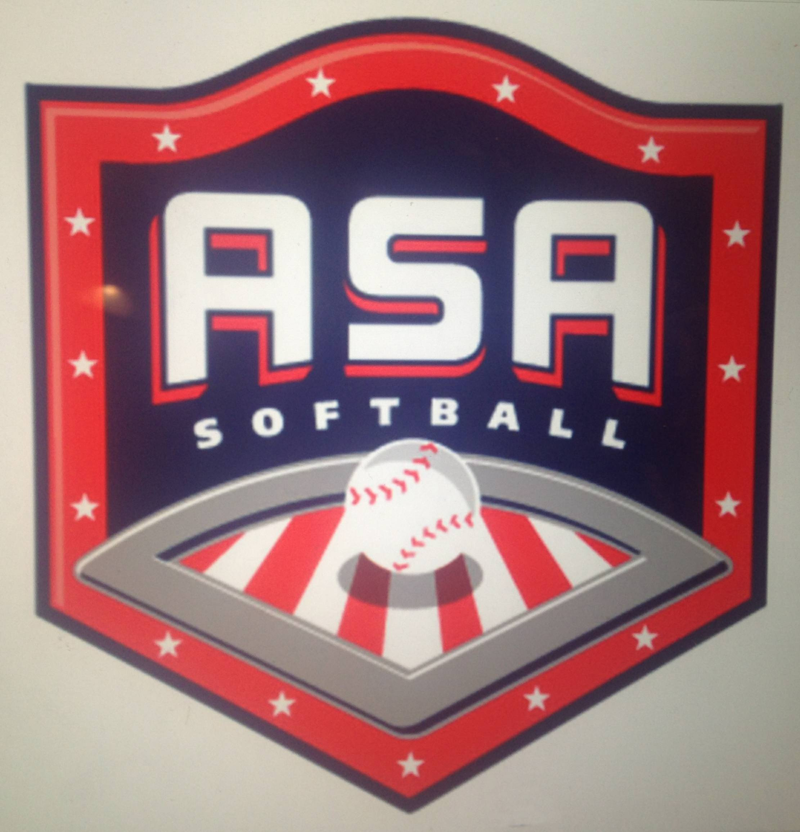
REMEMBER - At all levels of play, bats and helmets shall be inspected by the umpires outside the dugout/bench area before the game begins. The pre-game conference at home plate will not take place until this is accomplished. Please note, that any bat having the following approval marking is NOT ALLOWED for fast pitch softball.

REMINDERS -
1. Pitching distance in Sect.8 is 40 feet. If the pitcher's plate is not secured to the ground, a line may be drawn to pitch from. Make sure bases are secure. No game will be played without a legal double base at first base.

2. All USA rules and NYS modifications for fast pitch softball are in effect. These include bunting, stealing, and dropped 3rd strike. Dropped 3rd strike rule is optional if coaches decide beforehand. There is no "must slide" rule; head first slides are allowed. No metal cleats.

3. There is a 15 Run Rule after at least 5 innings. No visiting team can win by the 15 run rule in the top of any 5th,6th or 7th inning. Innings 1 - 6 allow no more that 3 outs or 5 runs scored. Unlimited runs in the 7th inning. With advance notice, inning 5 or 6 may follow the unlimited runs procedure if used to end game.

4. A minimum of 9 players bat and 9 play the field. 10 players may bat and 10 players many play the field. A 9 player vs. 10 player game is legal. There is another possible game line-up where 11 players bat and any 10 of those players then play in the field. Once a 10 player format game has started, if you are forced to play with 9 players because no legal subs are available, you may continue to play with 9, "without penalty". This is allowed since a 9 player vs. 10 player game is legal anyway at middle schools. In this case, no shorthanded penalty will be enforced.

5 You may not start with 8 at the middle school level nor may you continue to play with 8 at the middle school level. However, if for injury or even for personal reasons a middle school team is reduced to 8 players, re-entry rules may be waived (Sect.8 Ruling 2018). A sub who is on the bench and would not normally be eligible to return to play can be used again to be a replacement for the missing person. She may even bat in a different batting position on the line-up card than the one she was originally assigned. If there are no bench players to come into the game, the game is over, since you cannot continue with only 8 players.

6 No new inning can start after a generally allotted 2 hour time span. The game starts after the coach and captains' conference with the umpires at home plate. For example, a game starting at 4:15 can continue until no new inning being allowed to begin after 6:15. There is no such thing as, "All play ceases after 2 hours". We finish the inning as necessary No extra innings are allowed; a tie is a tie in middle school. There can be no 8th inning.

7 Report all substitutions to the plate umpire. All starters and all subs may legally re-enter the game once into the same batting position on the line-up card.

"PLAY BALL"

