# Competitors’ Safety Plan and General Information for Bedford Rowing Club Head Races

## *** Please read all of these points ***:

* **Do not overtake before the second bridge after the Start [Point 4 on diagram 1] as this will lead to disqualification.**
* **Parking information is provided on a separate document, beware of new charges/time limits at Aspects!**
* **If you are boating from the south side of the river, close to the Schools’ Boathouse, have hazards lights “ON” when manoeuvring, speed no more than 5mph please.**
* **If there is a capsize, the safety boat will get you to a warm shower, probably at Bedford RC. Please ensure that your dry clothes for this possibility are at hand with your club – we do not supply spare clothes for competitors!**
* Give yourself plenty of time to boat before your division. You must have left the finish area by 15 minutes before your division time and then be upstream of Star Club about 500 metres from the start [Point 6 on diagram 1] at least 10 minutes before your division time.
* Check your equipment carefully.
* Put your racing number on bow’s race kit and on bow’s outer kit so it can be seen at all time by the marshals.
* Be properly dressed for the cold weather, we would prefer you to be warm rather than matchy-matchy and cold.
* Use FOUR safety pins to attach your number. Put one in each corner please.
* When start and finish marshalling, spin only when told to by a marshal.
* Do not overtake before the second bridge after the Start [Point 4 on diagram 1] as this will lead to **disqualification.**
* When being overtaken, be aware of the line that the overtaking crew wish to take and make no sudden course changes
* Check out your results either in the Bedford Rowing Club bar or at rowstats.com
* Put our other events in your diary:
  + Bedford Eights & Fours Head - February
  + Bedford Spring Small Boats Head - April

## Diagram 1 - General Information

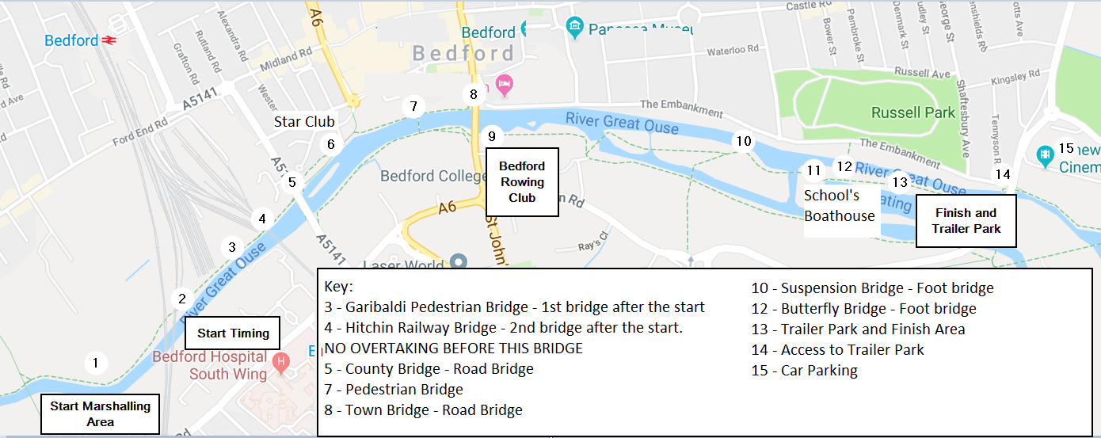

## Before the race

This Safety Plan incorporates the key points of the British Rowing publication 'Row Safe: A Guide to Good Practice in Rowing', and should be read by every cox, sculler and crew member.

All boats must have secure bow balls, heel restraints and watertight buoyancy chambers. Coxswains must wear a life jacket or buoyancy aid in the correct manner and be familiar with the method of operation. In “front-loader” boats coxswains must wear manually operated gas inflation life jackets (Rule 7-2-7). Inspections will be conducted and omissions may lead to disqualification.

All boats MUST have clearly visible Boat ID, as specified in Rules of British Rowing Section R ‘Boat Identification’. Boats not showing an ID may receive a time penalty and their club be reported to the Regional Umpires Commission.

#### Parking and Other Important Information

Longholme Island may be available for trailer parking. This will be updated closer to the time.

* We have arranged with the Council to have the parking on road (The Embankment next to Russell Park) by the finish area at Longholme reserved for TRAILERS ONLY, [Point 13 on diagram 1]. Please also see additional document with parking facilities.
* There is plenty of parking available nearby at Aspects Leisure Park.
* Please note that there is no public water supply in the trailer and finish areas.

#### Race Control and Number Collection

Race Control is on the first floor of Bedford Rowing Club, half-way down the course by the Town Bridge [Point 9 on diagram 1]. Your crew must be able to produce their racing licences at control when they collect their race number or at the request of a Race Official. Crew substitutions should be made at Race Control.

* Requests to change division should be made in person to Race Control. These will be approved at the discretion of Race Control and are subject to the number of crews the river can safely accommodate.
* Each crew is given 2 race numbers, both are to be pinned on the Bow’s back so that they can be clearly seen by Marshals and Race Timing. One number should be attached to racing kit, the other to the kit which will be worn when proceeding to the start marshalling area.
* Prizes can be collected from Race Control as soon as an event is completed and on production of a complete set of crew licences.  Prizes may also be issued at the discretion of the Entries Secretary up to one month after the event. Results will be available in the bar area of Bedford Rowing Club or after the event at [www.bedfordrowing.co.uk](http://www.bedfordrowing.co.uk) and www.rowstats.com.

#### Membership of British Rowing

Competitors please note that ‘The British Rowing membership insurance is only valid for UK residents who are resident in this country for more than six months in a year.

## On the Water

#### Getting to the Start and Circulation Pattern

The majority of crews will boat from the finish area. All boats should stay on the starboard (bowside) side of the river when making their way to the start (that's the cox's right). There is an island between Star Club and County Bridge - all crews should stay within the main channel, leaving the island to bowside. Be aware that some crews will be boating from Star Club, and MAY be using the channel on the other side of the island.

Give yourself plenty of time to boat before your division, as the marshaling area can become very congested and slow moving

Once all crews have left the finish area, they may be followed upstream by one of the safety boats, which will instruct all crews warming up to spin and proceed upstream. Failure to obey instructions from the Safety Boat or other marshals will lead to disqualification.

Any crew not upstream of the Schools' Boathouse 15 minutes before a division is due to start will not be allowed to race in that division. Also, any crew not upstream of Star Club 10 minutes before a Division is due to start will not be allowed to race in that Division. Crews prevented from racing due to lateness may be allowed to move to another division, at the discretion of Race Control.

Coaches cycling along the towpath should dismount before going underneath Hitchin Railway Bridge as it is very low. There have been several accidents in recent years.

There is a disembarkation pontoon in the Finish Marshalling area. Note that crew changes on this pontoon are NOT allowed – it is to be used for getting boats out ONLY. Once all boats racing in a division have disembarked, this pontoon will be available for outbound boats.

#### Start Marshalling

The Start marshals are positioned above the Twin Railway Bridges and the start. Any crew arriving at Start wearing the wrong number may be disqualified. All crews will be marshalled with their bows pointing upstream. DO NOT spin until instructed by the Start Marshal responsible for your section of river. Listen for, and follow, the Start Marshals’ instructions.

If a marshal considers that it is unsafe for a crew to race in the prevailing conditions (wind or stream) then that crew may be stopped and withdrawn from the race in the interest of their own safety and the safety of other crews and officials.

#### Start

The Head Race Start lies just downstream of the Twin Railway Bridges. Timing starts approximately 50 metres beyond the bridges.

#### Overtaking, Bridges and other Hazards

Overtaking is FORBIDDEN before Hitchin Railway Bridge (the second bridge after the Start) and will lead to disqualification (see diagrams 2 and 3). If you feel that you are considerably faster than the crew in front of you, then please inform the start marshals, who will try to ensure that an appropriate gap is left between you.

Overtaking crews have right of way, and so have priority to take the central, racing line. Crews which are being overtaken should move towards the closest bank. Note that BOTH crews have a responsibility to avoid collision.

#### Diagram 2 - Course Navigation – The Racing Line at Hitchin Bridge (Rail Bridge)

This is the narrow low green bridge, with a big modern stone road bridge straight after.

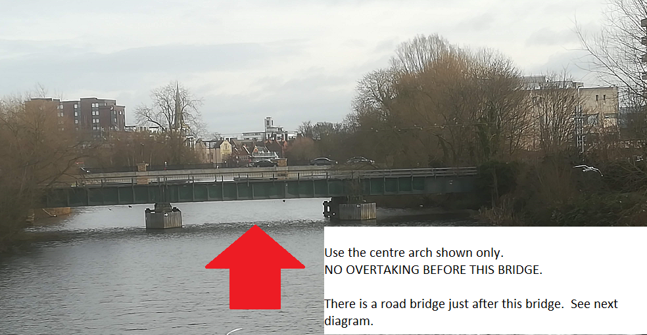

Only the centre arch of the low railway bridge (Hitchin Bridge) is navigable when racing; either arch of the modern road bridge (County Bridge) may be used (see diagrams 2 and 3). There will be a marshal positioned on the footbridge before Hitchin Bridge to assist you.

#### Diagram 3 - Course Navigation – The Racing Line at Hitchin Bridge (Rail Bridge) and County Bridge (Road Bridge)

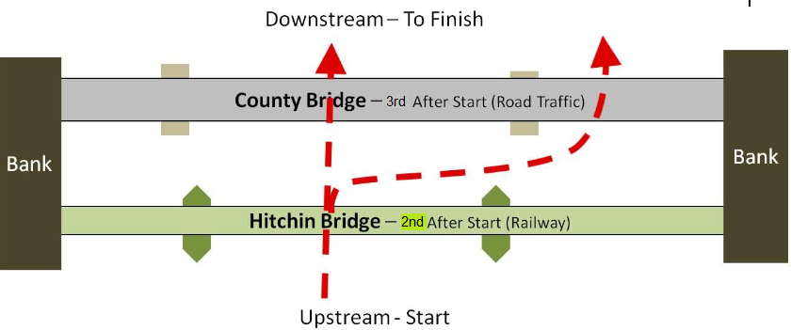

#### Diagram 4 - Course Navigation – Town Bridge (Old style Road Bridge)

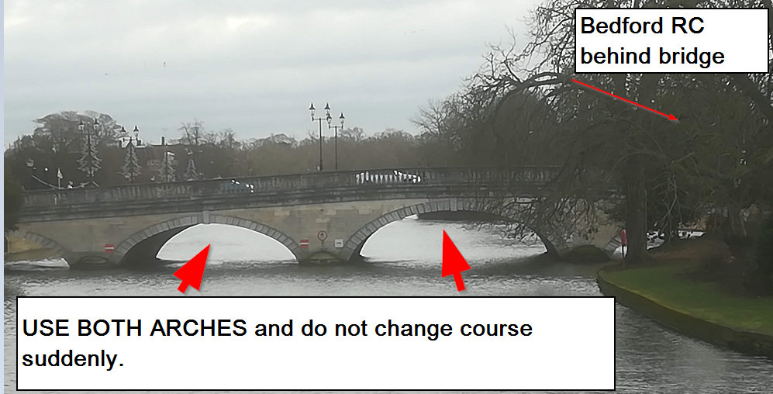

Either of the main arches of Town Bridge may be used.

Beware of the island just beyond Bedford RC, the pontoon projecting from the Schools’ Boathouse and the DSD work boat moored upstream of that boathouse. Keep in the middle of the river after passing Bedford RC in order to keep well clear of the main weir.

#### Finish

The Finish is approximately 200 metres downstream of the low footbridge in the trailer parking area (Butterfly Bridge). An electric horn is used to signal that each crew has crossed the line. Crews will be directed by finish marshals below the finish to wait for the completion of the division. Crews must not turn until instructed to do so by marshals. If you wish to use the disembarkation pontoon please let the finish marshals know.

## Safety

The whole course is visible to marshals. Every marshalling position is equipped with throwing lines and a radio to inform Race Control. In the event of capsize, stay with the boat until assistance arrives, and if possible try to make for the bank. Be aware of crews following you that are still racing. Your attention is drawn to the requirements of ‘RowSafe’, notably sections 1.8 and 1.9 which deal with cold water immersion, hypothermia and swamping, and section 4.1 which specifies the reporting procedures for accidents / incidents.

If you see an accident, give assistance if it looks necessary - you will be allowed to race again without penalty if you assist a crew in distress. An observing marshal will take action and alert the rescue services by radio as necessary.

#### Safety Boats

At least one Safety Boat will be available at all times, positioned at either Hitchin Bridge or Bedford Rowing Club.

#### First Aid

First Aid cover is provided at the Schools’ Boathouse (see diagram 1 point 9).

#### Emergency

The nearest A&E unit is Bedford Hospital (South Wing), which is accessed via Ampthill Road (A6). Telephones are situated at all three Boathouses, on the north side of the Town Bridge and in Russell Park opposite the Schools’ Boathouse (diagram 1 point 9).

For Fire, Police or Ambulance, dial 999 from any telephone.

## Event Organisation

|  |  |  |  |  |  |  |  |
| --- | --- | --- | --- | --- | --- | --- | --- |
| Safety Officer | Nick Weetman | Contact via Race Control |  | Race Committee Chairman | Gavin Dods |  |  |
| Event Secretary | Will Everitt | Contact via Race Control |  | Welfare Officer | Jonathan Dean |  |  |
| Entries Secretary | Will Everitt | Contact via Race Control |  | Bedford RC | (01234) 353183 |  |  |

The Race Committee reserves the right to amend the Safety Plan at any time.

## Competitors’ Responsibility

The Event Organisers will endeavour to provide a safe environment within the above mentioned Row Safe Guide although competitors, coxswains and coaches are specifically reminded that everyone using this local water course do so at their own risk and are solely responsible for:

* Their own safety, remembering that they have a duty of care to themselves and any third party both on the water and on land.
* Ensuring that any equipment (e.g. boats, blades, buoyancy aids, etc.) are safe and prepared to the standards as required under the ‘Rules of Racing’ and ‘RowSafe’. Spot checks may be made by marshals to check on bow ball, heel restraints or other quick-release mechanisms and coxes’ life jackets.
* Ensuring that their boats comply with the buoyancy requirements of section 2.3 of ‘Row Safe’.
* The strict observance of any ‘local rule’ or traffic/circulation pattern along with ‘RowSafe’ provisions.
* Deciding whether or not they are competent to use the water course in the prevailing weather conditions; this decision may be taken by the individual or with their coach/crew.
* Ensuring that they can swim in accordance with the requirements of ‘RowSafe’.
* Ensuring that they have their Racing Licences with them and that these are complete and up to date, in compliance with the rules of British Rowing.
* Ensuring that their outermost layer of clothing worn during the race conforms to their Club colours.
* Awareness of the British Rowing Rules of Racing.

#### Coxes

Buoyancy aids and self-inflating life-jackets are not allowed in front-loading boats (Rule 7-2-7). All coxes should be familiar with the method of operation of their life jacket, and those racing in front-loading boats should ensure that their life jackets allow for a quick escape.

Coxes are not allowed to wear Wellington boots.

Any crew arriving at the start whose cox is not wearing a correctly adjusted life jacket will be prevented from racing, and will be followed back to the boating area by a Safety Boat at the end of the division.

Swimming Ability

Every competitor is expected to be in good health and able to swim for a minimum of 50 metres in kit. Although the river is fairly narrow and access from the bank is relatively good, there are areas of dangerous undercurrent, especially around the large weir downstream of Bedford Rowing Club, the hydroelectric power station upstream of the Schools’ Boathouse, and the double railway bridges upstream of the Start.