Parking for Bedford RC Events

We have a parking suspension in place for the event, along the northern side of the embankment. This is strictly for trailers only, with their associated towing vehicles.

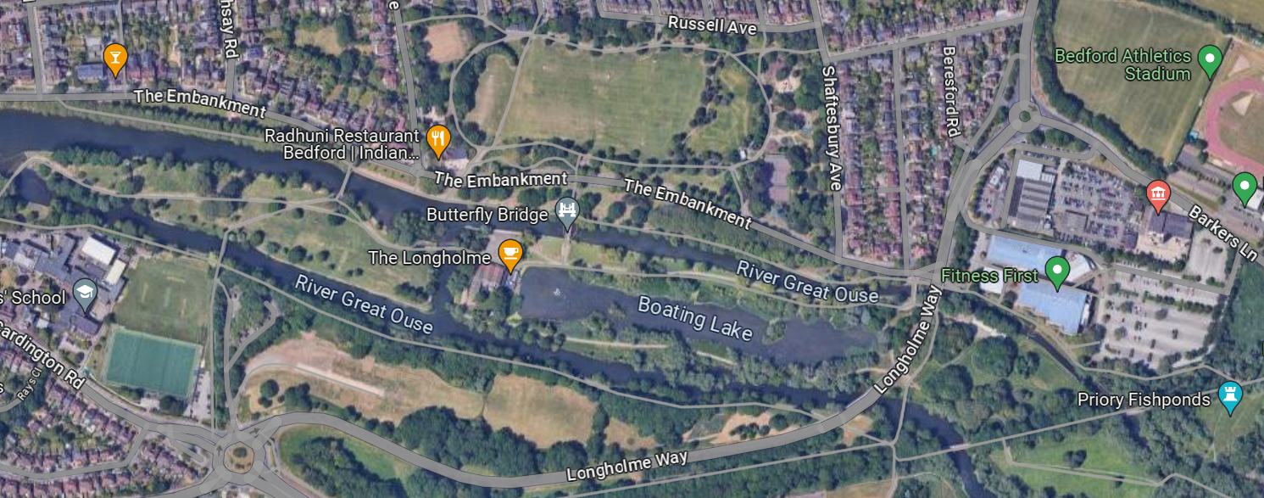

Weather permitting, parking may be available here, on Longholm Island.

Parking is now chargeable at Aspects. Beware of time limits too.

Other parking is available just north of the free end of the embankment, close to Russell Park.

Below is a link to Bedford Borough Council’s car parks. There are plenty within walking distance of the river.

<https://www.bedford.gov.uk/parking-roads-and-travel/parking-bedford-borough/council-car-parks>

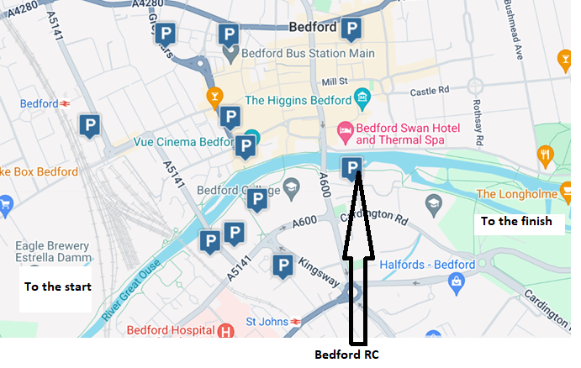

**What 3 Words:**

Embankment trailer parking What 3 words: thick.mixed.upgrading

Aspects Parking What 3 words: ticket.loves.wake

Bedford Rowing Club What 3 words: faces.laptop.clouds