Postoperative Instructions -Shoulder
Robert D. Simon, M.D.

You have just had surgery by Dr. Simon. The medications used in the operating room commonly cause drowsiness, dizziness, nausea and have other effects. Do not operate machinery, make important decisions or drive for 24 hours.
Dressing / incision site care:
Unless otherwise instructed, you should elevate and ice the area of your surgery. After arthroscopy it is very common for the dressing to become bloodstained. A combination of water left in the joint and a small amount of bleeding will lead to an ugly spot. It is nothing to worry about. You may change the dressing in 2 to 3 days. If the dressing becomes saturated before that you may change it or cover it with more gauze. Should blood actually drip from the dressing go to the emergency room or call the office. Band-Aids are usually enough to cover arthroscopy wounds. Drugstores generally carry larger Band-Aids if necessary. Surgical dressings must be kept dry and clean. After the dressing is changed in a few days, water can run over the wound but the wound cannot be soaked. Wounds may be immersed after 7 to 10 days or two days after sutures are removed.
Use instructions:
It is okay to be active unless otherwise advised. Please be careful as you may be unsteady on your feet. Range of motion is EXTREMELY IMPORTANT. Please begin at home exercises IMMEDIATELY following surgery. Mobility is of the utmost importance to avoid healing in a stationery position resulting for manipulation and potential repeat medical intervention. Please see exercises below to assist in regaining range of motion.
- Ad-lib - meaning you may use your arm as tolerated. Be gentle but gradually progress as you feel more comfortable. The sling is for comfort and should not be used for more than a few days except to go out of the house. It is a sign to other people that you have an injured wing. We want them to be careful. No sling after 2 weeks.
- Immobilized – meaning you need to keep the sling on. You may move your arm away from your body just enough to wash and remove the sling to work your elbow and wrist. Keep your elbow at your side and hand in the area of your stomach or in front of it so you don't rotate your shoulder.
Medication and Diet:
Antibiotic is generally given for a 24-hour period or so. You do not need any after that unless there is a problem. You should also have gotten pain medication. Use it as necessary to keep yourself comfortable. You may use anti-inflammatories such as Aleve, Advil, ibuprofen or aspirin ONLY AFTER YOU HAVE COMPLETED STEROID PROVIDED. You may eat a regular diet. Drink plenty of fluids. It is very common to have constipation as a result of the anesthetic and pain medication. This is a very common complaint and can get quite severe. It is best to prevent this early by using stool softeners and getting enough fiber. In bad cases, enemas or suppositories may be used. This is the most common complaint after surgery other than pain. If you take blood thinners regularly please ask your physician when you may start.
Call the office or go to the emergency room if you have any of the following or feel you have a medical emergency.
It is common to have a low-grade fever in a day or two after surgery. It should not get 101 or above.
Difficulty breathing or swallowing which causes distress.
Excessive redness, draining or pus at the wound site.
A severe rash.

Passive Range of Motion Shoulder Exercises

WALL CRAWL
Stand facing the wall, lay your palm on the wall, slowly walk toward the wall and use your fingers to help slide the hand upwards on the wall. Continue until the shoulder has maximum tolerable stretch, and hold for 30 seconds.
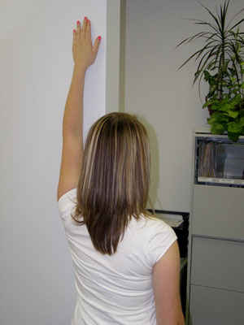

PASSIVE MOTION TABLE STRETCH
Place your injured arm on the table while you are sitting in a chair. Slide back ward in the chair and slide your arm forward on the table until you are in the position shown. Bend forward until you feel a good stretch. Hold for 30 seconds.
