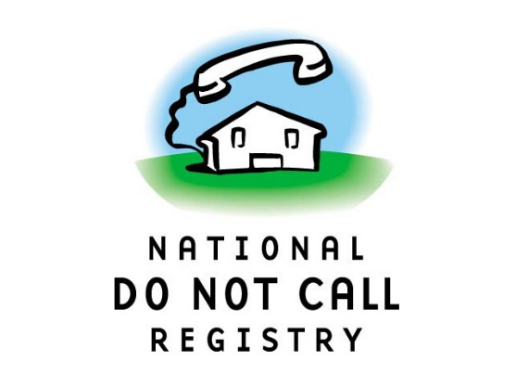

**WE HAVE A NEW DNC SYSTEM!!!!**

**Robo Calls Still Not Allowed!**

There's great news for agents needing to search for phone numbers on the DNC list. The area codes searchable are: 210, 512, 726, 737 and 832

The new system is easy to use.

Go to: [www.dncscan.com](http://www.dncscan.com/);

Enter your email.

The password is the last 5 digits of your social security number.

1) Agree to the conditions;

2) Click on scrub numbers at the top right.

2) Input numbers in the Input Numbers box.

3) Press GO!

That’s all you do. Much easier for all concerned. Happy scrubbing!!

xoxo Alice