August 30, 2019

Ms. Lara Cottingham
Chief Sustainability Officer
Office of Sustainability
City of Houston
611 Walker, 13th Floor
Houston, TX 77002
Via Email: Lara.Cottingham@houstontx.gov

Re: Scoping Comments for the City of Houston Draft Climate Action Plan

Dear Ms. Cottingham:

The Coalition for Environment, Equity and Resilience (CEER) is a collaboration of more than twenty-four non-profit organizations that work cooperatively to raise awareness of the connection between pollution, place, and the public’s health. CEER developed in the Greater Houston region shortly after Hurricane Harvey, when community members and leading non-profits recognized that philanthropic entities were being relied upon to fill gaps in environmental enforcement, monitoring, community education, and coordination. From issues of affordable housing, to transparency in how emergency management dollars are being spent, CEER continues to drive community voices into the post-Hurricane Harvey decision-making process to promote equity and resilience. CEER does this by emphasizing land, water, air, waste, and housing policies that reduce human exposure to pollution and strengthens environmental conservation. These policies are best reflected in CEER’s eight point plan, a copy of which is attached to this letter.

CEER’s eight point plan calls for decision-makers to commit to a region-wide climate action plan and ensure that future public investments reflect the environmental, social, and economic risks associated with a coastal landscape, an industrial ship channel and a growing population in a city rich with bayous and streams. Each individual member organization has adopted CEER’s eight point plan, which provides the basis for the comments now being provided for the City of Houston’s draft Climate Action Plan.
We applaud the City for its efforts. CEER supports the adoption of the Houston Climate Action Plan (CAP) as an important framework for the City of Houston to reduce greenhouse gas emissions. The comments below are provided with the intent of strengthening the plan.
Hurricane Harvey and other recent flooding events showed our region what a climate disaster looks like: loss of lives, flooded homes and property, chemical releases threatening neighborhoods. Climate change is a public health crisis that is harming Houstonians today. This harm will be magnified if greenhouse gas (GHG) emissions go unchecked. We also know that the effects of climate change are most deeply felt by those who are most vulnerable.
By adopting and implementing a strong CAP, Houston can take its place among those cities, states, and counties that are taking action to preserve a livable climate. Aggressive action to reduce GHG emissions can help reduce harmful air pollution, improve quality of life, create new economic opportunities, and save the city and its residents money.
Our comments include three major themes:
- Aggressive actions are needed now - accelerate time lines to reduce emissions as quickly as possible.
- Center climate equity in the implementation of the plan. Adopt principles of equity and identify how a plan to reduce greenhouse gas emissions will serve residents across the socioeconomic spectrum and facing several environmental justice issues. Analyze the needs of those who are most impacted by climate change and use that data to drive decision-making.
- Strengthen goals by clearly defining targets and setting timelines for monitoring and reporting; we recommend biennial reporting.
Our comments are limited to the draft CAP. The CAP is not adequate to address all of the causes and impacts of climate change. We hope, for example, that the Resilience Plan will make serious progress toward climate adaptation and that it will be formally adopted by the City of Houston City Council.

BACKGROUND: Align Language and Greenhouse Gas Reduction Goals with Climate Science

The CAP should clearly state a GHG reduction Goal
By signing the Mayors Climate Agreement, Mayor Turner has committed to adopt, honor, and uphold the goals of the Paris Climate Agreement, which aims to limit warming to 1.5°C. Since the development of the Paris Climate Agreement, research from the Intergovernmental Panel on Climate Change (IPCC) indicates that limiting warming to 1.5°C is necessary to avert the worst climate catastrophes and preserve a more livable environment. As the plan states, “Houston needs to define an ambitious agenda for the future.” We recommend that Mayor Turner clearly define that agenda by setting emission reduction targets consistent with the goal to limit warming to 1.5°C and state that goal in the plan. The plan should state that the goal is to achieve net zero carbon emissions in 2050.

Highlight Greater Irreversible Changes Beyond 1.5°C
Keeping average global temperature increase to no more than 1.5°C, with no or limited overshoot of that threshold, is critical in order to minimize irreversible effects of climate change (see Figure 1).

“Future climate-related risks depend on the rate, peak and duration of warming. In the aggregate they are larger if global warming exceeds 1.5°C before returning to that level by 2100 than if global warming gradually stabilizes at 1.5°C, especially if the peak temperature is high (e.g., about 2°C) (high confidence). Some impacts may be long-lasting or irreversible, such as the loss of some ecosystems (high confidence).” (IPCC; Special Report: Global Warming of 1.5°C, Summary for Policymakers; section A.3.2)

The relationship between increasing temperatures, especially where the increase in global temperature exceeds the 1.5°C threshold, and irreversible threats of extreme weather, ecosystem destruction, and other hazards is absent from the plan and should be added in the Background Section. Inclusion of these facts will help to make clear to readers of the plan why near term action is necessary.

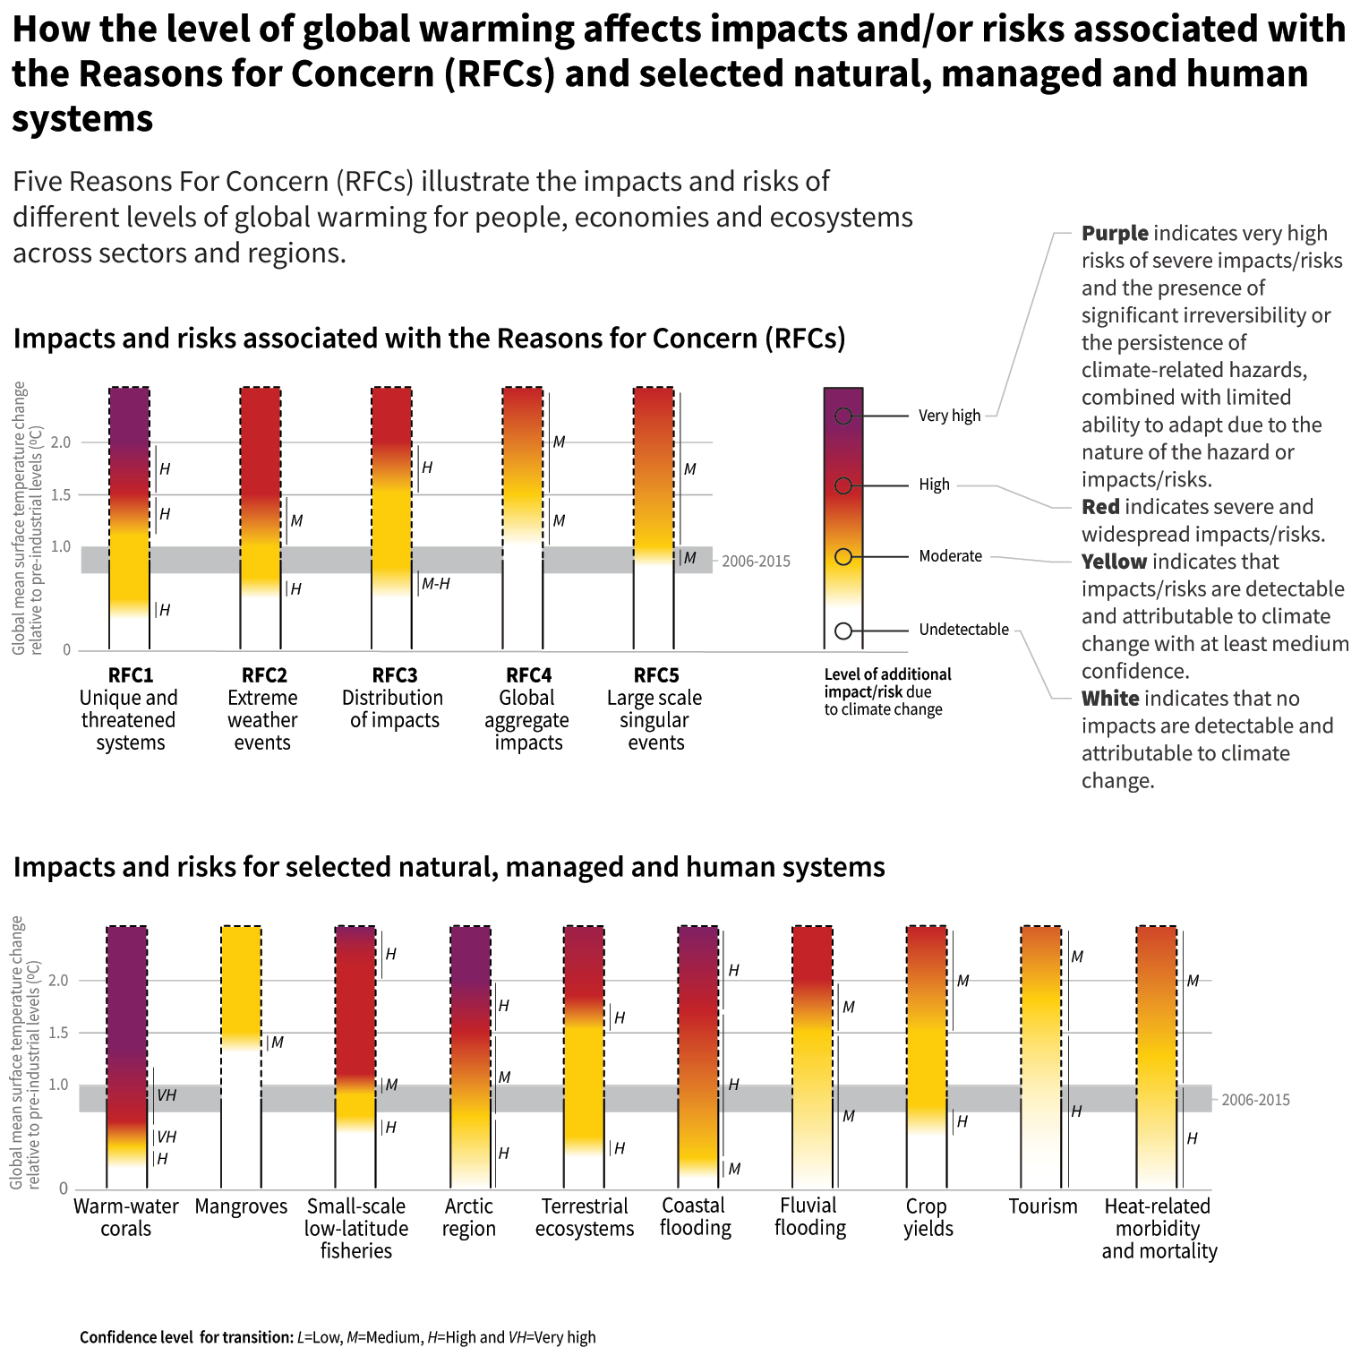
FIGURE 1: from the IPCC Special Report on Global Warming of 1.5°C

Provide Clear Details on Emissions Inventory
The background information provides some detail on the emissions inventory by including Houston’s large per capita emissions footprint of 14.9 metric tonnes of carbon dioxide equivalent (CO2e) per year and that in sum, Houston uses 35 million tons of CO2e in 2014.

The other major pieces of the emissions inventory are missing, however. The plan needs to provide detailed information about the 2014 emissions inventory, including how those emissions are parceled out between transportation, buildings and waste. This portion of the document also needs to clearly define the scope of the CAP. Even though portions of the Houston Ship Channel are part of the City of Houston’s extraterritorial jurisdiction, it was not included in the emissions inventory or the plan. If the city has made a clear decision to omit a large source of emissions that impacts city residents--from the Houston Ship Channel--then the CAP should clearly articulate that omission and explain the rationale. Neighborhoods along the Houston Ship Channel are considered environmental justice communities and experience disproportionately high impacts of climate change as compared to other parts of the City.

EMISSIONS REDUCTIONS GOALS: Clarity and Alignment are Needed
The Timeline for Emissions Reductions must Aggressively Reduce Emissions Between 2020 and 2030
The projected emissions chart shows CO2e reductions of 40% by 2030, 75% by 2040 and 100% by 2050. The city should prioritize ambitious goals in emissions reductions, particularly between the years 2020 and 2030 and achieve carbon neutrality as quickly as possible. We suggest a reduction target of 65% by 2030 and net zero by 2040.

The purpose of frontloading emissions reductions is to increase the probability of limiting average global temperature rise to 1.5°C. Staying under this threshold can help prevent the most catastrophic impacts of climate change and will also limit the need for carbon dioxide removal/offsets.

The IPCC “Special Report on Global Warming of 1.5°C” describes the global emissions trajectories that can likely achieve this target. In particular, the IPCC’s “P1 pathway” is a good guide for how global emissions should be reduced to increase the probability of achieving the 1.5°C target with limited reliance on carbon dioxide removal (see P1 line in Figure 2). It is notable that the P1, P2 or P3 pathways do not show straight line reductions, but rather start with steep reductions in the near term and then follow a somewhat more gradual downward path into negative emissions. The P1 emissions pathway results in approximately 65% emissions reduction between 2020 and 2030.

The IPCC Special Report on Global Warming of 1.5°C describes how reducing emissions more quickly increases the probability of keeping average rise in global temperature within 1.5°C. Reaching net zero greenhouse gas emissions globally by 2040 results in a high likelihood of average global temperature increase being within 1.5°C by 2100, but a substantial risk of temporary overshoot of that threshold remains (see blue band in Figure 3). Pushing the date to achieve net zero greenhouse gas emissions out further than that increases the risk of overshooting the 1.5°C threshold.
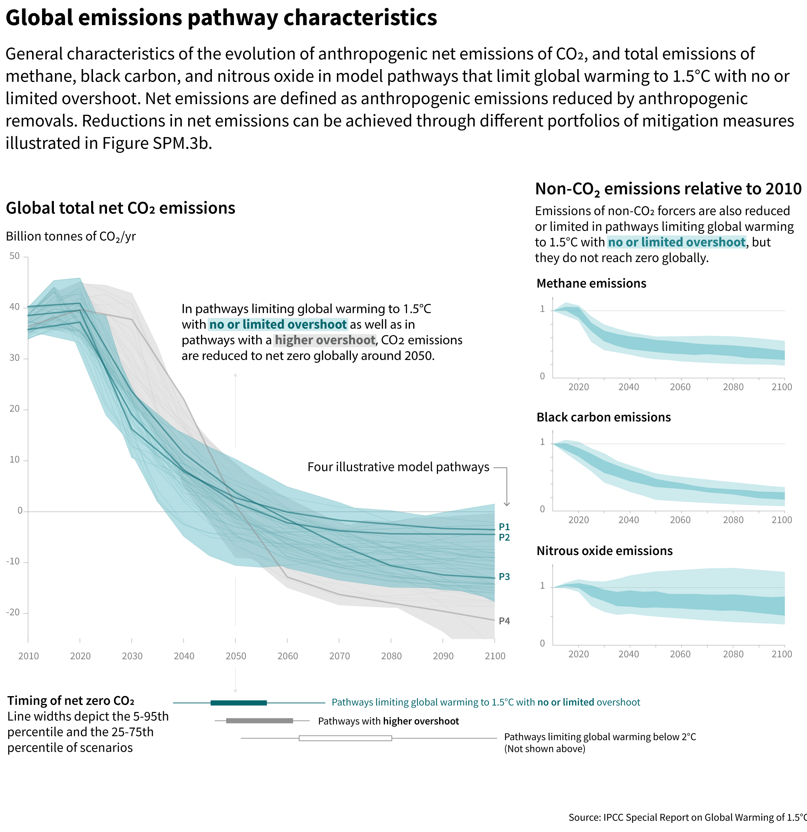
FIGURE 2: from the IPCC Special Report on Global Warming of 1.5°C

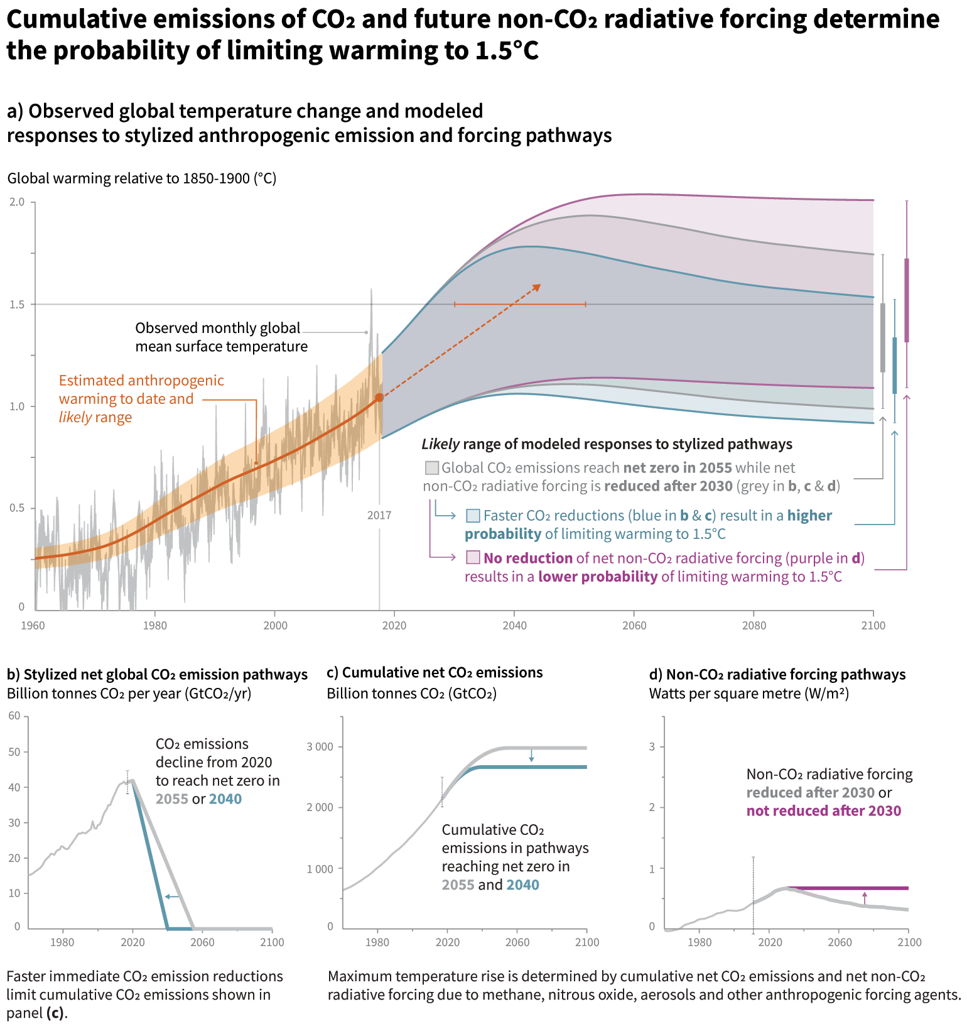
FIGURE 3: from the IPCC Special Report on Global Warming of 1.5°C

In its “Deadline 2020” report, C40 Cities applied global emissions reductions to categories of cities. Cities with higher emissions (greater than 5.1 tons of carbon dioxide equivalent per capita) and greater wealth (per capita gross regional product greater than $15,000) are expected to follow the “steep decline” emissions trajectory (see Figure 4).

Houston ought to embrace goals that set forth steep emissions reductions. Furthermore, the “Deadline 2020” report was issued prior to the IPCC “Special Report on Global Warming of 1.5°C,” which is widely understood to show that the climate crisis is even more urgent than previously believed.

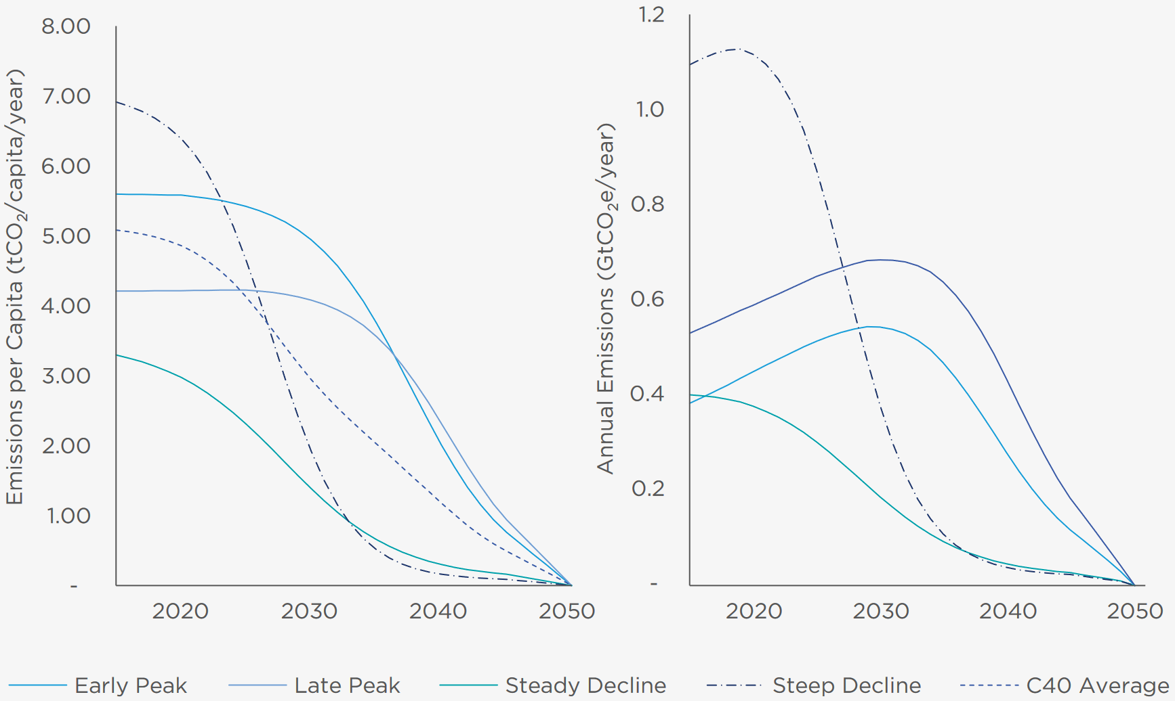
FIGURE 4: from the C40 Cities “Deadline 2020 Method Report”

Taken together, the IPCC “Special Report on Global Warming of 1.5°C” and the C40 Cities “Deadline 2020” reports make a strong case for Houston to adopt a goal of achieving net zero greenhouse gas emissions by 2040 and a 65% reduction in greenhouse gas emissions from 2014 levels by 2030.

These targets are what scientific research shows is necessary to avoid irreversible climate change at a level that may be impossible for societal adaptation. Technology that allows for the phasing out of fossil fuels is available now and already cost effective in many cases. The public is growing to realize that healthy societies depend upon healthy, functioning ecosystems. The first step to making the massive emissions reductions that are needed is to accurately quantify the reductions that are needed and use those as strong targets for the city’s plan.

ADD A SECTION ON EQUITY AS MOTIVATION: Build on Framing to Center Equity

Early on in the development process, the city identified equity as a major issue that the CAP sought to address through its actions. Reducing harmful greenhouse gas emissions serves an important role in creating a livable future for everyone. We want to see that framing continued and expanded, and the plan should include a section that defines equity and explains how the plan treats all Houstonians equitably .

Make it Clear that System Change is Needed, Not Only Individual Action
Climate change is a collective problem and requires collective solutions. While individuals can make lifestyle changes, systemic changes will be the hallmark of climate and environmental justice.

Discuss how the Climate Action Plan will benefit Low Income Communities and Communities of Color in Houston
Communities across Houston experience differential impacts of climate based on income levels and community demographics. We refer you to the work of Drs. Bob Bullard and Denae King, among others. Communities across Houston deserve climate justice. The CAP should clearly articulate not only how implementation will serve all Houstonians but explicitly how low-income communities and communities of color will benefit. For example, the City should work in partnership with communities like Sunnyside to ensure that new solar farms meet other community needs and solve for multiple problems at once.

The City should also analyze how policies (existing and new) and other implementation efforts across departments will impact different communities so that bias can be examined and removed. We recommend taking advantage of national climate justice speakers and trainers who can provide technical assistance to the City. The Climate Justice Alliance maintains a list of expert speakers on this topic: https://climatejusticealliance.org/newsroom/#Speakers-Bureau.

Discuss what Climate Change Means for Workers
The climate crisis certainly impacts businesses, but it is likewise important to highlight the harm that workers face from dangerous heat, more extreme storms, and flooding. While this plan does not include strategies to help workers adapt to a hotter and less hospitable environment, the city should be mindful that aggressively reducing emissions will be of benefit to workers by preventing the worst climate catastrophes. City departments that address economic development and business opportunity should develop strategies to create and provide jobs in renewable energy sectors with comparable salaries to ensure a just transition takes place in the greater Houston region.

People who work outside, people who provide social and care work, and people who work in the gig economy will especially benefit. Most of these jobs almost never come with inclement weather policies and people are often expected to show up to work regardless of weather conditions or risk losing their jobs. Time-off policies like paid sick time are not a guarantee, thus forcing people to choose between their wellbeing or their paycheck.

Climate Justice in Our Region: Rescind support for Liquid Natural Gas projects
We would like Mayor Turner to rescind his support for coastal liquid natural gas (LNG) projects. Natural gas is not a “bridge fuel”. Production and use of LNG releases high volumes of methane and carbon dioxide into the atmosphere. Even though relatively short-lived, methane is a more potent greenhouse gas than carbon dioxide. Methane leaks occur along the entire supply chain, and more and more Texans are concerned about their air quality and health due to the massive expansion of natural gas development. Communities along the Rio Grande Valley are fighting the construction of LNG facilities. South Padre Island, Port Isabel and Laguna Vista passed resolutions opposing the project, and we ask the Mayor to do the same.

Include Discussion of Global Equity Concerns with Climate Change
While equity in the local context should be a significant consideration in the plan, discussion of climate change and global equity is missing. While addressing the global inequities worsened by climate change is a daunting task, they cannot be ignored. Climate change is affecting many of the world’s poorest countries and most destitute individuals first and worst. A section of the plan should include discussion of rising sea levels inundating low-lying island nations and other coastal regions, flooding in places where the poorest of the poor are forced to live, famines caused by droughts, and violence triggered by these events and an increase in global migration of people due to climate change. For at least some people, a more clear understanding of how Houstonians can reduce suffering for other people globally will provide motivation to reduce greenhouse gas emissions.

Overview of the Goals: Can Co-Benefits be Quantified?

If the modeling framework provides additional information regarding community co-benefits, we would like to see those provided here. We know that several strategies within the plan provide benefits outside of reducing greenhouse gas emissions, and some of those co-benefits are listed. For instance, electric vehicles have lower cost of ownership, and if the city transitions its entire light-duty fleet to EV, that could have significant cost benefit to the city and taxpayer. That number could be quantified using tools like Afleet.

Leading By Example: Summary of City Specific Actions

We appreciate that the city highlighted actions that it can take on its own. While some of these actions will take time, we would like to see the time frames accelerated for many of these actions. Some examples:
- COH should achieve 100% renewable energy by 2022.
- The municipal benchmarking and energy audit policy should be updated by 2025.

COH should also reconsider its position on projects like the North Houston Highway Improvement Plan and the impact of that project on the goals outlined here. Highway expansion projects never result in reduced vehicle miles traveled (VMT). We would prefer to see more robust transit systems developed rather than a system that only adds to congestion and emissions.

IMPLEMENTATION

Monitoring and Reporting: A Necessary CAP Component
An effective CAP requires monitoring and reporting. We recommend annual reports on City-specific actions (page 5) and biennial reports on community greenhouse gas emissions through an updated emission inventory and report out to the community. We recommend that the city work with an independent third-party to verify city emissions.

Integrate Houston CAP with Other Plans
On page 15, the draft CAP includes a number of complementary initiatives. The CAP should
integrate and revise where appropriate the goals in these other plans.

Develop an Implementation Strategy
Several other cities with CAPs have developed implementation strategies to help launch their cities into action. See Seattle’s implementation strategy for an example of what COH could create.

Dedicated Funds are Needed to Support Implementation
Dedicated funds are necessary to implement several of the strategies listed here. Funds are also needed for communications and engagement. Funding sources should be included in the implementation strategy chart.

COMMENTS ON RECOMMENDATIONS
T1.1, Action 3: Charging infrastructure at multifamily homes should be called out here. We also want to flag this as a point where equity could be readily overlooked. Please include community based-organizations and nonprofits as partners in this work.

T1.2: the goal to convert the city fleet to electric vehicles should be expanded to include the heavy-duty vehicle fleet.

T2: Reduce VMT per capita is a general goal. We would like to see a specific amount of reductions called out here. Specific is terrific. Vehicles account for 47% of emissions and over 33 billion vehicle-miles are traveled each year in the city. The working groups included a reduction in VMT by 20%. That reduction is a minimum for what we should be aiming for.

T2.2, Action 4: We understand the role of infill development in mitigating climate change. We are also wary of gentrification, speculation and displacement. We want COH to prioritize affordable housing outside of the floodplain and along transit routes. We also want COH to prioritize net zero developments that work to reduce flood risk.

T3.1: We support mechanisms for vulnerable communities to access transit and support transit oriented development. We would like to see the programs discussed in this strategy to be set up by 2025 instead of 2040 and continue on an ongoing basis.

E2.1: Community needs to be included as a partner.

E2.2: State and federal policy changes could create a meaningful impact on the capacity of Houston and other cities to meet their climate goals. We support the inclusion of additional goals. This inclusion acknowledges the limitations that cities and states face as they attempt to mitigate harmful greenhouse gas emissions.

E3.1: The completion timeline on this strategy is not clear. Which actions will be completed by 2030 and which by 2040?

E3.2 and E3.3: We hope that the COH can reduce emissions as much as possible to reduce the need for offsets. Also, given that we generally believe a climate strategy should not rely on carbon capture, we are especially concerned about the prospect of carbon “utilization.” For example, the Petranova project at the WA Parish coal plant in Fort Bend County captures carbon that is sold for use in enhanced oil recovery operations. These operations inject carbon into geologic formations, leading to concern that this carbon will make its way back into the atmosphere and eliminate any benefits of its capture. We do not think that carbon utilization strategies should be part of a climate plan. If they are, any utilization plan must prove that carbon used will never reenter the atmosphere.

Woodlands, grasslands and wetlands sequester carbon, both in the vegetation and in the soil, and projects that protect these resources should be prioritized, particularly projects that are in the Greater Houston Area. Not only do these natural areas store carbon in soils and vegetation, they provide multiple benefits to the public, including recreation, water quality, improvements to mental and physical health, and improvements to the quality of life for all residents. Restoration activities, such as native prairie restoration and wetlands project, and land management practices, such as adaptive multi-paddock grazing, further increase the soil carbon sequestration.

Soil organic carbon has a great potential for storage and release of carbon, "because biomass and dead organic matter C pools are relatively small and ephemeral compared to soils." (See April 15, 2011 EPA Report 430-R-11-005, Inventory of U.S. Greenhouse Gas Emissions and Sinks 1990 – 2009). Disturbances to undeveloped land can lead to the release of carbon, while land management practices can lead to increases in carbon storage.
We request that the City of Houston adopt policies to promote land management practices that improve carbon storage using local natural resources, including the protection of wetlands, woodlands and grasslands, and the implementation of restoration projects and sustainable agriculture practices (such as native prairie restoration and adaptive multi-paddock grazing) to enhance the soil carbon storage of these areas.
We support carbon offset projects that show a permanent and measurable offset, particularly those projects that permanently protect our natural resources.

B1.2: We would like to see the city update its municipal building benchmarking and energy audit policy before 2025.

M2.1, Goal: Specificity is important. We support a 50% reduction in waste by 2040. We would also support the incorporation of a zero waste goal in the CAP and Solid Waste Long Term Plan.

M3.1, Action 4: We would not support incineration.

M3.2, Action 4: The text describing the last action is cut off in the document.

We would welcome the opportunity to meet with you at any time to discuss these comments and our support for these proposed changes. I can be reached at (713) 331-9913, or by email at iris@ceerhouston.org

Sincerely,

Iris Gonzalez
Coalition Director

https://www.ipcc.ch/sr15/
Pg 23 http://c40-production-images.s3.amazonaws.com/other_uploads/images/954_Deadline_2020_Methodology_%281%29.original.pdf?1480603800
Net zero by 2040 comes from the IPCC “Special Report on Global Warming of 1.5°C.”
https://oilprice.com/Energy/Energy-General/Shales-Dark-Side-Methane-Emissions-Are-Soaring.html
https://www.seattle.gov/Documents/Departments/Environment/ClimateChange/FinalCAPImplementationStrategy.pdf

