**DISTRIBUTION OF REPORT CARDS and 2nd PARENT-TEACHER CONFERENCE**

**AUGUST 19, 2017**

**GRADE/SECTION _____________________**

1. **ATTENDANCE**

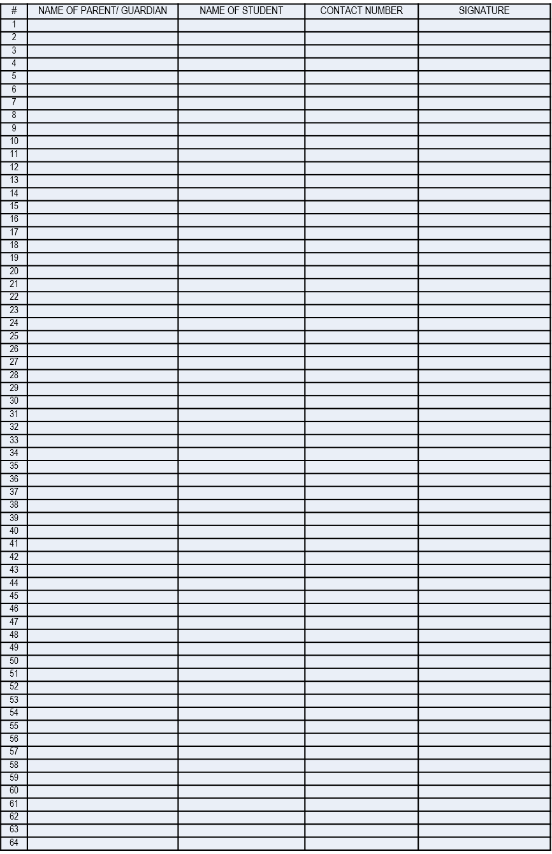

Total Number of Attendees =

X 100 = ______

Total Number of Students per Section =

1. **AGENDA**
2. K 12 Guidelines on Students Promotion and Retention ( DepEd Order No. 8, s. 2015)
3. Students Absences and Tardiness
4. Policy Guidelines on Awards and Recognition ( DepEd Order No. 36 s. 2016)
5. Upcoming Activities

* MTAP
* Division Contest ( Buwan ng Wika, History Month)

1. **TEACHERS ATTENDANCE**

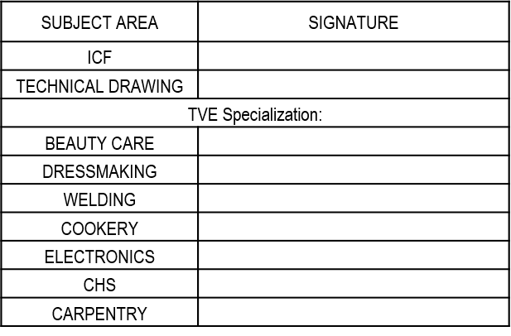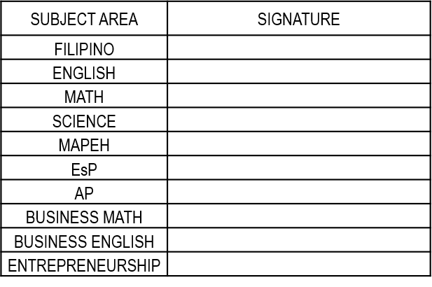

1. **MINUTES OF THE MEETING** (Attached separate sheets if needed)

**__________________________________________________________________________________________________________________________________________________________________________________________________________________________________________________________________________________________________________________________________________________________________________________________________________________________________________________________________________________________________________________________________________________________________________________________________________________________**

1. **AGREEMENT**

**____________________________________________________________________________________________________________________________________________________________________________________________________________________________________________________________________________________________________________________________________________________________________________________________________________________________________________________________________________________________________________________________________**

1. **DOCUMENTATION** (Attached pictures with caption**)**

**Prepared: Checked: Noted:**

_______________________ ________________________ **EDEN B. BINADAY**

Adviser Subject Coordinator/Dep’t Head Principal

(Signature Over Printed Name) (Signature Over Printed Name)