DR. JULIE DIGIOIA’S TRICKY TRAY IS BACK!!!
“HOPE STARTS HERE”
All Proceeds to benefit Community Breast Cancer Education and
Support Group Services in Hudson County

Thursday, October 6, 2022
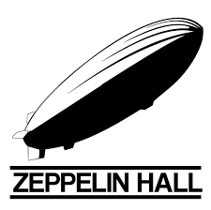
6 - 9 pm
Zeppelin Hall Biergarten
88 LIBERTY VIEW DRIVE, JERSEY CITY
(See https://zeppelinhall.com regarding free parking)
Enjoy the Main Hall, Rathskeller Room and tree shaded garden
Food available for purchase on site
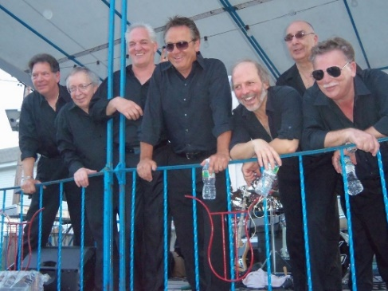
$65 ADMISSION Includes:
*ONE DRINK TICKET
*$25 RAFFLE TICKETS FOR THIS
AMAZING TRICKY TRAY AUCTION
*LED VOTIVE CANDLE TO HONOR AND REMEMBER
OUR FRIENDS, NEIGHBORS, AND FAMILY
MUSIC BY JERSEY SOUND

Tickets can be purchased on EVENTBRITE (www.eventbrite.com--search for Dr. Julie DiGioia’s Tricky Tray), by mail, or at the offices of Hall-DiGioia
Mon, Tues, Wed, Thurs, & Fri: Hall DiGioia Breast Care Center, 33 Overlook Road, Ste 205, Summit, NJ
Tues: Hall DiGioia Breast Care Center, 2 Journal Square on the second floor, Jersey City, NJ

To make a monetary donation in honor of a survivor or in memory of a loved one
lost to breast cancer, or to donate a basket, please call 973-294-9031.

ALL Breast Cancer Survivors-- Free Admission, sheet of raffle tickets and votive candle only
(must register by calling 973-294-9031)

