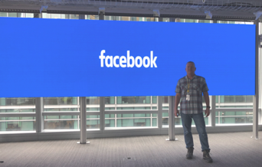
Andy Towers
andytowers@usaledwall.com (916) 844-9457
LinkedIn Profile

Summary

I have over 20 years of Audio-Visual industry experience selling and supporting advanced Video Processors and LED Walls. I’ve managed enterprise teleconferencing solution products and managed teams of electronics field engineers and in-house repair teams. I have Business Development experience in EMEA and APAC and have made dozens of trips to China for Sales, Product Planning, Product Training, and Product Improvement. I’ve supervised installs in Times Square, installed Digital Billboards and supported installations like the Facebook In-house Events Center. I worked on LED Spectaculars like The Comcast Experience, The Nike Flagship 5th Ave store, Crown Fountain Chicago and numerous other LED projects in the US.

Experience

EVP Live Events Product Sales at Unilumin USA
Unilumin USA
Jan 2020 - Sep 2020 (9 months)

EVP Customer Experience and Consultant Relationship Manager
Apr 2016 - Jan 2020 (3 years 10 months)

I was one of a team of four that started Unilumin USA. Unilumin Group is one of the largest LED companies in the world. They were not having sales success in the US because they did not have infrastructure to support sales in the US. Our team added a full-time repair depot and grew the company to over 25 employees in less than 3 years.
LED Solutions Manager
Christie Digital Systems
2014 - Feb 2016 (2 years 2 months)

As LED Solutions Manager I trained a US projector sales staff how to sell LED walls. Took LED wall sales from zero to over 20 Million in two years.
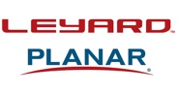
Inside Sales Manager/Customer Service Manager
Leyard American Corporation
Jan 2013 - Feb 2014 (1 year 2 months)

Leyard is the world leader in LED wall sales. The company was struggling with USA sales and support. I joined and built a service team but the company was in the process of procuring a US company (Planar Systems). Knowing Planar had a large sales and service structure in place I moved to a better opportunity at Christie Digital.

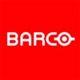
Customer Service Manager LED Products
Barco
2006 - 2013 (8 years)

Managed the in-house repair depot in Rancho Cordova, Ca. I also managed a team of 10 install customer service engineers that supported concert touring customers, LED walls for auto shows and LED walls for fixed installations.

Education

University of Phoenix
Bachelor's degree, Business Administration and Management

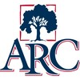
American River College
Associate of Arts and Sciences - AAS, Electronics and Communications
American River College
Associate of Arts - AA, Electrical and Electronics Engineering

Licenses & Certifications

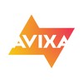 Certified Technology Specialist (CTS) – AVIXA 1342344

Skills

Sales and Sales Management • Customer Service Management • Public Speaking • Customer Experience • Business Development • Project Management

