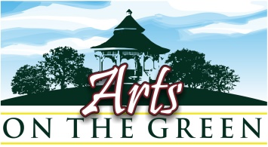
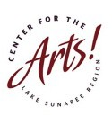

2019 Registration Form for ACCEPTED Juried Artists
Registration form and payment must be received no later than May 15th to reserve space and be included in publicity for the show (postcards, posters press releases, and ads).

Mail this registration form and check to: Center for the Arts AOG – P.O. Box 872, New London, NH 03257
OR Email this registration form to aog@centerfortheartsnh.org AND Pay with PayPal online at https://centerfortheartsnh.org/art-on-the-green

$110 / $100 for CFA Members 2019 Artist membership is $25.
To also become a 2018 CFA member at this time, please submit $125

Name _____________________
E-mail_______________________________________________Phone____________________________
Website ______________________
Mailing Address_______________________________________________________________________
Zip ___________________
I will display: Fine Arts_______ Fine Crafts______ What medium?___________________________________
Publicity: If you would like your artwork to be considered for publicity purposes, please email 3 images to aog@centerfortheartsnh.org with your name and title of artwork by May 15th. Please label each with your name, title and medium.

Donated artwork: If you would like to donate a piece of art for a raffle or silent auction to raise funds for the CFA scholarship program, please indicate here:

Media_______________Title______________________________________Size_____________
Donated artwork can be dropped off on the morning of the show at the info booth. Thank you!

I have read, understand, and agree to all of the statements in this application. I will not hold the Center for the Arts or any of its constituents liable for any injury or loss to me while participating at this event.

Signature: Date

Questions? Contact aog@centerfortheartsnh.org chk #_________ or Paypal________

