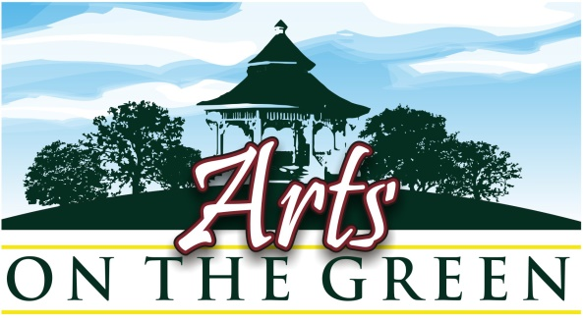
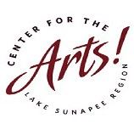
New London, NH

Fine Arts & Crafts Show : Saturday July 18TH , 2020
Jury Submission Application Form: For NEW Participants

Deadline: Application, jury fee, and submitted artwork due no later than May 15TH , 2020

Name: ________________________ Address__________________zip_________
Email: _______________________________________ Phone: ____________
Submit 3 entries for consideration in one of the following areas:
Fine Art (drawings, paintings, sculpture, photography) or Fine Crafts (jewelry, pottery, etc).
Do not submit mixed entries (i.e., 2 photos and 3 paintings, or jewelry and photography).

If you are submitting with your website? Please print web address here:

___________________________________________________________
ENTRY FORM (complete and submit with Jury Fee payment)
Entry title | Medium | Price
1.
2.
3.

Please read the instructions for completing submissions on the next page.

By submitting this Jury form and my fee I am applying for jurying to the
Center for the Arts,” Arts on the Green” Fine Arts & Fine Crafts Show.
I understand that the jury fee is non-refundable under any circumstances*.

If accepted I understand that my artwork may be used for promotional purposes,
And liability and insurance on all artwork and display tents/materials are my responsibility.

Signature:_____________________________________________Date_________
Signature and date required to complete the jury submission form.
Your signature verifies that you have read and do agree with all of the statements and rules in this document.

*Space is limited. If you submit your application after the show is filled, your fee will be returned.

Pa g e 2
For NEW Participants only
New Participants must submit Application Form, Jury Fee, and Artwork
to be considered for the 2020 Arts on the Green Show by May 15TH, 2020.

- Entry Form and Jury Fee Payment Options:
Complete the Application Form and mail it with your $30 check ($25 CFA members)
Mail to: Center for the Arts -AOG - PO Box 872 - New London, NH 03257
OR Email the Application Form to aog@centerfortheartsnh.org
AND Pay with PayPal at https://centerfortheartsnh.org/aog-2020-artist-info

- All Artwork must be submitted to aog@centerfortheartsnh.org
Email your website address OR E-mail 3 Jpeg images* of your artwork
Your 3 images should be labelled as follows:
Last name-Number on Entry Form-Title
For example: Smith-1-Morning Fog
*Jpeg images should be no larger than 10x10 at 100 psi

Your submissions will not be juried until your jury fee payment is received.
Jury fees are not refundable for any reason.

You will be notified by e-mail as to the jurors’ decision within one week after all materials have been received. If accepted, you will be emailed a registration form.
____________________________________________________________________________
Your registration form and site fee payment of $110 ($100 members) should be received
no later than May 20TH to confirm your participation and to be included on all promotional materials.
Late returns may be accepted only if room allows, but your name will not appear on any promotional materials (postcards, posters, press releases, and ads).
PLEASE NOTE: Site fee is non-‐refundable after May 20TH for any reason.

If you wish to become a 2020 member of the Center for the Arts at that time,
please make a payment of $125 for both registration and 2020 membership.

Dates to Remember:
May 15TH : 1) Jury Application Form 2) jury fee payment and 3) images must be received by
one of the methods above by this date.
May 20th : 1) AOG Registration Form and 2) site fee payment must be received
June 20TH : Orientation Packet will be sent to participants
July 18th : Arts on the Green-set up prior to 10:00am Break Down after 3:45pm

Questions about the show? Email aog@centerfortheartsnh.org

