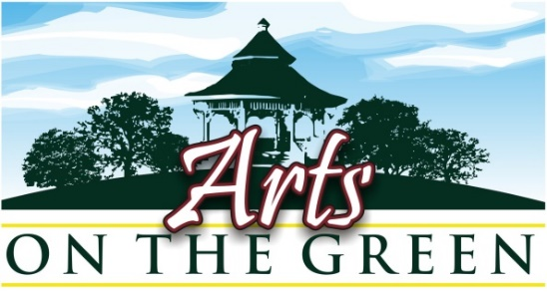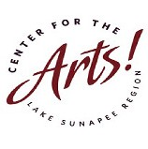

**Sunapee Harbor, NH**

**Fine Arts & Crafts Show:** **Saturday July 17TH, 2021\***

**Jury Submission Application Form: For NEW Participants**

***Deadline: Application, jury fee, and submitted artwork due no later than May 1st, 2021***

**Name:** ________________________ **Address:** ________________________________**Zip:** _________

**Email:** _______________________________________________ **Phone:** ____________________

Submit 3 entries for consideration in **one** of the following areas:

Fine Art (drawings, paintings, sculpture, photography) or Fine Crafts (jewelry, pottery, etc).

Do not submit mixed entries (i.e., *2 photos and 3 paintings*, or jewelry and photography).

**If you are submitting with your website? Please print web address here:**

**ENTRY FORM (complete and submit with Jury Fee payment)**

|  |  |  |
| --- | --- | --- |
| **Entry title** | **Medium** | **Price** |
| **1.** |  |  |
| **2.** |  |  |
| **3.** |  |  |

**Please read the instructions for completing submissions on the next page.**

**By submitting this Jury form and my fee I am applying for jurying to the *Center for the Arts, “Arts on the Green” Fine Arts & Fine Crafts Show.* I understand that the jury fee is non-refundable under any circumstances*.**

If accepted I understand that my artwork may be used for promotional purposes, and liability and insurance on all artwork and display tents/materials are my responsibility.

**Signature: Date:**

Signature and date required to complete the jury submission form.

Your signature verifies that you have read and do agree with all the statements and rules in this document.

*\*Space is limited. If you submit your application after the show is filled, your fee* ***will*** *be returned.*

**Pa g e 2**

**Additional NEW Participant Information**

1. **All Artwork must be submitted to** [**aog@centerfortheartsnh.org**](mailto:aog@centerfortheartsnh.org)

**Email your website address** **OR E-mail 3 Jpeg images**\* of your artwork.

Your 3 images should be labelled as follows:

**Last name - Number on Entry Form - Title**

*For example:* ***Smith-1-Morning Fog***

*Jpeg images should be no larger than 10x10 at 100 psi

**Your submissions will not be juried until your jury fee payment is received.**

**Jury fees are not refundable for any reason.**

**Mail jury fee** **check and form** to: Center for the Arts AOG -PO Box 872 -New London, NH 03257

**OR Email** form to [aog@centerfortheartsnh.org](mailto:aog@centerfortheartsnh.org) **and pay with PayPal** online at <https://centerfortheartsnh.org/aog2021>

You will be notified by e-mail as to the jurors’ decision one week after all materials have been received.

**If accepted, you will be emailed a registration form, or you may download from the website.**

**Your registration form and site fee payment of $110 ($100 for members) should be received no later than May 15th to confirm your participation and to be included on all promotional** **materials**.

Late returns may be accepted only if room allows, but your name will not appear on any promotional materials (postcards, posters, press releases, and ads).

PLEASE NOTE: **Site fee** is non-­‐refundable after May 15th for any reason.

If you wish to become a 2021 member of the *Center for the Arts* at the time you register, please make a payment of $125 for both registration and 2021 membership.

**Dates to Remember:**

**May 1st:** 1) Jury Application Form 2) jury fee payment and 3) images must bereceived by one of the methods above by this date.

**May 15th:** 1) AOG Registration Form and 2) site fee payment must be received.

**June 20th:** Orientation Packet will be sent to participants.

**July 17th:** Arts on the Green set up, prior to 10:00am and break down, after 3:45pm.

Questions about the show? Email [aog@centerfortheartsnh.org](mailto:aog@centerfortheartsnh.org)

*Last year, *Arts on the Green* took place under strict Covid Protocols. The day was

enjoyed by all and most artists reported “best sales of any show” they had been in previously.

We are planning a similar show this year under Covid guidelines, with a limited number of tents.

Please be sure that we will take every precaution to make this show “SAFE”. Your health and

peace of mind is important to us. As we get closer to the date, we will send you updated information.