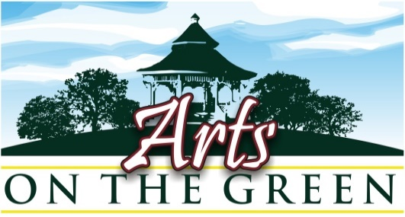

**10th Annual *Arts on the Green July 17th,* 2021: Prospectus\***

**Place: Sunapee Harbor-Sunapee, NH**

**Date: Saturday July 17th, 2021 - rain or shine** **Time: 10 am - 4 pm**

***Arts on the Green*** is a Fine Arts and Fine Crafts juried show. Acceptable works are:

**Fine Arts:** painting-oils, acrylics, watercolors, monotypes, pastels, drawings, photography, block prints, sculpture, (matted works: unframed originals, matted giclee prints- must be in bins). Greeting cards and hand painted cards are acceptable.

**Fine Crafts:** pottery, fine jewelry, gold and silver work, weaving, fiber arts, wood, metal, stone, sculpture.

Each participant must display **a minimum of 12 original artworks** during the show. Display only works for general viewing (all ages will be at the event, so nudes or images that are not acceptable for children to see are prohibited). **Only** original work should be displayed on outside walls of the tent.

Please note: **No tent sharing, and no organizational groups or commercial retail stores may participate**.

For questions, please email [aog@centerforthearstnh.org](mailto:aog@centerforthearstnh.org)

* All works must have been created by the person displaying at the site.
* There are no commissions taken by CFA.
* You are responsible for your own sales and you, or your representative, must be in attendance during the show at your booth.

**Fees: The following fees are payable by check or online with PayPal:**

* + - ***New Applicant Jury Fee*: Non-refundable $30 ($25 CFA members) *due by May 1st***

See jury application form for New Artists to the Show - 1st time jury submission.

* + - ***Site Fee* *for All Past and Newly Accepted Participants:* *due by May 15th***

$110 site fee ($100 members) along with your signed registration form

* + - **If you would also like to become a 2021 *Artist Member* of The *Center for the Arts***

please send $125 at this time

* + - **All fees must be received no later than May 15th** to reserve a space, and to be included in publicity(postcards, posters, press releases and ads). *We will not reserve your space without a check****.***
* **Mail checks and forms to: Center for the Arts AOG -PO Box 872 -New London, NH 03257**

**OR Email forms to** [**aog@centerfortheartsnh.org**](mailto:aog@centerfortheartsnh.org)

**and pay with PayPal online at** [**https://centerfortheartsnh.org/aog2021**](https://centerfortheartsnh.org/aog2021)

* ***Site fees will not be refunded after May 15th for any reason*.***

*\*Space is limited: If the show is filled your fee* ***will*** *be returned.*

**July 17th / Site Information:**

* Show times are 10 am to 4 pm. Plan to arrive early enough to have your set up done before 10 am. No break down before 3:45 please. You may park in the adjacent parking lot **before 8 am**.
* **You may not leave your car on the adjacent street or in the adjacent parking lots later than 8 am or you will be asked to move your vehicle.** If you have any questions when you arrive please see the Center for the Arts representatives at the information booth.



* CFA will provide coffee at the information booth the morning of set up.
* Your tent space is 10’ x 10’. Please be respectful of the neighboring tents. Freestanding racks or bins should be placed with your exhibiting neighbors in mind. You may use tent stakes.

* tents will be spaced 10 feet apart

* Exhibitors may display works only in the category registered on the application form below.

You may not display past awards, ribbons or advertisements.

* On Saturday morning please bring your site map and packet and plan to arrive **early** to set up in a timely fashion. The show starts promptly at 10 am. You may park and unload *before 8:00* but as soon as your equipment is unloaded *you must move your car to the designated parking areas shown on your map.*
* After disassembling your tent, you may drive back and park on the adjacent *street* for pick up, *but only at assigned times.* You will not be permitted to park on the street longer than 15 minutes to load.
* The park needs to be vacated by 6 pm. Please pick up and dispose of all paper and refuse in and around your site. You are responsible for the appearance of your site when you leave.

**You will be notified of your site number by June 20th.**

At that time, you will receive an Orientation Packet with the site map, directions to ***Arts on the Green***, and some postcards/ handouts for your own announcements.

Ads will be placed in the Hippo Press, Kearsarge Magazine, Soo Ni Pi, NH To Do magazine, Lake Sunapee papers and info guides to advertise the event.

## Artists and artisans are strongly encouraged to use e-mail, website announcements, and social media like Facebook, Linked In, and Twitter to notify clients and friends about the show ahead of time.

*Last year, *Arts on the Green* took place under strict Covid Protocols. The day was

enjoyed by all and most artists reported “best sales of any show” they had been in previously.

We are planning a similar show this year under Covid guidelines, with a limited number of tents.

Please be sure that we will take every precaution to make this show “SAFE”. Your health and

peace of mind is important to us. As we get closer to the date, we will send you updated information.