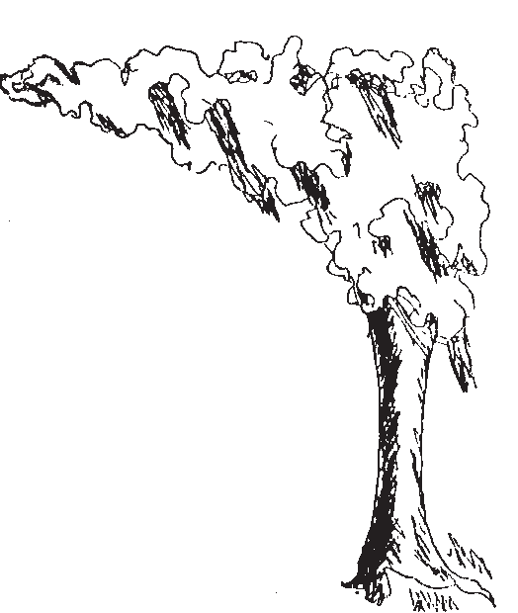
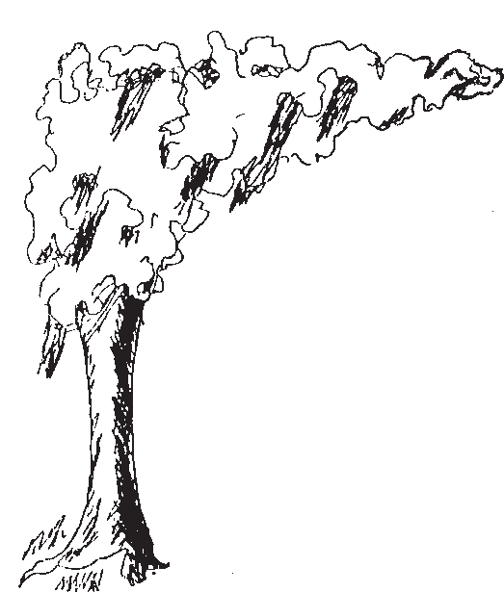
TWIN OAKS PARK
HOBOKEN, GEORGIA
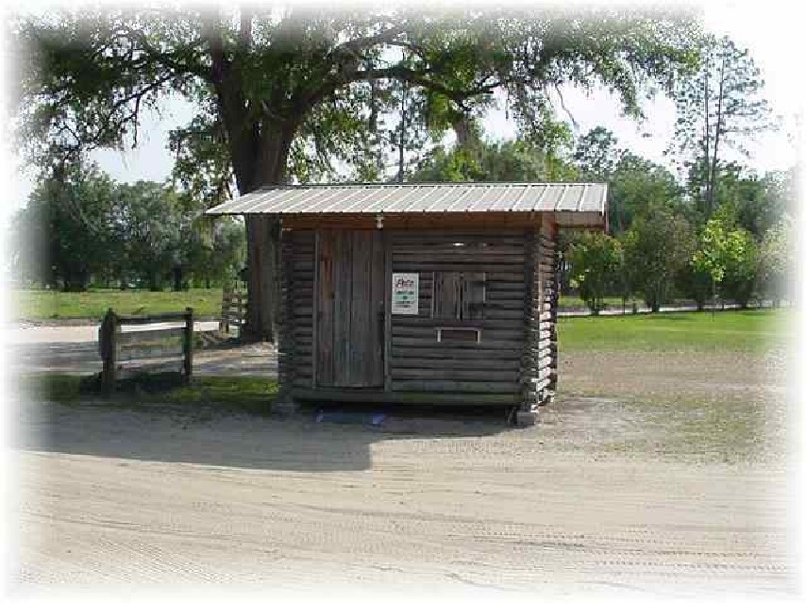

FLAT TOP TRAVELERS HOST
FIFTY-SECOND ANNUAL
BLUEGRASS MUSIC CONVENTION
September 4-5-6, 2025

Featuring:
C. F. Bailey & Shadow Ridge Carolina Bluegrass Style

Backline Black Creek String Band Crimson Creek

Thursday, September 4, 2025 – Bluegrass Gospel Music Night
Emcee:
Jo Odom
Sound by:
Jerry Hester

Betty Sibley & Friends Crimson Creek

881 CAMPING HOOK-UPS AVAILABLE
$25.00 PER DAY FOR ONE 30 AMP OUTLET WITH WEEKEND TICKTS - $30.00 FOR 50 AMP – Dry Camping $15.00
First Come-First Serve—No Reservations
Family Entertainment – No Alcoholic Beverages – Arts & Crafts – Pets Must Be On Leash – Clean up after Pets – No Pets in Concert Area
Come! Have a Good Time! BRING YOUR LAWN CHAIR—CLEAN RESTROOMS AND SHOWERS!


ADMISSION:
Upcoming Events:

Friends of Twin Oaks (FOTO)
Monthly Bluegrass Pick-In
1st Fri & Sat of each month
www.twinoaksfriends.com

www.bigzgaragsaleblackshear.com

Thursday: $10.00-6:00 P.M.
Friday: $12.00-6:00 P.M.
Saturday: $15.00-12:00P.M.
3 day pass - $30.00 • 2 day pass (Fri. & Sat.)- $25.00
Children 10 and under FREE with adult
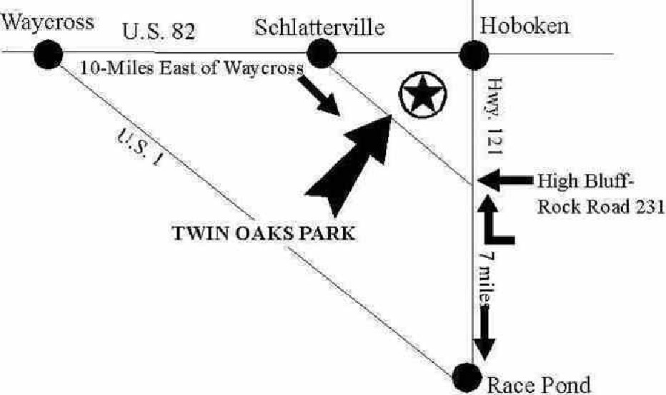
SORRY - NO DEBIT OR CREDIT CARDS ACCEPTED

LOOK FOR SIGNS TO TWIN OAKS PARK
5 Miles South of Hoboken, GA off Hwy 121
or 10 Miles East of Waycross, GA off Hwy 82

FOR MORE INFO CALL OR WRITE:
Sharon C. Crawford – 912-614-1506
Next Show Dates:

April 23-24-25, 2026
Website: www.twinoakspark.com

april 5-6-7, 2024

www.twinoakspark.comkspark.comm
401 Twin Oaks Dr. - Hoboken, GA 31542

Short Order Food Available:
Hamburgers - Hot Dogs - Slaw Dogs - Chili Dogs
Chicken Strips – Fries – Sausage Dogs
Ice Cream – Funnel Cakes – Root Beer Floats
Twin Oaks Bluegrass Park & Campground

