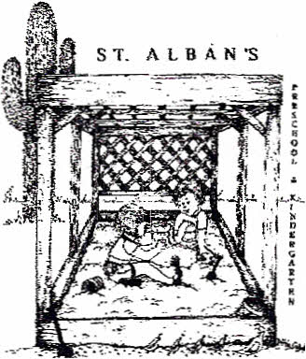 ST. ALBAN’S 2025 SUMMER CAMP REGISTRATION

CHILD’S NAME:________________________________________DATE OF BIRTH:___________________

ADDRESS: ZIP:

MOTHER’S NAME:

CELL PHONE:

EMAIL ADDRESS:

FATHER’S NAME:

CELL PHONE:

EMAIL ADDRESS:

**My child will attend the following sessions:**   
*Please note each camp session is 2 weeks, except the first session which is only 1 week.*

All sessions

(May 28-July 24th) Camp will be closed on June 19th and July 4th

Session 1 _____ Session 2 _____ Session 3 _____ Session 4 _____ Session 5 ______

(May 28-30) (June 2- 13) (June 16- June 27) (June 30-July 11) (July 14-24)

**My child will attend camp on the following days:**

*(Minimum of 3 days)*

Monday Tuesday Wednesday Thursday Friday

**My child will attend camp for:**

1. Camp only (9:00am-12:00pm)
2. Extended Day (7:00am-6:00pm)

**Registration Fees (non-refundable):**

$75 new students $50 continuing students

*\*All fees must be paid before your child’s first day of camp*

**I give permission to St. Alban’s personnel to apply sunscreen on my child. (initial)**

**I give St. Alban’s personnel permission to use Kirkland brand wipes on my child ______(initial)**

**I give permission for my child to go to Rooms 11/12, library & youth lounge_________(initial)**

**I give permission to St. Alban’s personnel to use my child’s image on:  
 Facebook _________(initial) School Website: ________(initial) lilio App: ________ (initial)**

**I understand I have to provide my email address and download the lillio app in order to receive all camp communications_______(initial)**