Josie Hughes

Professor Gary Vaughn

ENGL 2089

9 March 2022

The Effect of Genre on the Interpretation of Amending The Constitution

‘We The People of the United States of America’ have heard this phrase time and time again, as it is drilled into our minds from an elementary age, but why? This famous preamble comes from the United States Constitution, a foundational document that the country has been built on since 1787. This document holds immense importance as it is the blueprint of all of our government institutions, how they are run, and how they help maintain a functioning society. The topic of amending the Constitution has been widely debated and analyzed through many different and distinct genres. Even when approaching similar topics, sources often approach the idea in its own distinctive manner; whether that be through rhetorical appeals, the language used, or the complexity of analysis done by the author. These elements highlight the genre of media and offer different perspectives on whatever topic is at hand. Analyzing and comparing the topic of amending the Constitution through these differing perspectives such as a mainstream media article, a scholarly article, and a TEDx video allow for a better understanding of how genre plays into the overall goal of the author.

Amending, or changing, the Constitution has been in constant debate between members of all political affiliations for quite a while now, but has recently gained more popularity as the polarization of the United States has continued to increase. This has resulted in a great deal of different authors offering their perspectives and opinions surrounding the topic. Within this discourse, some authors hold supporting opinions while others oppose the idea entirely, and each uses specific rhetorical elements that solidify their difference in genre. The scholarly article comes from the *University of Arkansas at Little Rock Law Review,* a pristine organization, and was written originally by Ruth Bader Ginsburg, a trusted political figure and government actor. The article from a mainstream news outlet comes from the *Chicago Tribune*. This source is categorized as an opinion article and the author does not seem to have any noted credibility within the article. Lastly, a TEDx video that was hosted at Georgetown University. This source has both casual opinionated arguments yet also builds a credible profile of the speaker. All of these sources strive to inform and convince the audience on the same topic but vary in the way that their message is communicated to their intended audiences.

Amending the Constitution is a complex topic that requires background information to be fully understood because of factors like its age, its style of writing, and the discourse surrounding the idea. The United States Constitution is the oldest living constitution in the world, standing at 234 years old (Ginsburg, Elkins 11). To many people, especially Americans, the age of this document is not surprising, but it becomes more astonishing after realizing that the aver1age lifespan of a Constitution is merely 17 years, making the United States Constitution almost 17 times older than the average Constitution (Ginsburg, Elkins 11). To those who support keeping the original document the way that it is, the age reflects its ability to remain strong through decades of societal change. Conversly, to those who instead support altering the document, its age reflects the country’s outdated elements that show a darker side of the nation that no longer exists.

To amend or not to amend is the main argument from each source, leaving readers with a black and white choice to make on the topic. While developing their own arguments, readers may find themselves emotionally affected, logically compelled, or feel a sense of trust in the author; sometimes even all three. These rhetorical appeals of *ethos, logos,* and *pathos* are some of the main elements used by authors while backing their claims. When reading the mainstream article published by the *Chicago Tribune* it is clear that the author uses primarily *pathos*, appealing to the reader’s emotions. This can be seen by the author’s choice of words, phrases, and tones. For example, the author uses transitions such as “And if that doesn't scare you” when jumping from one point to another, and words like “ravaged” when describing the future in order to invoke a sense of fear from the reader (Super 2-5). On the opposite end of the spectrum, the scholarly article written by Ruth Bader Ginsburg and published by the *University of Arkansas at Little Rock Law Review* differs by focusing on primarily *ethos* and *logos*, appealing to the reader’s logic and building the reader’s trust as a credible source. By offering more historical background and context, such as informing readers that “only twenty-six amendments have achieved ratification, but over ten thousand proposed amendments have been introduced by members of Congress. 25 Of the twenty-six successful amendments, only four overrode Supreme Court decisions”(679), this genre of writing allows readers to gain a substantial amount of knowledge about the subject before making their own logically informed opinions. 

Throughout the article, Ginsburg consistently maintains a professional rather than casual tone in order to solidify her position as an expert on the topic. The author builds trust with the reader by being a respected political figure as well as providing contextual details and reasons why they are qualified to be talking about the topic. Although it is common to see one rhetorical appeal prevail over others within a source, some

| Figure 1 |
| --- |

contain and balance all three. The TEDx talk contains elements of *ethos, logos,* and *pathos*, appealing to the reader’s logic and emotions, while also building up trust as a credible source.

These rhetorical appeals can also be seen in the way that the author presents their material. Much of the argument surrounding the amending of the Constitution involves the dated elements that no longer apply to society but still exist within the document. Both the scholarly and mainstream articles communicate their arguments through the medium of written text. This makes the way they present their material more important and somewhat more difficult because they do not have the ability to observe their audience’s interpretations and reactions to their points, unlike the TEDx talk. To better deliver the argument that “the Constitution, through generations, has remained a foundation of fundamental law, a clean, uncluttered document” (Ginsburg), while also realizing much of the article’s intended audience believes that it holds outdated sexist, racist, and heteronormative aspects, the author must carefully assess the best method of delivery of their argument. By including the fact that “women, it is true, were not part of the political constituency in 1787, or even 1868” (Ginsburg), the author is using *logos*; appealing to the reader's logic by addressing a possible rebuttal. In contrast, the mainstream article's goal of defending the Constitution as it is uses a completely different method of delivery. Instead of resonating with readers' possible concerns or rebuttals, the author of this article emphasizes the negative aspects of Constitutional change instead of attempting to strengthen his own argument. In comparison, Ginsburg addressed the fact that women were left out of the constitutional process in order to analyze how this may have affected future generations; but the *Chicago Tribune* article offers a more abrasive view of the future impact of this aspect of the document by instructing readers “don't bring up our duty to future generations: They may not like the national debt we'll probably bequeath them, but far better that than a ravaged Constitution” (Super 5). This method of delivery is much less concerned with appealing to the reader’s logic than the scholarly article and relies more on the emotional reaction of the audience to gain support. This kind of ultimatum, offering two negative options, where the better option is in support of his argument, is applying *pathos.* Making the audience associate a negative connotation with the idea of Constitutional change is a delivery method commonly seen in this genre of writing because its primary goal is to persuade an average person, who lacks much knowledge of the topic, while simultaneously not offering any kind of supplemental education. In comparison to the articles, the TEDx talk has a completely unique method of presentation. Arguing in support of amending the Constitution, this speaker addresses the impact of outdated elements by first telling the audience that “the people who wrote it knew nothing about industrialization, or the internet, or the war on terror, or the NFL”(Seidman) in order to catch the attention of most audience members in one way or another through larger collective interests like the internet and more niche interests like the NFL. Once the audience's logic has been appealed to by a sense of connection to the topic, the speaker addresses that the Constitution was written “by people who died over 200 years ago and, by the way, though it was perfectly fine to own other human beings and thought that women had no role to play in public affairs and thought that the only people who should be allowed to vote are white, male property owners” (Seidman). This presentation of material allowed for the audience to connect with the topic from a logical and causal perspective before being exposed to racist, sexist, and overall unsettling subject matter that the author uses to invoke an intense emotional reaction from the audience. The TEDx speaker is also able to communicate in a way impossible of the other sources; through body language. The speaker has the advantage of being able to control how the audience takes in his messages because he has control over the way his presentation is being comprehended. Unlike the other sources, which are articles, the audience for the TEDx presentation is not able to skim through the author’s ideas to find main points or small details, but rather they must endure the entirety of the speech and ingest all of the given information, not solely what they may be looking for. Body language is also an advantage for how the audience interprets the author’s message. By raising his arms, he is making the audience perceive him as open and understanding, making them more susceptible to his argument.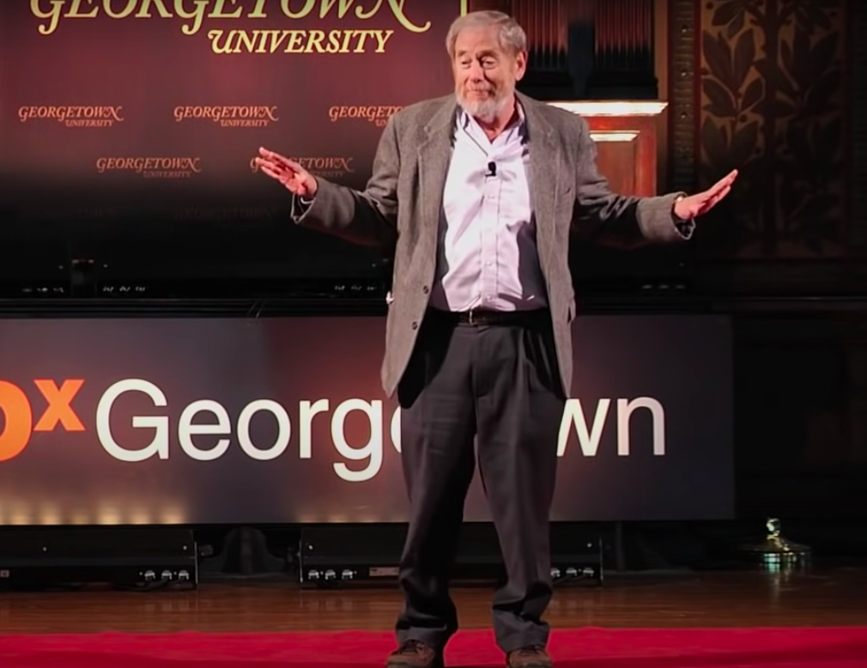

| Figure 2 |
| --- |

Other defining elements of genre, often implemented by authors, are the use of tone and diction. Someone without immense historical knowledge, who is just looking for quick facts on what amending the Constitution would entail would likely benefit from the mainstream article because it uses simple vocabulary in an easy-to-understand manner. Conversely, someone with academic or historical precedent, looking to understand the methods used for constitutional amendment or the effects it may cause would likely seek out a source, such as the scholarly article by Ruth Bader Ginsburg, using more complex language to thoroughly explain the topic. The sought-after outcome of both the author and reader shows the benefit of having multiple genres of media presenting the same topic. By arguing that “the congressional restraint and public conservatism this record shows have assured the endurance of the Constitution despite shifting political passions” (Ginsburg 680), in the professional tone that the author is using here, she is reducing the target audience to those who have knowledge surrounding the constitution or politics. Using complex diction and a professional tone to weed out less academically qualified readers is a common occurrence in this genre of writing. In contrast, the TEDx talk uses diction and tone in a much different manner, even though the speaker is aiming for the same goal: to convince the audience of his point. The tone the TEDx speaker uses to address the audience is much more casual, almost as if he is talking with friends or family, but he solidifies his position as an expert by still using very formal diction. He addresses the audience as “you guys” before taking the stance that “the people who hold the burden of proof are the people who think we should uphold the Constitution” (Seidman). This allows him to attract a widely diverse audience under the guise of an informal speech and then compel said audience with more complex diction surrounding the topic. Unlike both the TEDx talk and the scholarly article, the *Chicago Tribune* writing applies a distinctive style of both tone and diction which better suits this genre. The author takes a very casual, friendly, and almost concerned tone with the audience by telling them that “The representatives you love to hate now — not Madison, Hamilton, Franklin and Washington — would get the chance to revamp the Constitution”(Super 5). This makes it so that the intended audience for this genre would not need to know much more than how they stand with their current representatives, and if they don’t like them, they are already aligned with the author. The tone of concern when telling the audience that those making changes would be people they “love to hate” is invoking a sense of uncertainty, just by his tone. The simple, laid-back, diction he uses allows for almost anyone to be able to read and understand his message, making his potential audience prospects much larger than that of the scholarly article or TEDx talk.

The concept of Constitutional change, though still a complex and unresolved topic within the modern political world, is worth being dissected and debated in a way that allows readers to understand and take a stance on the matter. The ability of each author to use rhetorical elements to better argue their intended point on the topic highlights the importance of genre on an audience’s interpretation of material. No one stance taken by any of the authors is necessarily more correct than another, but by implementing elements such as rhetorical appeals, different methods of presentation, and the use of tone and diction, each author creates a genre of writing best suited for their intended audience and argument. The scholarly vernacular, sophisticated presentation and use of primarily *logos* within the article from *The Little Rock Law Review,* allow the topic to be debated within the scholarly political community, while the *Chicago Tribune* article allows the average person to get insight on the basic argument against constitutional change. The TEDx talk meets the needs of both the knowledgable communities and uneducated audiences by introducing the argument for constitutional change with easy-to-understand diction while maintaining the status of someone with credibility on the subject. Without the distinct differences in genre seen in each source, the future of Constitutonal change could be left to the interpretation of only those in high government standing, but with the ability to communicate the subject matter in a way that includes audiences of all demographics, the future of debate on Constituional change looks bright.

Works Cited

Ginsburg, R. B. (1989). On amending the constitution: A plea for patience. Retrieved March 9,

2022, from https://lawrepository.ualr.edu/cgi/viewcontent.cgi?referer=&amp;httpsredir=1&amp;article=1878&amp;context=lawreview

*The Constitu*Archives and Records Administration, 4 May 2020,

www.archives.gov/founding-docs/constitution-transcript.*tion of the United States: A Transcription*. *National Archives*, U.S. National

Super, David A. “Don't Even Think about 'Updating' the Constitution.”

*Chicagotribune.com*, Chicago Tribune, 11 May 2019, www.chicagotribune.com/opinion/commentary/ct-constitutional-convention-amendments-20170319-story.html.

TEDxTalks, director. *Let's Throw Away the Constitution! Mike Seidman at*

*TEDxGeorgetown*. *YouTube*, YouTube, 11 Dec. 2013, www.youtube.com/watch?v=gSqUUvEHjng.

Thomas Ginsburg, Zachary Elkins. “The University of Chicago the Law School.” *The*

*Lifespan of Written Constitutions | University of Chicago Law School*, 15 Oct. 2009, www.law.uchicago.edu/news/lifespan-written-constitutions#:~:text=Constitutions%2C%20in%20general%2C%20do%20not,only%2019%20percent%20will%20remain.