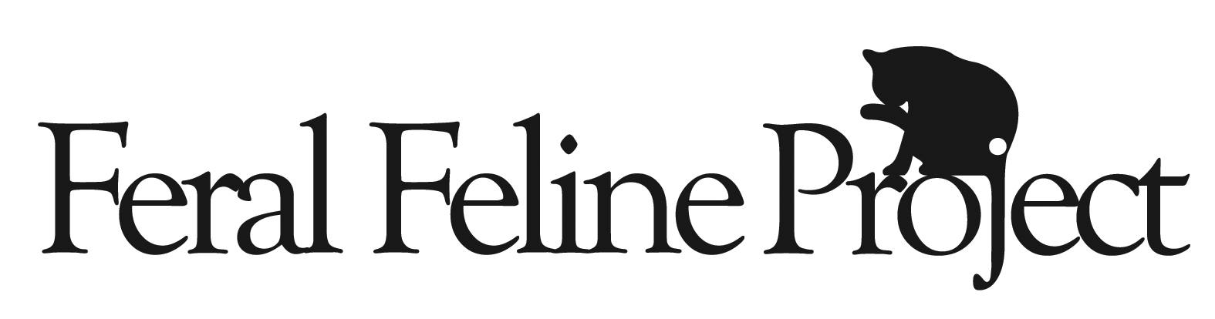
PO Box 1 Wheeling, IL 60090
Feralfelineproject@gmail.com
Feralfelineproject.org

VOLUNTEER APPLICATION

Your Information

Today’s date: ___________ Name: __________________________________________

Address: _______________________________________________________________

Home phone: ______________________Cell phone: ___________________________

Work phone: ______________________

May we call you at work (please circle): Yes No

E-mail: __________________________ Do you check your email regularly? Yes No

What is your profession? __________________________________________________

Availability (please list times)
Mon Tue Wed Thu Fri Sat Sun

Would you be interested in fostering cats or kittens? Y N

VOLUNTEER AGREEMENT

In consideration of this opportunity to volunteer, I agree to the following terms and conditions, intending to be legally bound by them:

1. I will abide by the mission, rules, regulations, policies and programs of Feral Feline Project while I am a volunteer.
2. I will notify the organization should I need to stop volunteering for Feral Feline Project for any reason.
3. If for any reason I stop being a volunteer for Feral Feline Project, I will promptly return all of Feral Feline Project’s supplies, equipment, records, moneys, and other items in good, clean condition, if I am in possession of any of these items.
4. I will conduct myself with professionalism and respect for other volunteers, caretakers, the public, and anyone I should come in contact with while performing my duties as a volunteer for Feral Feline Project. I will not speak negatively about any other humane organization or its staff/volunteers, even if their philosophy and practices do not match those of Feral Feline Project.
5. I have read the Cook County Managed Care of Feral Cats Ordinance located on our website.
6. I assume the risks of being bitten, scratched, injured, or frightened by cats and kittens in connection with my volunteer work for Feral Feline Project. Feral Feline Project is not liable to me for any injuries, damages, liabilities, losses, judgments, costs, or expenses whatsoever, which I might suffer or sustain in connection with the performance of my volunteer activities for Feral Feline Project, unless they are the result of Feral Feline Project’s gross negligence or intentional misconduct. I will indemnify and hold Feral Feline Project harmless from and against any claims, lawsuits, injuries, damages, losses, costs, or expenses whatsoever, sustained by any animal or any person in connection with my intentional misconduct or grossly negligent performance of volunteer activities for Feral Feline Project, or my breach of Feral Feline Project’s rules, regulations, policies, and programs.

Signature Date

_______________________________ ___________________________________

