BORROWING TRAPS

- It is the responsibility of the client to pick up and return traps unless otherwise agreed upon with your FFP representative.
- There is a $75 deposit when traps are borrowed. Please make checks out to Feral Feline Project. When the trap is returned, undamaged & clean, the check will be voided.

TRAPPING THE CATS

- Do not give the cats food the day you trap. They must be very hungry to be enticed into the trap. DO give them water. Prepare trap away from feeding area.
- Fold newspaper lengthwise and cover bottom of trap. (Tape newspaper to trap if windy.)
- Insert food all the way in the back of cage, drizzle juice to front of cage.
- Set trap
- Carefully and quietly, place trap where cats are fed.
- Monitor trap from window inside the house, if possible.

ONCE THE CATS ARE TRAPPED

- Once trapped, cover the cage with a large towel. This will calm the cat.
- Make sure you keep the cats in their traps.
- Give the trapped cats food and water until 8:00 p.m. the night before the surgery. Remove all food after 8:00 p.m.
- Keep them in a climate-controlled location.

RETURNING THE TRAPS

- Please contact your Feral Feline Project representative to make arrangements for returning the traps.
- Do not drop the traps off at our vet.
- Make sure the traps have been cleaned of all soil and food. THERE WILL BE A $25 CHARGE PER TRAP FOR ANY TRAPS RETURENED THAT WE HAVE TO CLEAN!!!

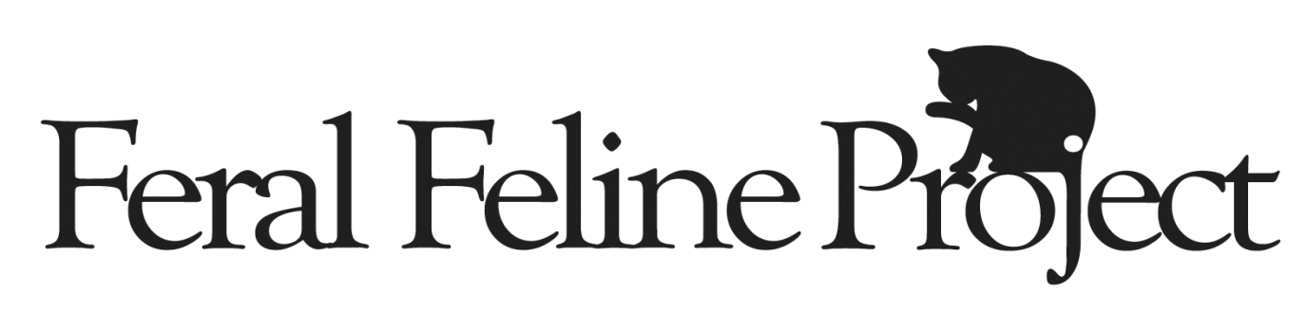

AGREEMENT TO BORROW RESCUE EQUIPMENT
BRING THIS DOCUMENT WHEN TRAPS ARE BORROWED

This agreement is entered into between _______________________________ residing at
_____________________________________________________________________ (“you”) and Feral Feline Project (“Charity”), a non-profit organization with an address at P.O. Box 1, IL 60090.
In consideration of the mutual promises in this Agreement, and other good and valuable consideration, Charity and you agree, intending to be legally bound by this Agreement, as follows:

- The Equipment. Charity owns the following items (the “Equipment”). The Cost to Replace the Equipment and the Security Deposit for the Equipment are as follows:

Qty | Type | Size/Color | ID/No(s). | Cost to Replace | Deposit
 | Tru-Catch Trap(s) | 30 LTD |  | $ $ 75/each | ( $75 per trap
 | Cage(s) |  |  |  | $ $
 | Carrier(s) |  |  |  | $ $
 | Other Item(s) |  |  |  | $ $
 |  |  | Total Deposit |  | $ $

- DUE DATE FOR EQUIPMENT. The equipment listed above is due back to Feral Feline Project no later than 2 weeks past issuance date. Failure to return the equipment by this date will result in FINES as described in Paragraph 3 below. If you are unable to return the equipment by this date, you must contact Feral Feline Project before your due date to avoid the fines specified in Paragraph 3 below. If demand is high, you may have to return your trap before the 2 week date.
- FINES FOR LATE RETURN. In order for Feral Feline Project to provide assistance to as many people as possible, it is imperative that all equipment be returned by the due date specified in Paragraph 2 above. Failure to do so will result in the following fines, imposed beginning the day following the due date and charged per day for each day until the equipment is returned or retrieved by Feral Feline Project:

- $1 per day for each trap listed in Paragraph 1 above.
- $5 per day for each cage listed in Paragraph 1 above.
- $1 per day for each carrier listed in Paragraph 1 above.
- $5 per phone call made by Feral Feline Project to remind you to return equipment.
- $20 retrieval fee if Feral Feline Project must retrieve the equipment from you.
- Equipment Loan. We are providing the Equipment to you until the due date shown in Paragraph 2 above. You agree to promptly return the Equipment and deliver it to the Feral Feline Project whenever we request it, or on your due date, whichever is sooner. You may not give or transfer the Equipment to anyone other than to us and temporarily to the veterinarian treating the animal. The Equipment may only be used for cats being put through Feral Feline Project program.

- Safekeeping. You will keep the equipment in a safe place and use reasonable care in operating and safeguarding it. You will not be financially responsible for ordinary wear and tear on the Equipment, nor for the cost of repairs and maintenance due to ordinary wear and tear. Damage or deterioration from prolonged exposure to rain or snow is not ordinary wear and tear. If you lose the Equipment, refuse to return it, it is stolen, or it is damaged beyond ordinary wear and tear as a result of your negligence or misconduct, you will promptly pay us the Cost to Replace the Equipment.

- Security Deposit. At the time you borrow the Equipment, you will pay the Security Deposit for the Equipment as specified in Paragraph 1 above. The deposit will be refunded when you return the Equipment in accordance with Paragraph 2 above. Any late fines due by you will be deducted from your deposit amount. Return of equipment by your due date will ensure a complete refund of your deposit amount.

- No Unattended Traps and Cages. You will not leave humane traps or cages unattended outdoors, in order to protect the animals and the Equipment. You will never leave traps set overnight.

- No Liability. We are not liable for any bodily injury, property damage, injury to any animals, injury caused by any animals, or any other losses or damages whatsoever, in connection with the use of the Equipment.

- Entire Agreement; Modification; Binding Effect. This Agreement is the entire agreement between you and us, and supersedes any prior understandings between you and us with respect to the subject matter. No modification of this Agreement will be valid unless in writing duly signed by you and us. This Agreement is binding on your and our successors, assigns, heirs, executors, and personal representatives.

FFP Representative Borrower

______________________ __________________________________________
Sign Name Print Name

______________________ Phone Number

