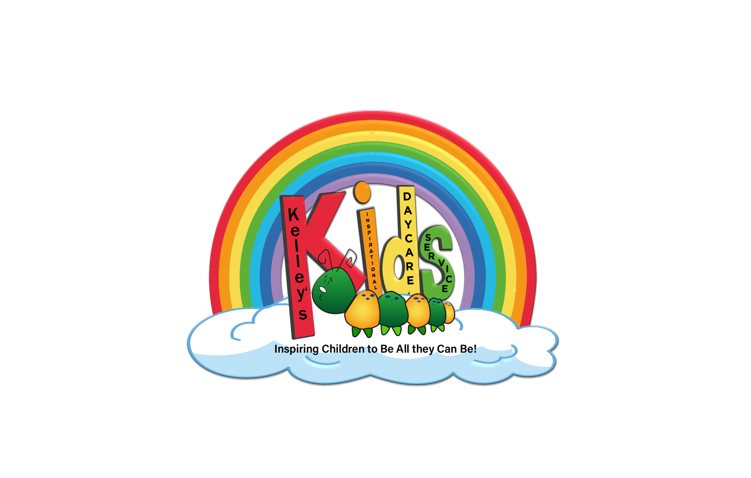 Kelley’s Inspirational Daycare Service, K.I.D.S.
FAMILY SURVEY

Instructions:
- Please select the best answer for each question.
- If you have more than one child enrolled in the program, kindly complete a separate survey of sections B, C, and G ONLY for each child in the program.
- Please return the survey by in the envelope provided to the drop box located .
- Thank you. We sincerely appreciate your feedback. It is crucial to our commitment to continuous improvement.

- Communication
- The program proactively communicates with me on a regular basis.

Strongly Agree Agree Neither Disagree Strongly Disagree

- The program does a good job returning my calls, emails, and notes promptly.

Strongly Agree Agree Neither Disagree Strongly Disagree

- The staff is helpful with answering questions.

Strongly Agree Agree Neither Disagree Strongly Disagree

- I receive formal written reports about my child’s developmental progress at the program.

Never Once a Year Twice a Year More than Twice a Year

- I receive program newsletters that are informative and helpful.

Strongly Agree Agree Neither Disagree Strongly Disagree

- Teacher
- My child’s teacher regularly communicates with me about my child.

Strongly Agree Agree Neither Disagree Strongly Disagree

- I have a good relationship with my child’s teacher.

Strongly Agree Agree Neither Disagree Strongly Disagree

- I am pleased with the amount and type of communications I have with my child’s teacher.

Strongly Agree Agree Neither Disagree Strongly Disagree

- I feel confident my child’s teacher takes good care of my child.

Strongly Agree Agree Neither Disagree Strongly Disagree

- My child’s teacher helps my child grow and develop in a nurturing and supportive environment.
Strongly Agree Agree Neither Disagree Strongly Disagree

- Teacher/Family Conferences
- Parent/Teacher conferences help me understand how my child is progressing.

Strongly Agree Agree Neither Disagree Strongly Disagree

- Parent/Teacher conferences give me ideas to implement at home.

Strongly Agree Agree Neither Disagree Strongly Disagree

- I feel at ease at parent/teacher conferences.

Strongly Agree Agree Neither Disagree Strongly Disagree

- I feel my child’s teacher really listens to me at parent/teacher conferences.

Strongly Agree Agree Neither Disagree Strongly Disagree

- Parent Teacher conferences are a positive experience.

Strongly Agree Agree Neither Disagree Strongly Disagree

- Facilities/Operations/Food

- The facility is clean.

Strongly Agree Agree Neither Disagree Strongly Disagree

- The facility has more than enough age-appropriate learning toys and books.

Strongly Agree Agree Neither Disagree Strongly Disagree

- The hours of the program are convenient.

Strongly Agree Agree Neither Disagree Strongly Disagree

- The outdoor play area(s) are safe and inviting to children.

Strongly Agree Agree Neither Disagree Strongly Disagree

- The meals prepared for my child are healthy.

Strongly Agree Agree Neither Disagree Strongly Disagree

- Meals respect my child’s special dietary restrictions or needs. (Answer only if applicable.)

Strongly Agree Agree Neither Disagree Strongly Disagree

- Family Relations
- When I first signed up, the Family Handbook was carefully explained to me to make sure I was aware of and understood the program policies.

Strongly Agree Agree Neither Disagree Strongly Disagree

- The staff did a good job giving me a tour of the facility so I could see where my child would learn, play and be cared for and what I should do for proper drop-off and pick-up.

Strongly Agree Agree Neither Disagree Strongly Disagree

- I feel that program policies are clear, sensible, and consistently applied.

Strongly Agree Agree Neither Disagree Strongly Disagree

- I have many opportunities to participate in the program such as volunteering in the classroom, on field trips, fundraising, etc.

Strongly Agree Agree Neither Disagree Strongly Disagree

- The program offers opportunities to learn and improve parenting and other child related skills.

Strongly Agree Agree Neither Disagree Strongly Disagree

- I feel that my child’s program encourages the involvement of families.

Strongly Agree Agree Neither Disagree Strongly Disagree

- Overall Satisfaction
- I feel welcome at the program.
Strongly Agree Agree Neither Disagree Strongly Disagree

- I feel respected at the program and that my contributions are valued.
Strongly Agree Agree Neither Disagree Strongly Disagree

- I feel the program respects and celebrates the cultural values of my family.
Strongly Agree Agree Neither Disagree Strongly Disagree

- I feel my child benefits from the program.
Strongly Agree Agree Neither Disagree Strongly Disagree

- My child enjoys the program.
Strongly Agree Agree Neither Disagree Strongly Disagree

- When the time is right, my child will be better prepared for the kindergarten experience because of the program.
Strongly Agree Agree Neither Disagree Strongly Disagree

- I would recommend the program to other parents.
Strongly Agree Agree Neither Disagree Strongly Disagree

- Other
- The age of my child in the program is:
Under 1 year 1 - 2 years 3-4 years 5 years or older

- My family is new to the center this year:
Yes No

- Here are other suggestions for improvement or comments I would like to share:

- I would like the director to please give me a call about my responses in this survey. In order to do so, I understand I must identify myself.
Yes
Name: ____________________________________
Phone Number: _____________________________
Email: _____________________________________
No, thank you.

Thank you for completing this survey. Your thoughts and ideas help us fulfill our commitment to being the best we can be.

