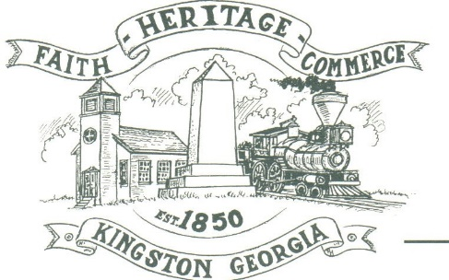
CITY OF KINGSTON
30 West Main St., Kingston, GA 30145
COUNCIL MEETING – CITY HALL
April 3, 2023 – 6:00 p.m.

The meeting began at 6:00 p.m. In attendance were council members, Louise Young-Harris, Michael McFarland, Allen Cochran, Mayor Elbert Wise, Payton Silvers, Kelly Ensley, City Clerk, and Police Chief TJ Sosebee,. There were five (5) attendees

The meeting began with Louise Young-Harris leading the invocation. The Pledge of Allegiance followed.

SIGN IN PERMISSION TO SPEAK.
Charlie Pecchio spoke to council regarding the SK Hundai plant and annexation

APPROVAL OF PREVIOUS MINUTES
Louise Young-Harris made a motion to approve previous minutes. Payton Silvers seconded the motion. Motion was carried unanimously.

APPROVAL OF AGENDA
Payton Silvers made a motion to approve agenda. Louise Young-Harris seconded the motion. Motion was carried unanimously.

DDA UPDATE
The DDA has an intern to help on marketing the downtown business mailer

APPROVAL TO PURCHASE 2 MOWERS
Payton Silvers made a motion to cap the purchase to $15,000 per mower. Michael McFarland seconded the motion. Motion carried unanimously.

CLOSED SESSION-PERSONNEL
At 6:15 p.m. Payton Silvers mad a motion to go into a closed session. Louise Young-Haris seconded the motion. Motion was carried unanimously. Returned from the closed session at 6:35 p.m.

COUNCIL COMMENTS
None

ADJOURNMENT
At 6:43 p.m. Payton Silvers made a motion to adjourn. Louise Young-Harris seconded the motion. Motion was carried unanimously.

_____________________________ ________________________
Mayor Elbert “Chuck” Wise, Jr. Kelly Ensley, City Clerk

