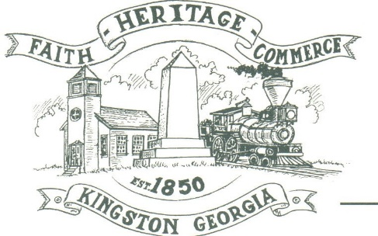
CITY OF KINGSTON
30 West Main St., Kingston, GA 30145
COUNCIL MEETING – CITY HALL
April 4, 2022 – 6:00 p.m.

The meeting began at 6:00 p.m. In attendance were council members, Louise Young-Harris, Michael McFarland, Payton Silvers, Allen Cochran, Mayor Elbert Wise, City Treasurer, Paula Stewart, Police Chief TJ Sosebee, and C. Kimberly Prine, Esq. Two members of the community were also in attendance.

The meeting began with Louise Young-Harris leading the invocation. The Pledge of Allegiance followed.

SIGN IN PERMISSION TO SPEAK.
No one signed in to speak.

APPROVAL OF PREVIOUS MINUTES
Louise Young-Harris made a motion to approve previous minutes. Payton Silvers seconded the motion. Motion was carried unanimously.

APPROVAL OF AGENDA
Louise Young-Harris made a motion to approve the agenda. Payton Silvers seconded the motion. Motion was carried unanimously.

DDA UPDATE
Charlie Pecchio stated the downtown tree removal on March 22, 2022, was a success. It took about 6 hours. He also introduced Cari Rainwater, owner of Kingston Body Wellness, to the council. Pastor Dallas of Faith Baptist will have volunteers for the Spring Fling and Car Show.

APPROVAL TO RENEW CHARLIE PECCHIO DOWNTOWN DEVELOPMENT TERM AND APPROIVAL TO REPLACE BRENT BAGBY WITH GINA FOWLER FOR TERM
Payton Silvers made a motion to renew Charlie Pecchio’s term and for Gina Fowler to replace Brent Bagby. Allen Cochran seconded the motion. Motion was carried unanimously.

APPROVE ZONING ORDINANCE
C. Kimberly Prine, Esq. explained that public hearings were required to be held on the issues of: (1) the amendment on the City’s zoning ordinance; (2) the standards for the exercise of the zoning power; (3) policies and procedures for calling and conducting public hearings; (4) regulations of signs; and (5) re-adoption and amendment of the official zoning map.

Public hearing opened to discuss Amendment of the City’s Zoning Ordinance. No one spoke on the matter. Hearing closed.

Public hearing was opened before Council meeting to discuss the standards for the exercise of zoning power. No one showed and no one spoke on the matter. Hearing closed.

Public hearing opened on the issue of the policies and procedures for calling and conducting public hearings. No one spoke on the matter. Hearing closed.

Public hearing opened on the issue of the regulation of signs. C. Kimberly Prine pointed out that there are studies that show that road signs impact traffic safety and aesthetics. The studies were produced at the meeting and left with the City Treasurer, Paula Stewart, to be kept in City Hall to be accessible by the public for review. No one spoke on the matter. Hearing closed.

Public hearing opened on the issue of re-adoption and amendment of the official zoning map. No one spoke on the matter. Hearing closed.

Mayor recommended adoption of the zoning ordinance be tabled to next meeting, pending receipt of a large version of the zoning map to be posted in City Hall. Payton Silvers made a motion table the zoning ordinance adoption to next month meeting. Michael McFarland seconded the motion. Motion was carried unanimously.

APPROVE BARTOW COUNTY AGREEMENT FOR DAWSON STREET MEETING VAULT

Mayor recommended this be tabled to next meeting. Payton Silvers made a motion table to next month meeting. Michael McFarland seconded the motion. Motion was carried unanimously

COUNCIL COMMENTS
Mayor stated he has rearranged maintenance personnel and requested patience from the public as they get organized.

Michael McFarland asked about the light poles on Railroad Street on the sidewalks and whether electrical outlets can be installed on them. The Mayor explained that in his experience that will not be possible as the light poles are not metered.

Chief Sosebee gave update on a police car being purchased under budget. He discussed the fact that the appropriate equipment will be installed on the vehicle at a cost that is less will still come in under budget.

Payton Silvers asked everyone to remember Darren & Kelly Ensley in your prayers as Darren had had a heart attack.

Louise Young Harris announced that Kingston Sunrise Service & Egg hunt will be held on Easter Sunday in the City Park. Good Friday services will be held and a feed the community event will also be hosted.

ADJOURNMENT
Payton Silvers made a motion to adjourn. Louise Young-Harris seconded the motion. Motion was carried unanimously.

_____________________________ ________________________
Mayor Elbert “Chuck” Wise, Jr. Paula Stewart, Treasurer, obo Kelly L. Ensley, City Clerk

