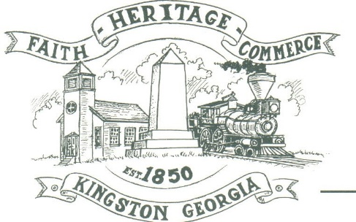
CITY OF KINGSTON
30 West Main St., Kingston, GA 30145
COUNCIL MEETING – CITY HALL
April 5, 2021 – 6:00 p.m.

The meeting began at 6:06 p.m. in attendance was Mayor Elbert “Chuck” Wise, council members, Louise Howell, and Michael McFarland Louise Young-Harris, Chief T.J. Sosebee, and Trent Lard of Sweitzer Engineering. Absent was Payton Silvers, there was 8 attendee.

The meeting began with Mayor Wise leading the invocation. The Pledge of Allegiance followed.

SIGN IN PERMISSION TO SPEAK
Kingston Women’s History Club presented 2 projects to the City. Grants are available and the City needs to assist them in receiving. The matching funds will be provided by the Bartow Visitors Bureau.
Michael McFarland made a motion for the City to carry on with helping the Kingston Women’s History Club in getting the Grants needed. The motion was seconded by Louise Howell. Motion was carried unanimously.

Charlie Pecchio stated the DDA would resume meetings on April 27th.

APPROVAL OF PREVIOUS MINUTES
Louise Young-Harris made a motion to approve previous minutes. The motion was seconded by Michael McFarland. Motion was carried unanimously.

APPROVAL OF AGENDA
Louise Young-Harris made a motion to approve the agenda. The motion was seconded by Louise Howell. Motion was carried unanimously.

APPROVAL FOR MORATORIUM
Louise Howell made a motion to approve moratorium 293 west of the City for a year. The motion was seconded by Michael McFarland. Motion was carried unanimously.

DISCUSS DRAINAGE ISSUES WITHIN THE CITY
Mayor Wise discussed drainage issues within the City and the possibility of an intergovernmental agreement to get help on equipment use and cleaning out ditches.

COUNCIL COMMENTS
Mayor Wise Thankful for everyone for coming and employees of the City. Louise Young-Harris commented glad Mrs. Howell was back.

ADJOURNMENT
Louise Young-Harris made a motion to adjourn at 6:36 p.m. Michael McFarland seconded the motion. Motion was carried unanimously.

_____________________________ ________________________
Mayor Elbert “Chuck” Wise, Jr. City Clerk, Kelly L. Ensley

