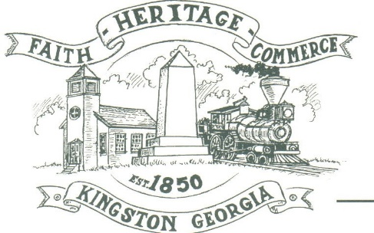
CITY OF KINGSTON
30 West Main St., Kingston, GA 30145
COUNCIL MEETING – CITY HALL
August 24, 2020 – 6:00 p.m.

The meeting began at 6:30 p.m. in attendance was Mayor Elbert “Chuck” Wise, council members, Payton Silvers, and Louise Howell, Michael McFarland, Louise Young-Harris (Zoom), and Chief T.J. Sosebee, There were 2 attendees.

The meeting began with Payton Silvers leading the invocation. The Pledge of Allegiance followed.

SIGN IN PERMISSION TO SPEAK
No one signed to speak

APPROVAL OF PREVIOUS MINUTES
Payton Silvers made a motion to approve previous minutes. The motion was seconded by Louise Young-Harris. Motion was carried unanimously.

APPROVAL OF AGENDA
Payton Silvers made a motion to approve the agenda. The motion was seconded by Michael McFarland. Motion was carried unanimously.

RECOGNIZE BILLY SANDERS AND G.B. HOOD
Mayor Chuck Wise spoke of the previous council members to recognize their service to the city as council members and long time members of the community.

APPROVAL TO SIGN GEFA 6 MONTH HOLD ON INTEREST DRAWS
Payton Silvers made a motion to approve the GEFA six month hold on interest draws. The motion was seconded by Louise Howell. Motion was carried unanimously.

1st READ ADOPT ANIMAL CONTROL ORDINANCE AMENDMENT FOR COMMUNITY CAT PROGRAMS

APPROVE CARES ACT RESOLUTION
Payton Silvers made a motion to approve the CARES ACT resolution. The motion was seconded by Michael McFarland. Motion was carried unanimously.

CARES ACT APPROVAL OF WHAT ITEMS TO PURCHASE WITH FUNDS
Louise Howell made a motion to have the City Clerk to determine the items needed by the City to cover the CARES ACT. The motion was seconded by Louise Harris-Young. Motion was carried unnimously

COUNCIL COMMENTS
Mayor Wise suggests everyone be careful with the COVID virus and wear face masks.

ADJOURNMENT
Payton Silvers made a motion to adjourn at 7:10 p.m. Louise Howell seconded the motion. Motion was carried unanimously.

_____________________________ ________________________
Mayor Elbert “Chuck” Wise, Jr. City Clerk, Kelly L. Ensley

