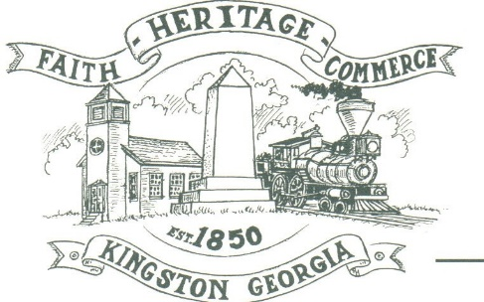
CITY OF KINGSTON
30 West Main St., Kingston, GA 30145
COUNCIL MEETING – CITY HALL
June 7, 2021 – 6:15 p.m.

CLOSED SESSION:

_____________________________ ________________________
Mayor Elbert “Chuck” Wise, Jr. City Clerk, Kelly L. Ensley

