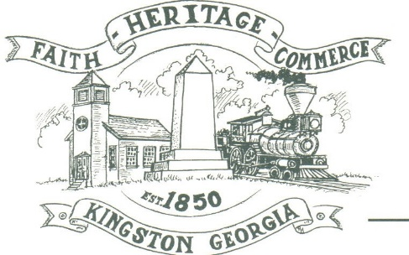
CITY OF KINGSTON
30 West Main St., Kingston, GA 30145
COUNCIL MEETING – CITY HALL
December 4, 2023 – 6:00 p.m.

The meeting began at 6:00 p.m. In attendance were council members, Louise Young-Harris, Michael McFarland, Allen Cochran, Mayor Elbert Wise, Payton Silvers, Kelly Ensley, City Clerk, Timara Williams, Treasurer Attorney Elliott Noll, and Police Chief TJ Sosebee. There were nine (4) attendees.

The meeting began with Louise Young-Harris leading the invocation. The Pledge of Allegiance followed.

SIGN IN PERMISSION TO SPEAK.
John Cross spoke inquiring about the striping on Hardin Bridge Road and concerns of the Bartow County connect being close to the road.
Don Riley asked about the office hours and concerns of trash and glass through the walking trail.

APPROVAL OF PREVIOUS MINUTES
Michael McFarland made a motion to approve previous minutes. Louise Young-Harris seconded the motion. Motion was carried unanimously.

APPROVAL OF AGENDA
Payton Silvers made a motion to approve agenda. Michael McFarland seconded the motion. Motion was carried unanimously.

APPROVAL OF 2024 BUDGET
Louise Young-Harris made a motion to approve the 2024 Budget. Payton Silvers seconded the motion. Motion was carried unanimously.

APPROVAL TO PURCHASE POLICE CAR
Payton Silvers made a motion to purchase a police vehicle. Michael McFarland seconded the motion. Motion was carried unanimously.

COUNCIL COMMENTS
Mayor Wise stated this was the last meeting for 2023 and thanked Michael McFarland for his service to the City. Allen Cochran asked regarding new street signs for the city and Dawson Street issue.

ADJOURNMENT
At 6:45 p.m. Payton Silvers made a motion to adjourn. Louise Young-Harris seconded the motion. Motion was carried unanimously.

_____________________________ ________________________
Mayor Elbert “Chuck” Wise, Jr. Kelly Ensley, City Clerk

