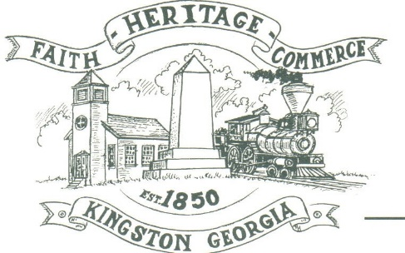
CITY OF KINGSTON
30 West Main St., Kingston, GA 30145
COUNCIL MEETING – CITY HALL
February 1, 2021 – 6:00 p.m.

The meeting began at 6:02 p.m. in attendance was Mayor Elbert “Chuck” Wise, council members, Payton Silvers, and Louise Howell, Michael McFarland Louise Young-Harris, Chief T.J. Sosebee and Attorney Brandon Bowen. There was 1 attendee.

The meeting began with Louise Young-Harris leading the invocation. The Pledge of Allegiance followed.

SIGN IN PERMISSION TO SPEAK
Charlie Pecchio spoke about DDA projects.

APPROVAL OF PREVIOUS MINUTES
Louise Young-Harris made a motion to approve previous minutes. The motion was seconded by Payton Silvers. Motion was carried unanimously.

APPROVAL OF AGENDA
Louise Howell made a motion to approve the agenda. The motion was seconded by Payton Silvers. Motion was carried unanimously.

APPROVAL TO ADOPT BUDGET FOR 2021 AND SIGN RESOLUTION
Michael McFarland made a motion to approve the 2021 budget and sign the resolution. The motion was seconded by Louise Howell. Motion was carried unanimously.

APPROVAL TO PURCHASE A NEW POLICE VEHICLE
Payton Silvers made a motion to approve the purchase of the Ford Police Interceptor. The motion was seconded by Michael McFarland. Motion was carried unanimously.

APPROVAL TO PURCHASE A BACKHOE AND TRACK HOE OF WATER DEPARTMENT
Payton Silvers made a motion to table until suitable options are available. The motion was seconded by Michael McFarland. Motion was carried unanimously. (It was suggested the DDA help in finding a grant to aid in the purchase of equipment for maintenance.)

COUNCIL COMMENTS
Mayor Wise commented on the importance of being safe and encourage everyone to wear a mask.
Louise Young-Harris read a Bartow County health department report stating there was an increase of 408 cases in the last week and 7 deaths. Bartow County has had the largest number of deaths during the pandemic.

ADJOURNMENT
Payton Silvers made a motion to adjourn at 6:35 p.m. Louise Young-Harris seconded the motion. Motion was carried unanimously.

_____________________________ ________________________
Mayor Elbert “Chuck” Wise, Jr. City Clerk, Kelly L. Ensley

