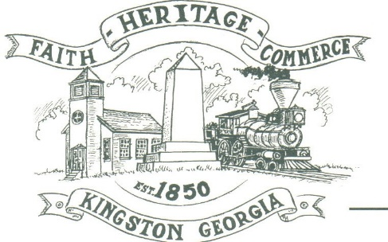
CITY OF KINGSTON
30 West Main St., Kingston, GA 30145
COUNCIL MEETING – CITY HALL
February 23, 2023 – 6:00 p.m.

The meeting began at 6:03 p.m. In attendance were council members, Louise Young-Harris, Michael McFarland, Allen Cochran, Mayor Elbert Wise, Payton Silvers (face time), Kelly Ensley, City Clerk, and Police Chief TJ Sosebee,. There were five (5) attendees

The meeting began with Louise Young-Harris leading the invocation. The Pledge of Allegiance followed.

SIGN IN PERMISSION TO SPEAK.
No one signed in to speak

APPROVAL OF PREVIOUS MINUTES
Louise Young-Harris made a motion to approve previous minutes. Michael McFarland seconded the motion. Motion was carried unanimously.

APPROVAL OF AGENDA
Louise Young-Harris made a motion to approve agenda. Michael McFarland seconded the motion. Motion was carried unanimously.

DDA UPDATE
Nothing at this time.

APPROVAL TO ADOPT THE BARTOW COUNTY JOINT COMPREHENSIVE PLAN (2023-2027)
Michael McFarland made a motion to adopt the Bartow County Joint Comprehensive Plan for 2023-2027. Allen Cochran seconded the motion. Motion carried unanimously.

COUNCIL COMMENTS
Louise Young-Harris glad to see residents involved with the City. Michael McFarland spoke about the Cruise-in April 1st.

ADJOURNMENT
At 6:16 p.m. Michael McFarland made a motion to adjourn. Louise Young-Harris seconded the motion. Motion was carried unanimously.

_____________________________ ________________________
Mayor Elbert “Chuck” Wise, Jr. Kelly Ensley, City Clerk

