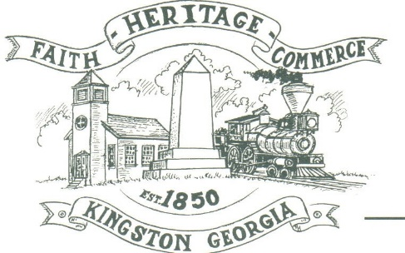
CITY OF KINGSTON
30 West Main St., Kingston, GA 30145
COUNCIL MEETING – CITY HALL
January 11, 2021 – 6:00 p.m.

The meeting began at 6:02 p.m. in attendance was Mayor Elbert “Chuck” Wise, council members, Payton Silvers, and Louise Howell, Michael McFarland, Chief T.J. Sosebee and Attorney Brandon Bowen. There were 2 attendees. (not in attendance Louise Young-Harris)

The meeting began with Payton Silvers leading the invocation. The Pledge of Allegiance followed.

SIGN IN PERMISSION TO SPEAK
No one signed in to speak

APPROVAL OF PREVIOUS MINUTES
Payton Silvers made a motion to approve previous minutes. The motion was seconded by Michael McFarland. Motion was carried unanimously.

APPROVAL OF AGENDA
Payton Silvers made a motion to approve the agenda. The motion was seconded by Louise Howell. Motion was carried unanimously.

APPROVAL TO SET DATE/TIME FOR BUDGET HEARING
Payton Silvers made a motion to approve Thursday, January 21, 2021 at 2:00 p.m. for Budget Hearing. The motion was seconded by Michael McFarland. Motion was carried unanimously.

APPROVAL TO REPLACE CHEM FEED SYSTEM AND REPAIRS FOR THE DAWSON WELL HOUSE
Payton Silvers made a motion to approve the replacement of the chem feed system and repairs for the Dawson Street well house. The motion was seconded by Michael McFarland. Motion was carried unanimously.

APPROVAL OF QUALIFYING FEES FOR NOVEMBER 2, 2021 ELECTION-COUNCIL FEE $63; MAYOR FEE $144
Payton Silvers made a motion to approve qualifying fees for November 2, 2021 election-Council fee $63; Mayor $144. The motion was seconded by Louise Howell. Motion was carried unanimously.

COUNCIL COMMENTS
Mayor Wise commented on the accomplishments in 2020 for the City. Thanked everyone that works for the city.
Michael McFarland asked about annexation.
Louise Howell stated everything seems to be going fine.

ADJOURNMENT
Payton Silvers made a motion to adjourn at 6:35 p.m. Louise Howell seconded the motion. Motion was carried unanimously.

_____________________________ ________________________
Mayor Elbert “Chuck” Wise, Jr. City Clerk, Kelly L. Ensley

