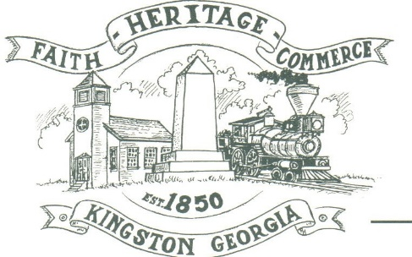
CITY OF KINGSTON
30 West Main St., Kingston, GA 30145
COUNCIL MEETING – CITY HALL
July 10, 2023 – 6:00 p.m.

The meeting began at 6:04 p.m. In attendance were council members, Louise Young-Harris, Michael McFarland, Allen Cochran, Mayor Elbert Wise, Payton Silvers, Kelly Ensley, City Clerk, attorney Elliott Noll, Trent Lard (Sweitzer Engineering) and Police Chief TJ Sosebee,. There were seven (7) attendees.

The meeting began with Louise Young-Harris leading the invocation. The Pledge of Allegiance followed.

SIGN IN PERMISSION TO SPEAK.
John Ellis spoke about a tree on his property. The Contractor had dug through the roots and the tree is dying. Council made an approval to remove the tree at the City’s expense.
Dale Grizzle spoke on behalf of the Kingston Lodge to help gather supplies for flags to be set up in the park area for flag holidays. Mayor Wise, Councilman Silvers and Chief Sosebee all donated $100 each and Mayor made an approval for the City to supply what was needed.

APPROVAL OF PREVIOUS MINUTES
Louise Young-Harris made a motion to approve previous minutes. Payton Silvers seconded the motion. Motion was carried unanimously.

APPROVAL OF AGENDA
Payton Silvers made a motion to approve agenda. Michael McFarland seconded the motion. Motion was carried unanimously.

DDA UPDATE
Nothing at this time

APPROVE COLORS AND DESIGN FOR WELCOME SIGN AT POINT AND CHANGE SIGN SIZE TO 10 X 6
Payton Silvers made a motion to use the color star gazer and to increase the sign size. Louise Young-Harris seconded the motion. Motion was carried unanimously.

APPROVE PAVING CONTRACTOR
Payton Silvers made a motion to approve Bartow Paving to do the paving within the City. Michael McFarland seconded the motion. Motion was carried unanimously.

ISSUES ALONG 293 AND WATER LINE/FIREFLOW
Mayor Wise discussed with Trent Lard (Sweitzer Engineering) the moratorium for 293. We can provide domestic service, but cannot allow fire flow. It is advised we have the homeowner sign an agreement/waiver of liability.

COUNCIL COMMENTS
Mayor Wise introduced thanked everyone for coming. Thanked the Kingston Lodge for their participation in the events the City is involved in. Thanked the attorney and Trent for attending

ADJOURNMENT
At 6:58 p.m. Payton Silvers made a motion to go into a closed session. Allen Cochran seconded the motion. Motion was carried unanimously.

_____________________________ ________________________
Mayor Elbert “Chuck” Wise, Jr. Kelly Ensley, City Clerk

