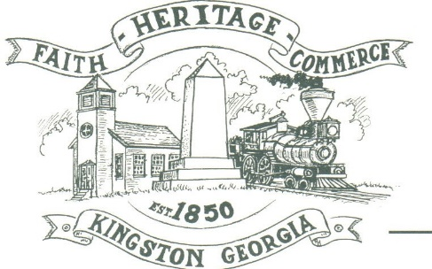
CITY OF KINGSTON
30 West Main St., Kingston, GA 30145
COUNCIL MEETING – CITY HALL
July 11, 2022 – 6:00 p.m.

The meeting began at 6:03 p.m. In attendance were council members, Louise Young-Harris, Michael McFarland, Allen Cochran, Mayor Elbert Wise, Payton Silvers (Face time), City Clerk Kelly Ensley, Police Chief TJ Sosebee, and Elliott Noll representing the City Attorney. There were three attendees

The meeting began with Louise Young-Harris leading the invocation. The Pledge of Allegiance followed.

SIGN IN PERMISSION TO SPEAK.
No one signed in to speak.

APPROVAL OF PREVIOUS MINUTES
Louise Young-Harris made a motion to approve previous minutes. Michael McFarland seconded the motion. Motion was carried unanimously.

APPROVAL OF AGENDA
Louise Young-Harris made a motion to approve the agenda. Allen Cochran seconded the motion. Motion was carried unanimously.

DDA UPDATE
Charlie Pecchio spoke of a Fall festival possibility and getting with the City on a 3 year plan for what the City would like to accomplish.

1st READING ANIMAL CONTROL ORDINANCE; INCLUDING AMENDMENTS
Ordinance was read

1ST READING FOR JOHN CROSS APPLICATION FOR CONSTRUCTING A GUEST HOUSE ON HIS PROPERTY
Zoning application was read. Mr. Cross spoke explaining the reason for guest home.

COUNCIL COMMENTS
Louise Young-Harris asked about the City Treasurer, Paula Stewart. Mayor Wise thanked the DDA and also thanked John Cross for his organization of his application for the guest home.

ADJOURNMENT
At 6:50 p.m. Louise Young-Harris made a motion to adjourn. Payton Silvers seconded the motion. Motion was carried unanimously.

_____________________________ ________________________
Mayor Elbert “Chuck” Wise, Jr. Kelly L. Ensley, City Clerk

