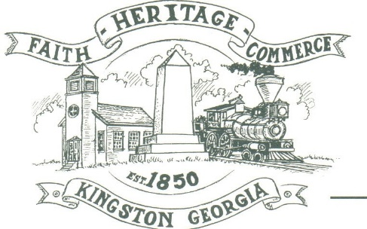
CITY OF KINGSTON
30 West Main St., Kingston, GA 30145
COUNCIL MEETING – CITY HALL
July 12, 2021 – 6:00 p.m.

The meeting began at 6:15 p.m. in attendance was council members, Louise Howell, Michael McFarland, Payton Silvers, Mayor Elbert Wise, Chief T.J. Sosebee and City attorney Brandon Bowen. Absent was Louise Young-Harris, there was 7 attendees.

The meeting began with Mayor Wise leading the invocation. The Pledge of Allegiance followed.

SIGN IN PERMISSION TO SPEAK
Jason Wright spoke regarding communication with the city and the DDA, says they have had a lot of resistance-the city doesn’t work with the DDA

Charlie Pecchio spoke regarding having a joint meeting with the city to discuss projects the city would like to do.

Allen Cates of Treetop Residential and developer of the Stratford Subdivision spoke regarding the water meters for the subdivision. States that 2004 the city mad an agreement to supply the meters. Said they would pay double for each meter. He even requested a temporary meter if possible. It was explained the moratorium prevented the City from doing anything about supplying him with any meter until the suppression was increased on that side of the City.

APPROVAL OF PREVIOUS MINUTES
Louise Howell made a motion to approve previous minutes. The motion was seconded by Payton Silvers. Motion was carried unanimously.

APPROVAL OF AGENDA
Payton Silvers made a motion to approval the agenda. The motion was seconded by Michael McFarland. Motion was carried unanimously.

DDA UPDATE
None

APPROVE TO ADOPT THE AMENDED REVISION TO CHAPTER 14, ARTICLE II BARTOW COUNTY CONTROL ORDINANCE; RELATING TO FEES AND CHARGES
Payton Silvers made a motion to approve the amended revision to Chapter 14, Article II Bartow County Ordinance; relating to fees and charges. The motion was seconded by Michael McFarland. Motion was carried unanimously.

APPROVE RESOLUTION FOR ELECTION QUALIFYING DATES AND TIME; AUGUST 16TH THRU AUGUST 20TH 9:00 A.M. UNTIL 4:00 P.M. QUALIFYING FEES MAYOR $144 AND COUNCIL SEAT $63
Michael McFarland made a motion to approve the resolution for election qualifying dates and time; August 16th thru August 20th 9:00 a.m. until 4:00 p.m. qualifying fees Mayor $144 and council seat $63. The motion was seconded by Louise Howell. Motion was carried unanimously.

APPROVE REPAIRS ON CITY DUMP TRUCK; EST. $5500
Payton Silvers made a motion to approve repairs on city dump truck up to $5500. The motion was seconded by Michael McFarland. Motion was carried unanimously.

APPROVE TO REPAVE WELLS DRIVE & HARDIN BRIDGE ROAD (FROM BRIDGE TO MAIN ST.)
Payton Silvers made a motion to approve the repave of Wells Drive and Hardin Bridge Road. The motion was seconded by Michael Mcfarland. Motion was carried unanimously.

DISCUSSION USE OF ARPA LOCAL FISCAL RELIEF FUNDS
Payton Silvers stated he would like to see the water lines down 293 (toward Rome) expanded and a water tank installed to improve the water suppression. Michael McFarland stated the same.

CLOSED SESSION: EMPLOYEES
At 7:05 p.m., Payton Silvers made a motion to go into closed session regarding personnel. The motion was seconded by Louise Howell. Motion carried unanimously. Motion was carried unanimously.

COUNCIL COMMENTS
None

ADJOURNMENT
Michael McFarland made a motion to adjourn at 7:15 p.m. Louise Howell seconded the motion. Motion was carried unanimously.

_____________________________ ________________________
Mayor Elbert “Chuck” Wise, Jr. City Clerk, Kelly L. Ensley

