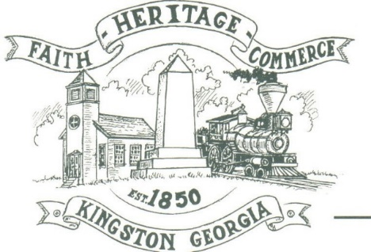
City of Kingston
Lead Protection Program
Frequently Asked Questions

If Crews find a lead service line, who will fix it?
If the city locates a lead service line, the next step is to conduct routine water monitoring for lead in the drinking water. Historical City of Kingston results show levels of lead meet safe drinking water standards, therefore lead lines are not required to be replaced as per EPA and GA EPD guidance.
If monitoring results change and are above regulatory limits, the City will follow GA EPD regulations to replace the City-owned portion of the service line and coordinate with homeowners to replace the customer side of the service line, at the owner’s expense. The city is investigating funding options to support lead service line replacements.
Are they digging in the yard?
Yes, digging will occur during each inspection. Crews are tasked with locating and confirming the material of the service line on both the City and Customer sides. All excavation efforts will be repaired back to normal condition.
Do property owners need to be home or present for the inspection?
No. Crews will be working at the property’s meter box and up to six feet past it. Crews do not need to interact with property owners, nor will they need to enter your home.
What type of test(s) will be performed during the service line inspection?
Crews may need to complete one or more of the following tests to confirm the material of the service line. Lead swab kits, scratch, magnet, and visual tests per EPD guidelines, will be conducted to identify the service line if it is a metal plumbing material.
What if my service line is damaged?
Any damage to the customer’s side of the service line caused by field crews during inspection will be repaired by a third party hired by the KWD. KWD staff will only be responsible for the repair of the city’s portion of the service line. If a customer’s service line is noted to be damaged before the inspection begins, the service line will not be inspected, and the property owner will be notified. The property owner will be responsible for repairing their service line.

