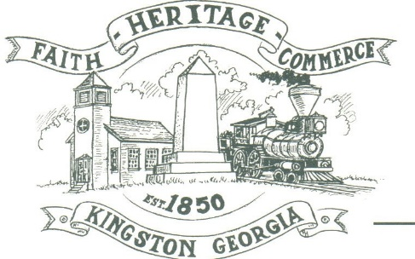
CITY OF KINGSTON
30 West Main St., Kingston, GA 30145
COUNCIL MEETING – CITY HALL
March 1, 2021 – 6:00 p.m.

The meeting began at 6:11 p.m. in attendance was Mayor Elbert “Chuck” Wise, council members, Payton Silvers, and Michael McFarland Louise Young-Harris, Chief T.J. Sosebee, Attorney Brandon Bowen and Trent Lard of Sweitzer Engineering. There was 3 attendee.

The meeting began with Louise Young-Harris leading the invocation. The Pledge of Allegiance followed.

SIGN IN PERMISSION TO SPEAK
None

APPROVAL OF PREVIOUS MINUTES
Louise Young-Harris made a motion to approve previous minutes. The motion was seconded by Payton Silvers. Motion was carried unanimously.

APPROVAL OF AGENDA
Payton Silvers made a motion to approve the agenda. The motion was seconded by Michael McFarland. Motion was carried unanimously.

APPROVAL FOR USDA PROJECT WORK
Payton Silvers made a motion to approve additional USDA project work on Turner St. The motion was seconded by Michael McFarland. Motion was carried unanimously.

COUNCIL COMMENTS
Mayor Wise commented for everyone to keep Mrs. Howell in our prayers and keep an eye on the elderly in our community. Louise Young-Harris commented regarding a woman stating she was Charles Manson. Chief stated she was passing through.

ADJOURNMENT
Payton Silvers made a motion to adjourn at 6:24 p.m. Louise Young-Harris seconded the motion. Motion was carried unanimously.

_____________________________ ________________________
Mayor Elbert “Chuck” Wise, Jr. City Clerk, Kelly L. Ensley

