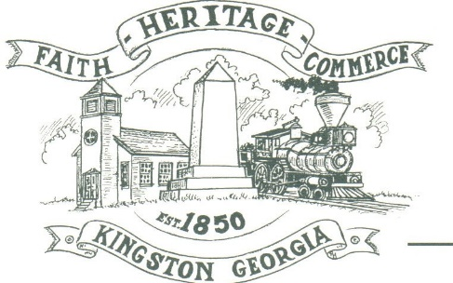
CITY OF KINGSTON
30 West Main St., Kingston, GA 30145
COUNCIL MEETING – CITY HALL
March 2, 2020 – 6:00 p.m.

The meeting began at 6:00 p.m. in attendance was Mayor Elbert “Chuck” Wise, council members, Payton Silvers, and Louise Howell, Michael McFarland, Louise Young-Harris, Chief T.J. Sosebee, and City attorney Brandon Bowen. There were 27 attendees.

The meeting began with Louise Young-Harris leading the invocation. The Pledge of Allegiance followed.

SIGN IN PERMISSION TO SPEAK
No one signed to speak

APPROVAL OF PREVIOUS MINUTES
Louise Young-Harris made a motion to approve previous minutes. The motion was seconded by Michael McFarland. Motion was carried unanimously.

APPROVAL OF AGENDA
Payton Silvers made a motion to approve the agenda. The motion was seconded by Louise Howell. Motion was carried unanimously.

KDDA UPDATE
Michael McFarland spoke about the KDDA wanting to set up a meeting with council. The KDDA will redo signs at Hardin Bridge Road both side of 411. Charlie Pecchio spoke of application submission to HGTV Hometown take over. A request was made to vote Julian Powell as KDDA secretary. Louise Young-Harris made a motion to approve Julian Powell as KDDA secretary. The motion was seconded by Payton Silvers. Motion was carried unanimously.

UPDATE/APPROVE KDDA MAP CHANGES
Payton Silvers made a motion to approve the KDDA map changes. The motion was seconded by Louise Young-Harris. Motion was carried unanimously.

APPROVEL TO ALLOW CURRENT 5 MEMBERS OF PLANNING AND ZONING BE THE VARIANCE BOARD
Payton Silvers made a motion to approve the current 5 members of Planning and Zoning to be the Variance board. The motion was seconded by Louise Howell. Motion was carried unanimously.

RECOGNIZE NOAH WOODS/SMALL TOWN HERO
County Commissioner Steve Taylor presented a Proclamation in honor of Noah. Mayor Wise and Council member Payton Silvers presented Noah with a Small Town Hero Plaque, $100 gift card and a fire fighter uniform. Council members, Louise Howell, Michael McFarland, Louise Young-Harris, Payton Silvers and Mayor Wise presented Noah with a T-shirt and quilt donated from Stella Hopkins with patches donated all over the world.

COUNCIL COMMENTS
Mayor Wise thanked the County Commissioner, Fire Chief and the other firemen for attending and being a part of Noah’s recognition.
Louise Young-Harris spoke of how proud of our small town hero and his great deed.

ADJOURNMENT
Payton Silvers made a motion to adjourn at 6:29 p.m. Louise Howell seconded the motion. Motion was carried unanimously.

_____________________________ ________________________
Mayor Elbert “Chuck” Wise, Jr. City Clerk, Kelly L. Ensley

