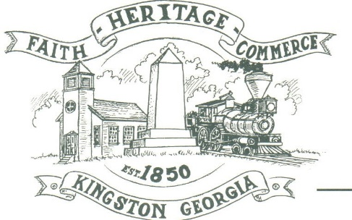
CITY OF KINGSTON
30 West Main St., Kingston, GA 30145
COUNCIL MEETING – CITY HALL
May 1, 2023 – 6:00 p.m.

The meeting began at 6:05 p.m. In attendance were council members, Louise Young-Harris, Michael McFarland, Allen Cochran, Mayor Elbert Wise, Payton Silvers (absent), Kelly Ensley, City Clerk, Timara Williams, attorney Elliott Noll and Police Chief TJ Sosebee,. There were seven (7) attendees

The meeting began with Louise Young-Harris leading the invocation. The Pledge of Allegiance followed.

SIGN IN PERMISSION TO SPEAK.
Alan Wilber (of Kingston) with Troop 700 out of Kennesaw proposed to build a little library box for the city for his Eagle Scout pin. The City will fund the project for supplies.

APPROVAL OF PREVIOUS MINUTES
Louise Young-Harris made a motion to approve previous minutes. Michael McFarland seconded the motion. Motion was carried unanimously.

APPROVAL OF AGENDA
Louise Young-Harris made a motion to approve agenda. Michael McFarland seconded the motion. Motion was carried unanimously.

DDA UPDATE
Jason Wright introduced James Davey doing marketing for the KDDA. He also spoke about helping the city with annexation.

POLICE REPORTS-CHIEF SOSEBEE
Chief Sosebee spoke regarding the car seat program, the department has gave away 30 car seats. He formally thanked the City of White for their donation of a 2007 Crown Vic with most of the equipment.
The Veiga family donated 2 brethalyzers for DUI detection w/extra mouth pieces and 3 window tint meters with extra batteries.
The police department received a grant for 24 Narcan kits and 200 Fentanyl strips for Opoid (Heroin/Meth) overdoses.

APPROVAL TO PROCEED WITH GDOT TRANSPORTATION ALTERNATIVE GRANT
Michael McFarland made a motion not to approve to proceed with the GDOT Transportation Alternative Grant due to the out of pocket cost to the City. Michael McFarland seconded the motion. Motion was carried unanimously.

DISCUSSION OF GARBAGE SERVICE/FEES
Michael McFarland made a motion to approve Republic Services proposal. Allen Cochran seconded the motion. Motion was carried unanimously.

COUNCIL COMMENTS
Mayor Wise introduced Timara Williams and welcomed her to City Hall. Cruise in event Saturday, May 6th.
Louise Young-Harris made an announcement for National Day of Prayer on Thursday, May 4th.
Thanked the Chief and department

ADJOURNMENT
At 7:04 p.m. Louise Young-Harris made a motion to go into a closed session. Michael McFarland seconded the motion. Motion was carried unanimously.

_____________________________ ________________________
Mayor Elbert “Chuck” Wise, Jr. Kelly Ensley, City Clerk

