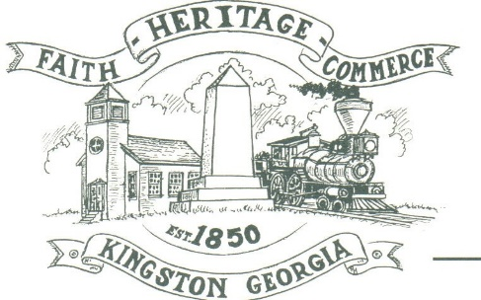
CITY OF KINGSTON
30 West Main St., Kingston, GA 30145
COUNCIL MEETING – CITY HALL
May 2, 2022 – 6:00 p.m.

The meeting began at 6:00 p.m. In attendance were council members, Louise Young-Harris, Michael McFarland, Payton Silvers, Allen Cochran, Mayor Elbert Wise, City Clerk Kelly Ensley, Police Chief TJ Sosebee, Trent Lard of Sweitzwer Engineering, and Brandon Bowen, City Attorney. There were seven attendees

The meeting began with Mayor Wise leading the invocation. The Pledge of Allegiance followed.

SIGN IN PERMISSION TO SPEAK.
No one signed in to speak.

APPROVAL OF PREVIOUS MINUTES
Louise Young-Harris made a motion to approve previous minutes. Payton Silvers seconded the motion. Motion was carried unanimously.

APPROVAL OF AGENDA
Louise Young-Harris made a motion to approve the agenda. Payton Silvers seconded the motion. Motion was carried unanimously.

DDA UPDATE
Michael McFarland spoke regarding the Spring Fling on June 4th.

APPROVE ZONING ORDINANCE AND LAND USE MAP
Payton Silvers made a motion to approve the Zoning Ordinance and Land Use Map. Michael McFarland seconded the motion. Motion was carried unanimously.

APPROVE RESOLUTION FOR A UNIFIED ZONING BOARD
Louise Young-Harris made a motion to approve for a Unified Zoning Board. Payton Silvers seconded the motion. Motion was carried unanimously.

1ST READING ANIMAL CONRTOL ORDINANCE; INCLUDING AMENDMENTS
This item was tabled to next meeting. Brandon Bowen to have ordinance with all amendments included.

STATUS UPDATE BARTOW COUNTY AGREEMENT FOR DAWSON STREET METERING VAULT (T. LARD)
Trent Lard spoke regarding the agreement with the County for the connection to the Dawson Street well. We are awaiting pricing. This will allow more water pressure down 293. It will not allow enough water pressure for fire flow or allow for additional meters to be connected at this time.

APPROVE APPOINTMENTS TO THE UNIFIED ZONING BOARD (SWEAR IN MEMBERS ATTENDING)
Louise Young-Harris made a motion to approve the appointments to the Unified Zoning board members. Payton Silvers seconded the motion. The motion was carried unanimously. Larry Posey and James Kaul were sworn in.

COUNCIL COMMENTS
Payton Silvers recommended everyone ride out to the new subdivision (Kingston Park) and recommended the City do a newsletter to the new citizens to our City welcoming them.

Mayor thanked everyone for coming to the meeting. Thanked officers and employees.

Louise Young Harris spoke regarding an address issue on Lee St.-was informed Bartow County had been contacted and changes will be made.

ADJOURNMENT
At 6:31 p.m. Payton Silvers made a motion to adjourn. Louise Young-Harris seconded the motion. Motion was carried unanimously.

_____________________________ ________________________
Mayor Elbert “Chuck” Wise, Jr. Kelly L. Ensley, City Clerk

