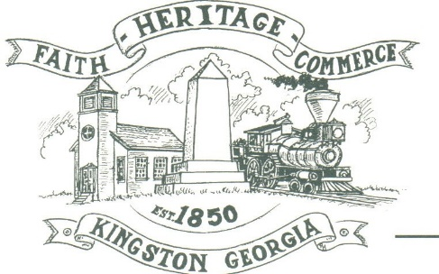
CITY OF KINGSTON
30 West Main St., Kingston, GA 30145
COUNCIL MEETING – CITY HALL
November 8, 2021 – 6:00 p.m.

The meeting began at 6:10 p.m. in attendance was council members, Louise Young-Harris, Michael McFarland, Payton Silvers, Mayor Elbert Wise, and Chief T.J. Sosebee. Absent was Louise Howell, there was three attendees.

The meeting began with Louise Young-Harris leading the invocation. The Pledge of Allegiance followed.

SIGN IN PERMISSION TO SPEAK
None

APPROVAL OF PREVIOUS MINUTES
Michael McFarland made a motion to approve previous minutes. Louise Young-Harris seconded the motion. Motion was carried unanimously.

APPROVAL OF AGENDA
Louise Young-Harris made a motion to approve the agenda. Payton Silvers seconded the motion. Motion was carried unanimously.

DDA UPDATE
Quote for Benches on Railroad Street was presented $1,375.00 and ok was given by Mayor Elbert Wise. Charlie Pecchio Spoke with Steve Taylor concerning deed to City Hall building and stated Steve Taylor was going to get the deed put back in the City’s name. Annexation was also discussed with Steve Taylor, and he stated the county would not stand in the way of it. Update on sewage is it is 2-3 years out and that grants are available to assist with City and citizens. Valerie Gilreath will assist with grants.

APPROVE 2022 BUDGET
Payton Silvers made motion to approve the 2022 Budget. Michael McFarland seconded the motion. Motion was carried unanimously.

APPROVAL TO PURCHASE NEW TURBIDIMETER FOR DAWSON STREET WELL
Payton Silvers made a motion to approve the purchase of new Turbidimeter for Dawson Street Well. Michael McFarland seconded the motion. Motion was carried unanimously.

APROVAL TO UPDATE MISSION TECHNICAL SUPPORT OF WELL PUMPS
Louise Young-Harris made a motion to approve update Mission Technical Support of well pumps. Payton Silvers seconded the motion. Motion was carried unanimously.

COUNCIL COMMENTS
Mayor Elbert Wise spoke about the disappointing turn out in the recent election and how we need to encourage our citizens to vote. Thanked Patsy Zachery, Charlie Pecchio and Austin Williams from WBHF for coming.

Louise Young-Harris spoke about the Trunk or Treat and what a good turn out it was and Thanked Paula Stewart for stepping up in Kelly Ensley’s absence.

ADJOURNMENT
Payton Silvers made a motion to adjourn at 6:30 p.m. Louise Young-Harris seconded the motion. Motion was carried unanimously.

_____________________________ ________________________
Mayor Elbert “Chuck” Wise, Jr. Paula Stewart, Treasurer

