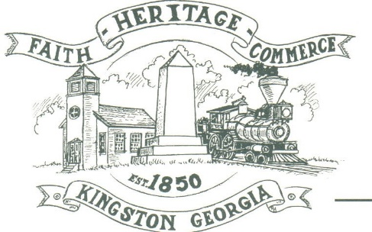
CITY OF KINGSTON
30 West Main St., Kingston, GA 30145
COUNCIL MEETING – CITY HALL
October 3, 2022 – 6:00 p.m.

The meeting began at 6:05 p.m. In attendance were council members, Louise Young-Harris, Michael McFarland, Allen Cochran, Mayor Elbert Wise, Payton Silvers (absent), City Clerk Kelly Ensley, Police Chief TJ Sosebee, and Elliott Noll representing the City Attorney. There were five attendees

The meeting began with Louise Young-Harris leading the invocation. The Pledge of Allegiance followed.

SIGN IN PERMISSION TO SPEAK.
Charlie Pecchio spoke regarding a toilet system for 13 Railroad St.

APPROVAL OF PREVIOUS MINUTES
Louise Young-Harris made a motion to approve previous minutes. Michael McFarland seconded the motion. Motion was carried unanimously.

APPROVAL OF AGENDA
Louise Young-Harris made a motion to approve the agenda. Allen Cochran seconded the motion. Motion was carried unanimously.

DDA UPDATE
DDA met with Brielle Shinall to do grants for the city. Possibly having a monthly cruise in starting in the spring.

APPROVE 2023 BUDGET
Louise Young-Harris made a motion to approve the 2023 budget. Michael McFarland seconded the motion. Motion carried unanimously.

1st READ KINGSTON COMMUNITY DEVELOPMENT PROJECT ORDINANCE AND REGULATIONS
Read

APPROVAL TO MAKE DAWSON STREET A ONE-WAY STREET
Louise Young-Harris made a motion to table the approval to make Dawson Street a one-way street for attorney to have necessary items ready. Michael McFarland seconded the motion. Motion carried unanimously.

APPROVE PURCHASE OF POLICE CAR FOR GRANT
Louise Young-Harris made a motion to approve the purchase of a 2022 Ford Explorer with the Police Car Grant. Michael McFarland seconded the motion. Motion was carried unanimously.

COUNCIL COMMENTS
Louise Young-Harris asked Mr. Pecchio that the toilet approval not cause any problems with the city. Mayor Wise thanked everyone for coming.

ADJOURNMENT
At 7:00 p.m. Michael McFarland made a motion to adjourn. Louise Young-Harris seconded the motion. Motion was carried unanimously.

_____________________________ ________________________
Mayor Elbert “Chuck” Wise, Jr. Kelly L. Ensley, City Clerk

