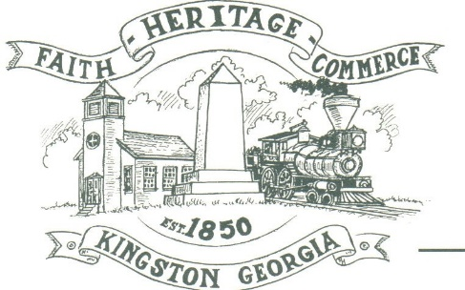
CITY OF KINGSTON
30 West Main St., Kingston, GA 30145
COUNCIL MEETING – CITY HALL
October 4, 2021 – 6:00 p.m.

The meeting began at 6:02 p.m. in attendance was council members, Louise Young-Harris, Michael McFarland, Payton Silvers, Mayor Elbert Wise, Chief T.J. Sosebee, and attorney Elliot Noll (sitting in for Brandon Bowen). Absent was Louise Howell, there were three attendees.

The meeting began with Louise Young-Harris leading the invocation. The Pledge of Allegiance followed.

SIGN IN PERMISSION TO SPEAK
None

APPROVAL OF PREVIOUS MINUTES
Louise Young-Harris made a motion to approve previous minutes. Michael McFarland seconded the motion. Motion carried unanimously.

APPROVAL OF AGENDA
Louise Young-Harris made a motion to approve the agenda. Michael McFarland seconded the motion. Motion carried unanimously.

DDA UPDATE
No update

SET BUDGET HEARING FOR 2022 BUDGET
2022 Budget hearing scheduled for Thursday, October 21, 2021 at 2:00 p.m.

APPROVE TO HAVE AJ’S TREE SERVICE TO CLEAR THE CITY’S LOT ON KITCHEN’S ALLEY
Payton Silvers made a motion to approve for Aj’s Tree Service to clear the city’s lot on Kitchen’s Alley. Michael McFarland seconded the motion. Motion carried unanimously.

APPROVE EMPLOYEE BONUS AND AMOUNT THROUGH ARPA FUNDS
Payton made a motion to approve a bonus of $1000 to the full-time employees that worked during COVID and $500 for newly hired employees. Michael McFarland seconded the motion. Motion carried unanimously.

APPROVE TO PROVIDE PROPOSAL FOR DEMOLITION OF RAILROAD ST. PUMPHOUSE
Payton Silvers made a motion to demo building at Railroad Street pumphouse and build a 3 sided brick building. Louise Young-Harris seconded the motion. The motion carried unanimously.

COUNCIL COMMENTS
Roxie Pritchett spoke regarding running for Council position in November.
Mayor Wise read over Happenings in Kingston.

ADJOURNMENT
Payton Silvers made a motion to adjourn at 6:31 p.m. Louise Young-Harris seconded the motion. Motion carried unanimously.

_____________________________ ________________________
Mayor Elbert “Chuck” Wise, Jr. City Clerk, Kelly L. Ensley

