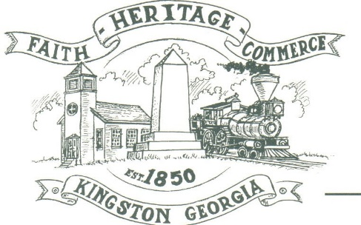
CITY OF KINGSTON
30 West Main St., Kingston, GA 30145
COUNCIL MEETING – CITY HALL
September 12, 2022 – 6:00 p.m.

The meeting began at 6:00 p.m. In attendance were council members, Louise Young-Harris, Michael McFarland, Allen Cochran, Mayor Elbert Wise, Payton Silvers (absent), City Clerk Kelly Ensley, Police Chief TJ Sosebee, and Elliott Noll representing the City Attorney. There were seven attendees

The meeting began with Louise Young-Harris leading the invocation. The Pledge of Allegiance followed.

SIGN IN PERMISSION TO SPEAK.
Reggie Applin spoke regarding Coleman St.

APPROVAL OF PREVIOUS MINUTES
Louise Young-Harris made a motion to approve previous minutes. Michael McFarland seconded the motion. Motion was carried unanimously.

APPROVAL OF AGENDA
Louise Young-Harris made a motion to approve the agenda. Michael McFarland seconded the motion. Motion was carried unanimously.

DDA UPDATE
Nothing to update.

AUDIT REPORT
Christian Hatch presented the 2021 Audit with good findings.

SET BUDGET HEARING DATE
Louise Young-Harris made a motion to set the Budget hearing for Wednesday, September 28th at 1:00 p.m. Michael McFarland seconded the motion. Motion was carried unanimously.

APPROVAL TO PURCHASE A CITY WORK TRUCK & UTILITY CART FOR MAINTENANCE; SET PRICE LIMITS
Michael McFarland made a motion to set $50,00 to purchase a city work truck and utility cart for maintenance. Louise Young-Harris seconded the motion. Motion was carried unanimously.

CLOSED SESSION REGARDING POSSIBLE PROPERTY PURCHASE
At 6:40 p.m. Louise Young-Harris made a motion to go into a closed session regarding possible property purchase. Allen Cochran seconded the motion. Motion was carried unanimously. At 7:20 p.m. meeting was called into session.

COUNCIL COMMENTS
None

ADJOURNMENT
At 7:23 p.m. Michael McFarland made a motion to adjourn. Louise Young-Harris seconded the motion. Motion was carried unanimously.

_____________________________ ________________________
Mayor Elbert “Chuck” Wise, Jr. Kelly L. Ensley, City Clerk

